The Principles of Design

Starting with the Basics
We can group all of the basic tenets of design into two categories: principles and elements. For this article, the principles of design are the overarching truths of the profession. They represent the basic assumptions of the world that guide the design practice, and affect the arrangement of objects within a composition.
Web design is a relatively new profession compared to other forms of design, due to the youth of our medium. As with any design discipline, there are aspects of the Web design process that are unique to the medium, such as screen resolution, additive color spaces and image compression. But too often these more unique details override our sense of the bigger picture. We focus on the fact that it is Web design and push aside core design concepts—concepts that can that make any project stronger without interfering in the more technical considerations later on.
How Does Web Design Fit In?
I tend to define Web design as being one of many disciplines within the larger field of design (a peer to print design, industrial design, interior design, etc.). To step back even further, I see design as a discipline within the field of art (a peer to painting, illustration, sculpture, etc.) The point is that in order to start with a discussion about the fundamentals of design as they relate to Web design we need to understand that there is a good degree of inheritance that design has received over the years from other art forms. These art forms, such as lithography, typography, painting/illustration and industrial design, evolved over many centuries, and a number of basic ideas have emerged as providing universal guidance to any artistic endeavor. When talking about fundamental concepts we inevitably look outside our discipline and adopt a slightly larger perspective.
The first three articles of this column will be dedicated to unearthing these universal gems of insight so that we may better understand our profession. In the first two articles, we will adopt a larger perspective to establish a foundation. In the third article we will tie it all together, using real-world examples to see how the basics are put into practice through the medium of the Web.
The Principles of Design
There are many basic concepts that underly the field of design. They are often categorized differently depending on philosophy or teaching methodology. The first thing we need to do is organize them, so that we have a framework for this discussion.
We can group all of the basic tenets of design into two categories: principles and elements. For this article, the principles of design are the overarching truths of the profession. They represent the basic assumptions of the world that guide the design practice, and affect the arrangement of objects within a composition. By comparison, the elements of design are the components of design themselves, the objects to be arranged.
Let’s begin by focusing on the principles of design, the axioms of our profession. Specifically, we will be looking at the following principles:
- Balance
- Rhythm
- Proportion
- Dominance
- Unity
Balance
Balance is an equilibrium that results from looking at images and judging them against our ideas of physical structure (such as mass, gravity or the sides of a page). It is the arrangement of the objects in a given design as it relates to their visual weight within a composition. Balance usually comes in two forms: symmetrical and asymmetrical.
Symmetrical
Symmetrical balance occurs when the weight of a composition is evenly distributed around a central vertical or horizontal axis. Under normal circumstances it assumes identical forms on both sides of the axis. When symmetry occurs with similar, but not identical, forms it is called approximate symmetry. In addition, it is possible to build a composition equally around a central point resulting in radial symmetry¹. Symmetrical balance is also known as formal balance.
Asymmetrical
Asymmetrical balance occurs when the weight of a composition is not evenly distributed around a central axis. It involves the arranging of objects of differing size in a composition such that they balance one another with their respective visual weights. Often there is one dominant form that is offset by many smaller forms. In general, asymmetrical compositions tend to have a greater sense of visual tension. Asymmetrical balance is also known as informal balance.
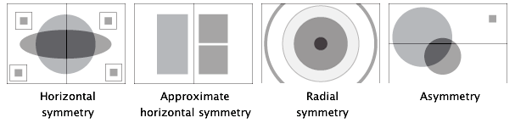
Rhythm
Rhythm is the repetition or alternation of elements, often with defined intervals between them. Rhythm can create a sense of movement, and can establish pattern and texture. There are many different kinds of rhythm, often defined by the feeling it evokes when looking at it.
- Regular: A regular rhythm occurs when the intervals between the elements, and often the elements themselves, are similar in size or length.
- Flowing: A flowing rhythm gives a sense of movement, and is often more organic in nature.
- Progressive: A progressive rhythm shows a sequence of forms through a progression of steps.
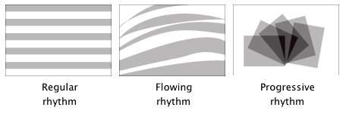
Proportion
Proportion is the comparison of dimensions or distribution of forms. It is the relationship in scale between one element and another, or between a whole object and one of its parts. Differing proportions within a composition can relate to different kinds of balance or symmetry, and can help establish visual weight and depth. In the below examples, notice how the smaller elements seem to recede into the background while the larger elements come to the front.
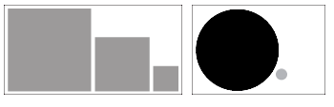
Dominance
Dominance relates to varying degrees of emphasis in design. It determines the visual weight of a composition, establishes space and perspective, and often resolves where the eye goes first when looking at a design. There are three stages of dominance, each relating to the weight of a particular object within a composition.
- Dominant: The object given the most visual weight, the element of primary emphasis that advances to the foreground in the composition.
- Sub-dominant: The element of secondary emphasis, the elements in the middle ground of the composition.
- Subordinate: The object given the least visual weight, the element of tertiary emphasis that recedes to the background of the composition.
In the below example, the trees act as the dominant element, the house and hills as the secondary element, and the mountains as the tertiary element.
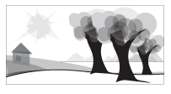
Unity
The concept of unity describes the relationship between the individual parts and the whole of a composition. It investigates the aspects of a given design that are necessary to tie the composition together, to give it a sense of wholeness, or to break it apart and give it a sense of variety. Unity in design is a concept that stems from some of the Gestalt theories of visual perception and psychology, specifically those dealing with how the human brain organizes visual information into categories, or groups².
Gestalt theory itself is rather lengthy and complex, dealing in various levels of abstraction and generalization, but some of the basic ideas that come out of this kind of thinking are more universal.
Closure
Closure is the idea that the brain tends to fill in missing information when it perceives an object is missing some of its pieces. Objects can be deconstructed into groups of smaller parts, and when some of these parts are missing the brain tends to add information about an object to achieve closure. In the below examples, we compulsively fill in the missing information to create shape.
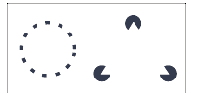

Perspective
Continuance is the idea that once you begin looking in one direction, you will continue to do so until something more significant catches your attention. Perspective, or the use of dominant directional lines, tends to successfully direct the viewers eye in a given direction. In addition, the eye direction of any subjects in the design itself can cause a similar effect. In the below example, the eye immediately goes down the direction of the road ending up in the upper right corner of the frame of reference. There is no other dominant object to catch and redirect the attention.
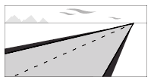

Similarity, Proximity and Alignment
Items of similar size, shape and color tend to be grouped together by the brain, and a semantic relationship between the items is formed. In addition, items in close proximity to or aligned with one another tend to be grouped in a similar way. In the below example, notice how much easier it is to group and define the shape of the objects in the upper left than the lower right.
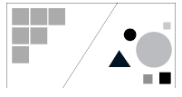

Related concepts
There are many additional concepts that are related to the principles of design. These can include specific terms and/or techniques that are in some way based on one or more of the above tenets. In they end, they add to the collection of compositional tools available for use by the designer.
Contrast or Opposition
Contrast addresses the notion of dynamic tensionÔthe degree of conflict that exists within a given design between the visual elements in the composition.
Positive and Negative Space
Positive and negative space refers to the juxtaposition of figure and ground in a composition. The objects in the environment represent the positive space, and the environment itself is the negative space.
Rule of Thirds
The rule of thirds is a compositional tool that makes use of the notion that the most interesting compositions are those in which the primary element is off center. Basically, take any frame of reference and divide it into thirds placing the elements of the composition on the lines in between.
Visual Center
The visual center of any page is just slightly above and to the right of the actual (mathematical) center. This tends to be the natural placement of visual focus, and is also sometimes referred to as museum height.
Color and Typography
Many would place color and typography along side the five principals I have outlined above. I personally believe both to be elements of design, so I’ll give them some attention in my next column. In addition, both topics are so robust that I plan on writing an entire article about each of them in the future.

