Creating a random image viewer

Rather than just show people our images, we want to make them a bit interactive and for this we will use Flash CS3. Rather than let the user select which image to view (As you already know how to accomplish this!), we will make an application that jumps to random images at the click of a button.

First thing to do is open Flash CS3, a new Actionscript 3.0 document and make sure that you save it immediately onto your h:/ drive as random frames.fla.

Adding a button

- Insert-> New symbol.
- Select ‘Button’. Call the button Submit.
- Select keyframes for each state: Up, Over, Down and Hit. Change the state of the button in each keyframe to a different colour.
- Return to the main timeline (Select ‘Scene 1’).
- Rename your layer ‘button’ and add an instance of your button onto the stage.
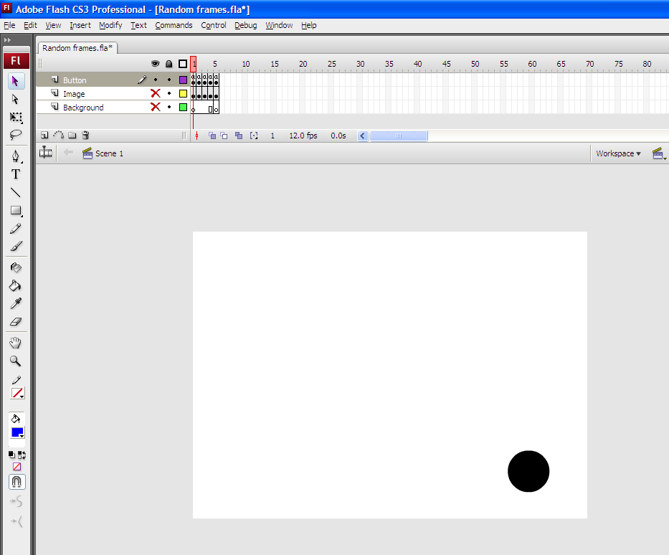

- Name the instance submit_btn
- Create keyframes (F6) at frame 1, 2, 3, 4 and 5.
Renaming your layers

      - Rename your layers so that you now have 3 layers – Button, Image and Background. You need to put the button layer on top as otherwise your click event (That we will create shortly) may have trouble functioning.

      - Create keyframes (F6) on the first 5 frames of your image layer and frame 5 of your background layer.

      - Your timeline should now look as follows:

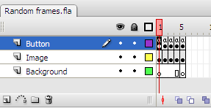

Adding your images

- Import 5 pictures that you have taken to your library. They must all represent one of the elements of visual design – line, form, texture, shape, tone and colour.

- For each of your 5 keyframes on your Image layer, add a different picture.

- Above the picture on your layer, write the element that it represents using the text tool.

- Below the picture, write a short description of the element.

- Select your background layer and change the colour to one of your choice.

- Your stage should now look something like this:

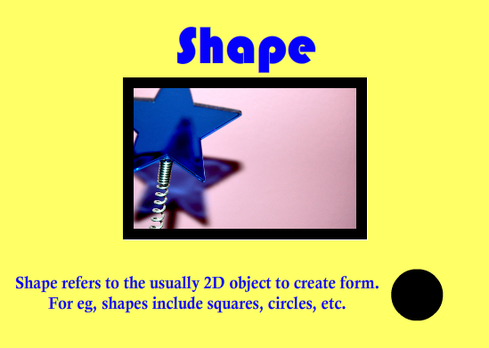
Coding your button

- Select the button layer and press F9 to open the Actions panel.

- Select frame 1, and write the following line:

stop();

- Do the same for frames 2, 3, 4 and 5.

- Select frame 1 again. After the stop(); place a blank line then the following code:

//add a click event to the submit button
submit_btn.addEventListener(MouseEvent.CLICK, jump);

// function called by the click event
function jump(event:MouseEvent) :void {
gotoAndPlay((Math.floor(Math.random()*4))+1);
}

- Now publish your settings and test your application.

Good luck!

