Creating an Interactive Flash File
To create an interactive Flash file (As we have to for our current assignment) we will need to make use of Actionscript 3.0. It is not too hard to begin with and make a fun, working, interactive file so lets make a quick multiple choice question to see how we go!
Adding a button
- Insert-> New symbol.
- Select ‘Button’. Call the button ‘Start’.
- Select keyframes for each state: Up, Over, Down and Hit.
- Return to the main timeline (Select ‘Scene 1’).
- Rename your layer ‘Interactive’ and add an instance of your button onto the stage.
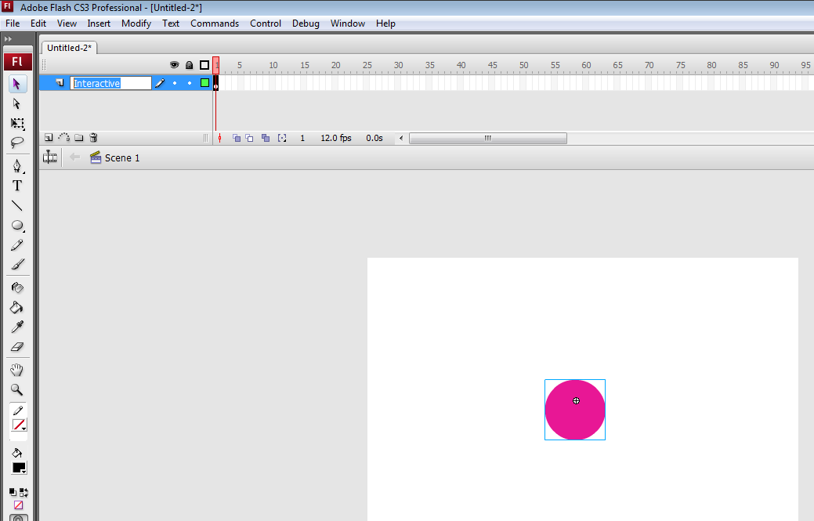
- Name the instance start_btn
- Make some text ‘Click to start’ above the button.
- Create a keyframe (F6) at frame 5, another at frame 10, another at frame 15 and another at frame 20 of your Interactive layer.
Renaming your frames
- Select frame 1 of your Interactive layer. Select the box Frame in the property inspector. Change the name so start.
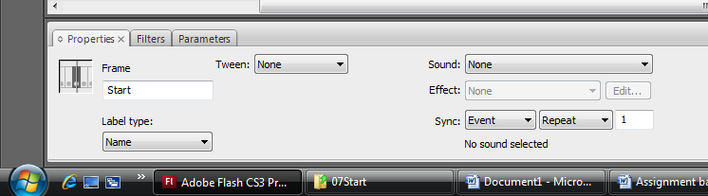
- Now select frame 5 and change the name to Question.
- Select frame 10 and change the name to Correct.
- Select frame 15 and change the name to Wrong.
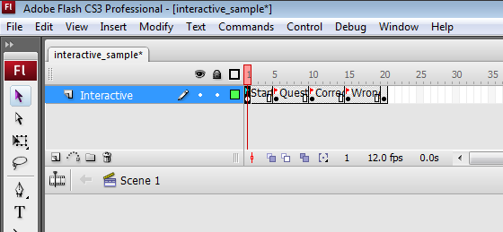

Adding the question
- Select frame 5, and delete all of the content on your stage. Create 3 instances of your start button on the stage. Name the instances answer1_btn, answer2_btn and answer3_btn.
- Create a basic question on your page, in this example ‘Which Australian sporting legend is known as the Great White Shark?’
- Write 3 answers next to the buttons (Making sure at least 1 is Greg Norman!)
If you’re correct…
- Select frame 10, and delete everything off the stage.
- Create text that says ‘Congratulations! You’re a winner!’
If you’re wrong…
- Select frame 15, and delete everything off the stage.
- Create text that says ‘Better luck next time. The correct answer is Greg Norman’
The basics of Actionscript 3.0
If you play your movie (Ctrl + Enter) now, it will just flick through your 10 frames in a loop, so it’s really quite useless! Let’s use some Actionscript 3.0 to try and make our program work and be interactive!
- Select frame 4. Select Window -> Actions or press F9 to open the actions panel. Type the following:
stop();
This stops your movie from continuing. The brackets mean the current action and the semi-colon means that it’s the end of the line.
- Do the same on frames 9, 14 and 19.
- Open up frame 4 again, and type the following:
stop();

start_btn.addEventListener(MouseEvent.CLICK, ask);

function ask(event:MouseEvent) :void {
gotoAndPlay("Question");
}

start_btn is the instance of your button on the stage.
The first line is creating a mouse function called ask that is called when you click on the button.
You then set the values for when this function is called (When the mouse clicks on the button) and you go to the keyframe Question which we have started at frame 5.
Creating more functions!
- Select frame 5. The stage currently looks like this:

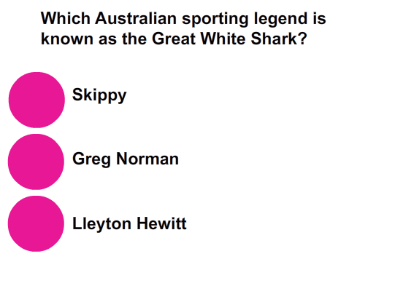
- Press F9 to see the Actions window. You will write some Actionscript very similar to your first button, but do it for all 3. Obviously with answer1_btn and answer3_btn they will take you to the Wrong frame (Frame 15), and selecting answer2_btn it will take you to the Correct frame (Frame 10).
The code that you need will look like the following:

stop();

answer1_btn.addEventListener(MouseEvent.CLICK, wrong);
answer2_btn.addEventListener(MouseEvent.CLICK, right);
answer3_btn.addEventListener(MouseEvent.CLICK, wrong);

function right(event:MouseEvent) :void {
gotoAndPlay("Correct");
}

function wrong(event:MouseEvent) :void {
gotoAndPlay("Wrong");
}

Extension Activity

- Add a button in the ‘You’re Wrong’ stage to take you back to the question to have another try.
- Try adding buttons to go to a new question from the ‘You’re right’ frame that takes you to another question.

Congratulations! Now you have an understanding of Actionscript 3.0! Think about how you can apply this knowledge to our assignment.

