Creating input and output text boxes using keystrokes and conditionals

Today we are going to make a simple Flash CS3 program that prompts the user to enter a guess in the top text box, and then press enter. We will use Actionscript 3.0 to determine whether they got the answer right or wrong, and a subsequent message will be displayed down the bottom. For this we will use variables, conditionals and maximum values.

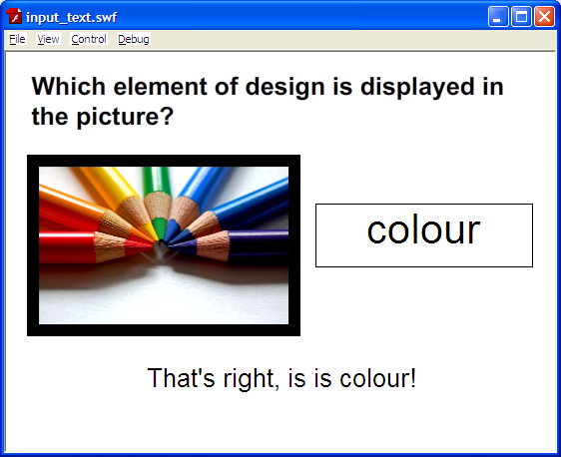

- Open Flash and start a new document with Actionscript 3.0 as the code.
- Create 3 layers for your document, in this order:

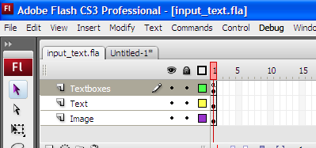

Note: If your text boxes are not the top layer, you won’t be able to write in them during run-time!

- On the Text layer, write the heading “Which element of design is displayed in the picture?”
- On your image layer, import the image colour.jpg to your library and then place it on your stage. My dimensions used were 274 for width and 183 for height.
- Create 2 textboxes using the text tool (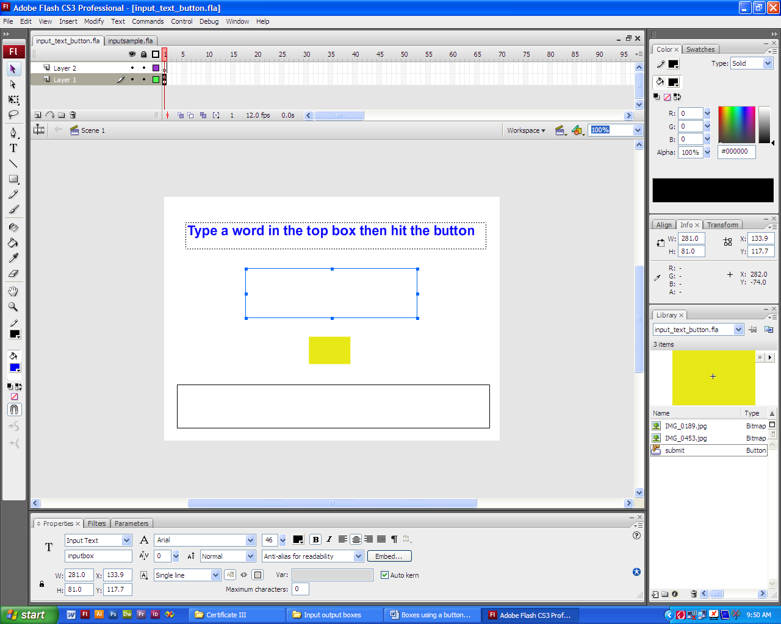), making sure that you change their properties from static text to input text so we can add Actionscript to them.
- For the property instance name, call the top textbox inputbox and the bottom
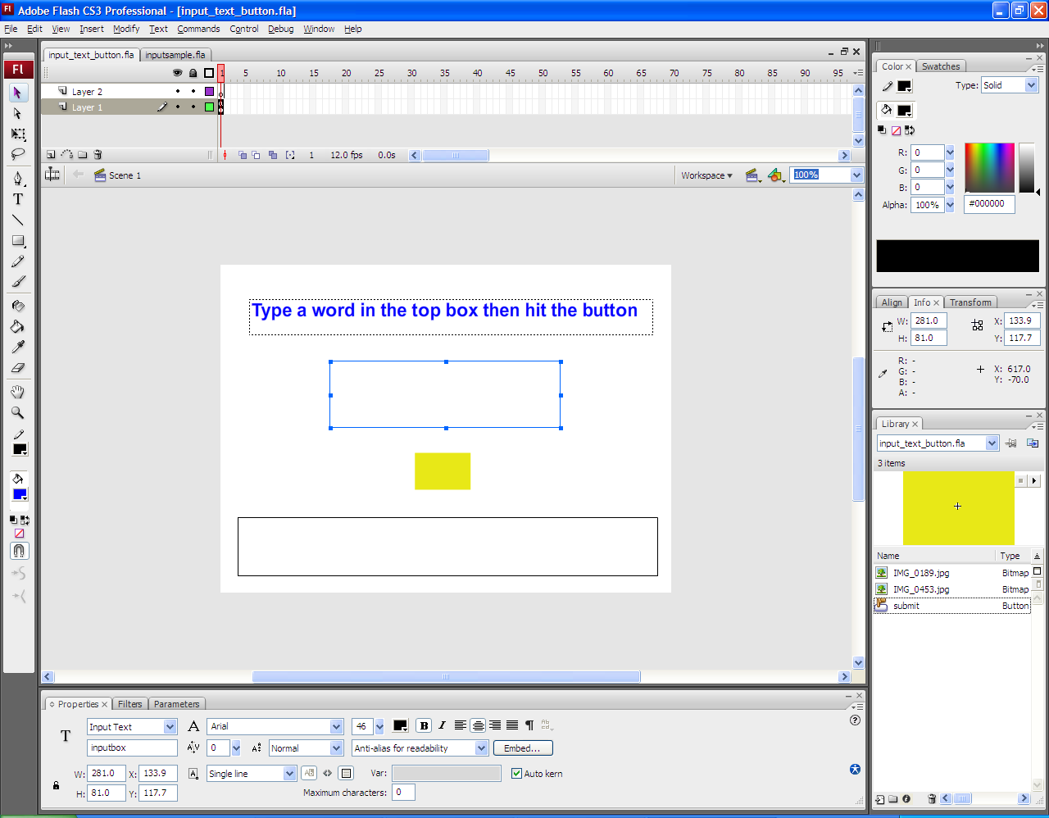

In our last tutorial on textboxes, we used a button to make the text appear in the bottom textbox. Now we are going to go a step further and use a keystroke.

- On your Textboxes layer, open the actionscript panel and put a stop(); on it.
- Type the following code in, after your stop();

//Import the key handling events
import flash.ui.Keyboard;
import flash.events.KeyboardEvent;

// Set a maximum value on the input textbox
inputbox.maxChars = 10;

// Check for a keyPress event on the stage
stage.addEventListener(KeyboardEvent.KEY_DOWN, keyDownHandler);

// Check whether the key pressed was enter, and if so call the submit function
function keyDownHandler(event : KeyboardEvent) : void
{
if (event.keyCode == Keyboard.ENTER)
{
submit();
}
}
- We have now called the submit() function, so we need to code it. We will do this using a conditional, or an if statement as it is commonly known. This will be written below the rest of your code, like so:

//Check if the user got it right, and inform them of the outcome
function submit():void {

// If the user wrote ‘colour’
if (inputbox.text == "colour") {
// Inform them they're right
outputbox.text = "That's right, it is colour!";
} else {
// Otherwise, they're wrong
outputbox.text = "You got it wrong. Try again.";
}

}

- Note that the code contains comments, or internal documentation. It is really important that you use them, even if you know what your code does, as the person who has to come along and debug or upgrade your program may not!
- There are a number of other elements of design that this picture covers, like line. Try to write this into your code so that typing colour and line will both be correct, and if you can get this right then try to make it not case-sensitive!
- If you can finish all of this, instead of displaying a message when you get it right you could skip to the next frame and display a picture with another element and write the code for that!

Enjoy!

