Year 10 Digital Photography Theory Exam 2007

Name: /35

This is a closed booked exam to be completed within the session.

- Explain the term digital convergence (2)

- Give two changes that occur when light is refracted (2)

- When light is diffused, what affect does that have when you are taking a photo? (1)

- What angle is the light coming from in these photos(2) ?
  - 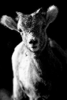
  - 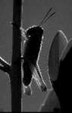
- What is a Charge Couple Device or CCD? (1)

- What is the purpose of a shutter on a camera? (1)

- What is stereoscopic vision? (1)

- Name 2 properties of a lens (2)

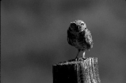
- Does this image use the Rule of Thirds for composition? Why or why not? (2)

- What is a focal point? (1)

- Is front light good for taking portraits? Why or why not? (2)

- When you use a low angle, that is placing the camera above the subject, what effect does this have for the viewer? (1)

- Explain what saturation of colour is (1)

- What are secondary colours? Name them(2)

- What is a complementary colour scheme? Give an example (2)

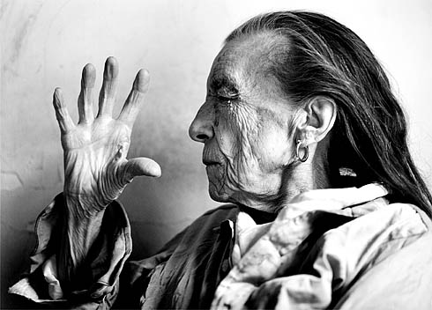
- This is a photo by Annie Leibovitz who is a famous photographer.

For the image given, describe
  - What sort of light is used? Why did Leibovitz chose this type of light? (2)

  - Has she used the Rule of Thirds? Explain why you think this (2)

  - Given that this is a portrait of a famous sculptor, Louise Bourgeois, what element within the photograph is Leibovitz trying to draw the attention of the viewer to? Why do you think this? (2)

  - How has Leibovitz used the Design Elements to enhance the image?
    - Colour (1)

    - Line (1)

    - Shape (1)

    - Form (1)

    - Texture (1)

    - Pattern (1)

I hope you have had a pleasant experience and learned lots from completing Digital Photography this semester☺ Ms McLean

