Design Elements for year 10 digital photography

Line
A line is an element characterized by length and direction. Lines create contours and form, and are often used to convey a specific kind of feeling or point to an important feature in a design. Lines are also used to create perspective, and dominant directional lines are often adopted to create a sense of continuance in a composition. In addition, lines that are grouped together often create a sense of value, density or texture.
 | 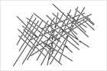 | 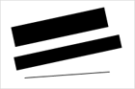
Organic | Rigid | Differing weights

Shape
The simplest definition of shape is a closed contour, an element defined by its perimeter. The three basic shapes are: circle, rectangle (square) and triangle. Form is the shape and structure of a dimensional element within a given composition. Form can be both two-dimensional and three-dimensional and can be realistic, abstract or somewhere in between. The terms form and shape are often used synonymously, which is why they are both included here. In reality, form is derived from the combination of point, line and shape.
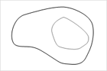 | 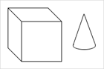
Contour | Dimensional

