Mentone Girls Grammar

VET Multimedia Certificate II

Semester 1 Examination

Part 1: Theory (50 Marks)

- Define the following terms:
  - Aperture
  - Exposure
  - PPI
  - Vector
  - Raster
/10
- What resolution would you save your images with:
  - For a webpage
  - For printing
/2

- If you are printing out an image 1000 pixels wide and 640 pixels high at 200ppi, what will the size (in inches) of the print be?
/2

- Indicate if you would require a faster or slower shutter speed in the following situations, and explain your choice:

  - When taking photos of racing cars
  - When taking a still-life photo in dim light
  - Taking a photo of a man taking a golf swing, while wanting to convey a sense of the movement of his arms.

/3
- When would you use the JPEG compression format to save artwork?
/2
- When would you use the GIF compression format to save artwork?
/2
- Describe one safety issue to keep in mind when handling batteries.

/1
- Name a file extension that would indicate:
  - A vector image
  - A raster image
  - A webpage
/3
- Reproduce the code for the following webpage:
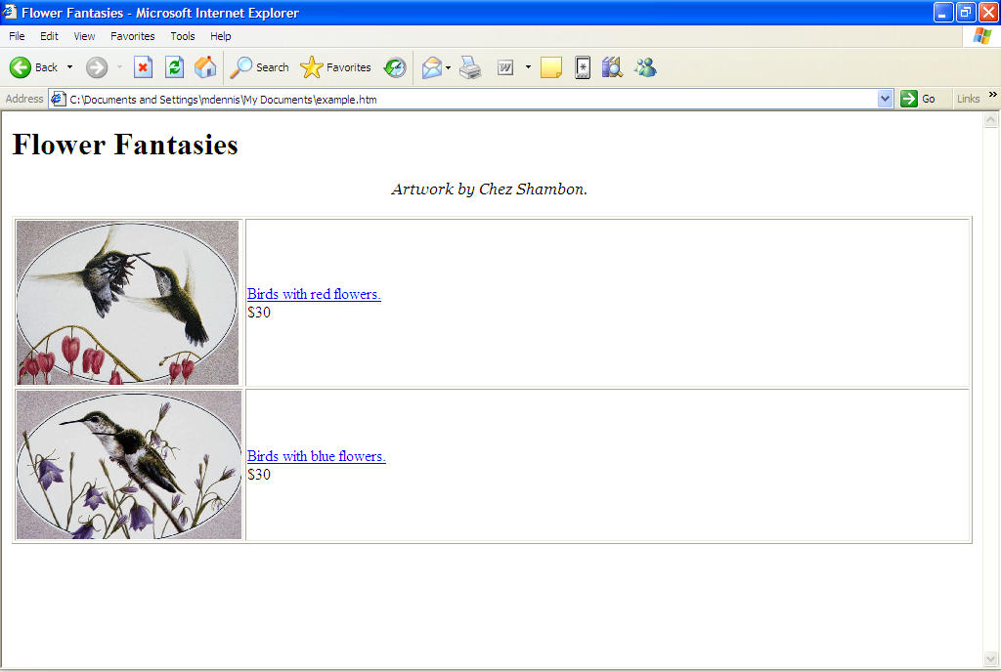
Picture:
red.jpg
Picture:
blue.jpg
Link:
Blue.html
Link:
Red.html
Font:
Italics

/20 marks
(Table: /5
Structure: /5
Formatting: /5
Pictures: /5)
- The following questions are about CSS:
  - What does the following code do:
p { font-family: Arial; font-size: 12pts; color: red; }
  - Using the code above, write the CSS to make a size 18 heading in Arial with a green font color.
Part 2: Practical (50 Marks)

To submit your files, you will need to copy them to:
Shared/Student Dropboxes/DennisM/Multimedia/Exam/YourName

Make sure you check that your files have been correctly submitted before leaving the room.

All the files needed for this section can be found on the intranet.

Part A: Photoshop (25 marks)

- Add blue streaks to the woman’s hair.
- Adjust the hue of her shirt so that it’s colourized blue.
- Place the woman upon the landscape photo provided.

Part B: Illustrator (25 marks)

Draw a simple logo for a car magazine called ‘Move’. It must not include more than three colours, including black and white. The magazine is aimed at young men in the 16-24 year age bracket.

