USING AUDACITY

Part 1. Editing a .wav file using Audacity

Handout: Audacity 1.2 Tutorial Steps 1 to 7. (ref: www.edhsonline.org/other/audacity)

Part 2. Recording using a microphone using Audacity 1.2 and Windows Volume Control.

Open the program ‘Audacity’.
Plug your microphone into the microphone input
of your computer.
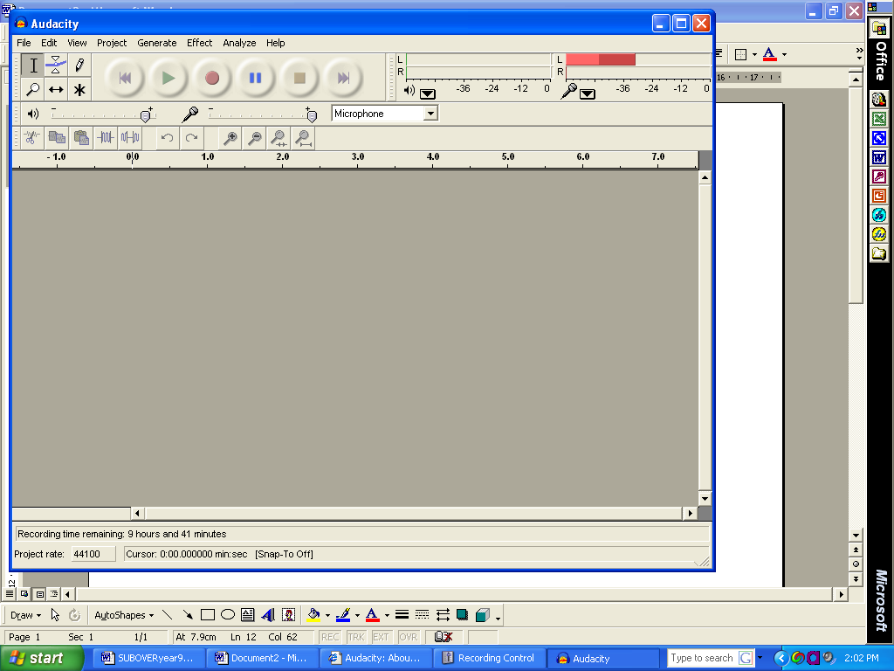
In the top corner you will see a microphone and a down-arrow.
- Click on the arrow and select ‘Monitor input’

Now we need to set the microphone input volume.
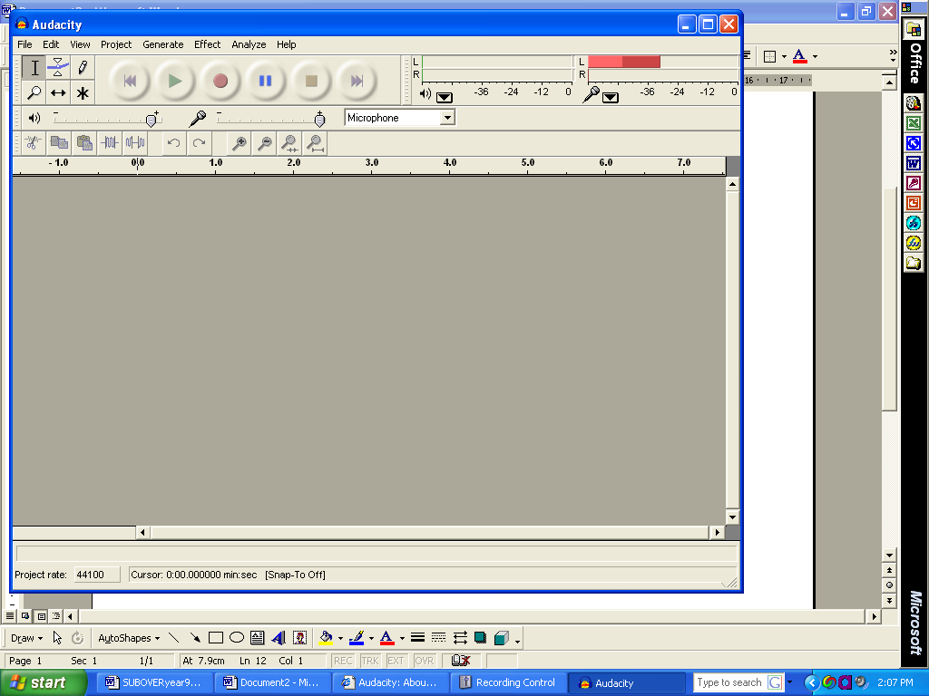
- Select ‘Microphone’.
- Set this to maximum level.

The Windows Volume Control needs to be set correctly so recording can be done.

- Double click the Volume Control icon.
- Select Options, Properties
- In ‘Adjust Volume for’, select Recording.
- Tick the check box for ‘Microphone’ if it is not already ticked.
- Select ‘OK’.

You will now only see ”Recording Control’ that only has 3 selections.
- Tick the ‘Select’ box for microphone and make sure the volume control is set at the maximum level.
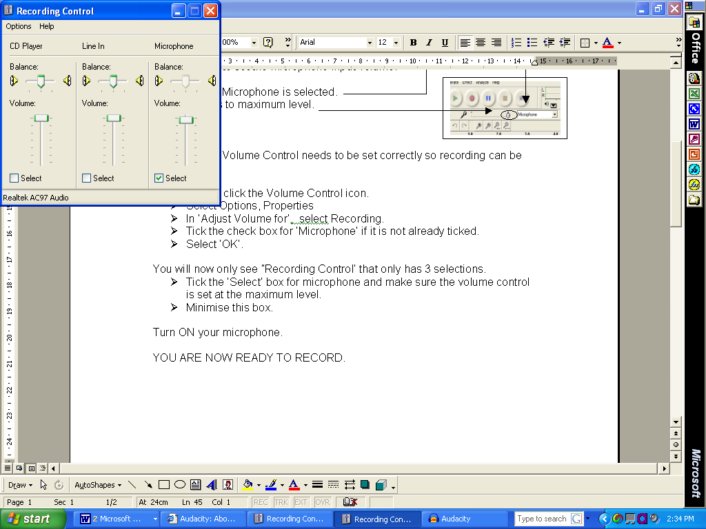
- Minimise this box.

Turn ON your microphone.

YOU ARE NOW READY TO RECORD.

Recording.

- Click on the record button and record you voice.
- Select the stop button when complete.

If you forget to hit STOP remember you can cut the blank section off.

TASK:

In groups of three record your voice for 2 seconds each, consecutively. This will result in a 6 second recording. Have a look at your voice variations, some of your voices create more vibrations than others.

Us the effects and edit your recordings.

Part 3. Using Multitrack Audio to create a Music Track.

Handout: An Audacity Tutorial by Daniel James.
(ref: http://www.daniel.uklinux.net/tutorial/)

Features
This is a list of features in Audacity.

Recording
Audacity can record live audio through a microphone or mixer, or digitize recordings from cassette tapes, vinyl records, or minidiscs. With some sound cards, it can also capture streaming audio.
- Record from microphone, line input, or other sources.
- Dub over existing tracks to create multi-track recordings.
- Record up to 16 channels at once (requires multi-channel hardware).
- Level meters can monitor volume levels before, during, and after recording.

Import and Export
Import sound files, edit them, and combine them with other files or new recordings. Export your recordings in several common file formats.
- Import and export WAV, AIFF, AU, and Ogg Vorbis files.
- Import MPEG audio (including MP2 and MP3 files) with libmad.
- Export MP3s with the optional LAME encoder library.
- Create WAV or AIFF files suitable for burning to CD.
- Import and export all file formats supported by libsndfile.
- Open raw (headerless) audio files using the “Import Raw” command.
- Note: Audacity does not currently support WMA, AAC, or most other proprietary or restricted file formats.

Editing
- Easy editing with Cut, Copy, Paste, and Delete.
- Use unlimited Undo (and Redo) to go back any number of steps.
- Very fast editing of large files.
- Edit and mix an unlimited number of tracks.
- Use the Drawing tool to alter individual sample points.
- Fade the volume up or down smoothly with the Envelope tool.

Effects
- Change the pitch without altering the tempo, or vice-versa.
- Remove static, hiss, hum, or other constant background noises.
- Alter frequencies with Equalization, FFT Filter, and Bass Boost effects.
- Adjust volumes with Compressor, Amplify, and Normalize effects.
- Other built-in effects include:
  - Echo
  - Phaser
  - Wahwah
  - Reverse

Sound Quality
- Record and edit 16-bit, 24-bit, and 32-bit (floating point) samples.
- Record at up to 96 KHz.
- Sample rates and formats are converted using high-quality resampling and dithering.
- Mix tracks with different sample rates or formats, and Audacity will convert them automatically in realtime.

