Gisborne Secondary College
VET Interactive Digital Media

November Exam 2013
Teacher: K. Rattan



Question Book

Thursday 17 November
Session 2: Reading 11.15 to 11.25
Writing 11.25 to 2.55

Total writing time allowed for the test: 90 minutes

Student Name Marks_____/90

This exam has four sections

Section | Type of Questions | Marks | To be done
A | Multiple Choice Questions | 20 | Answer Sheet
B | Short Answer Questions | 30 | Exam booklet
C | 1 Practical Tasks | 40 | VET IDM Outcome folder
 | Total | 90

Instructions
Section A

This section must be completed in the Answer Sheet Provided

Section B

This section is to be completed in the Question booklet. Answers are to be hand written. Once this section is complete hand the booklet to the supervisor and then go to a computer and complete Section C

Section C

This section is to be completed on the computers

- Create a folder with this following name Vet3Novexam13-your name.
on your H:\Drive
- Save all your section C work in this folder.

- Resources for this task are in the subjects drive:

W:\Information Technology\2013\VET IDM Nov_Exam_Resources

- When you have finished Section C

Copy and Paste
W:\Dropboxes\KR\2013\Vet IDM Y11\November Exam

THEORY SECTION.

SECTION A: Multiple Choice Questions:
(20 Questions 1 mark each-Total 20 marks).

Question 1

Question 2

Question 3
Question 4
4. The following icon in Dreamweaver is used

- To show HTML tags
- To show code view of the page
- As a flash object.
- As a button

Question 5

Question 6
6. Which one of the following file formats is NOT a sound file?

A. WAV
B. AAC
C. OGG
D. AVI

Question 7
Question 8
. A frame in which you establish exactly what should appear on the Stage at particular moment in time is called a

    - Mainframe.
- Blank keyframe
- Key frame
- End frame

Question 9
Codecs are
- used to give better quality picture
- Used to compress and decompress video files only.
- Used to compress and decompress audio only
- Used to compress and decompress audio and video files

Question 10

Question 11

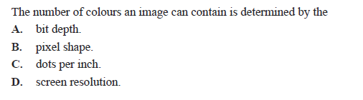
Question 12

Question 13
Question 14

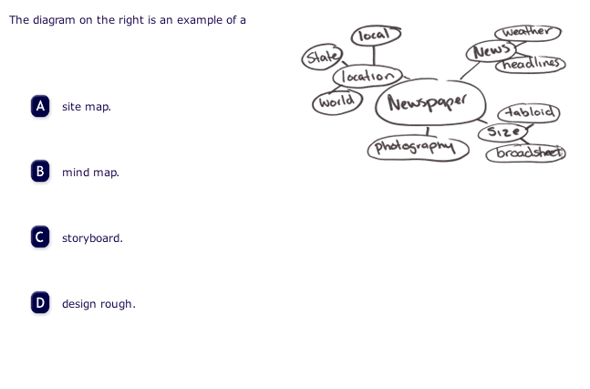
Question 15
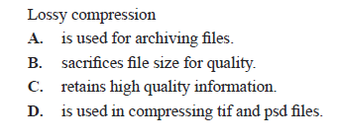

Question 16
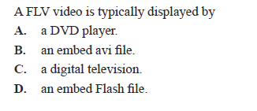

Question 17
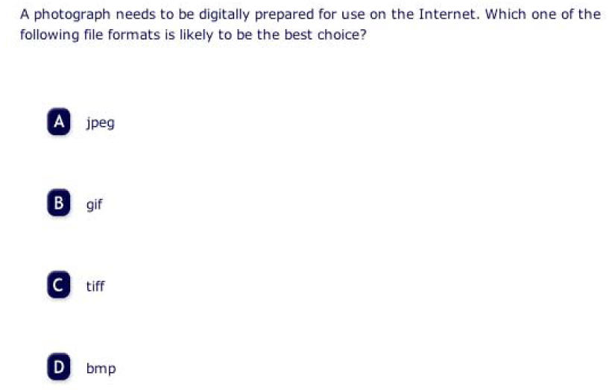

Question 18
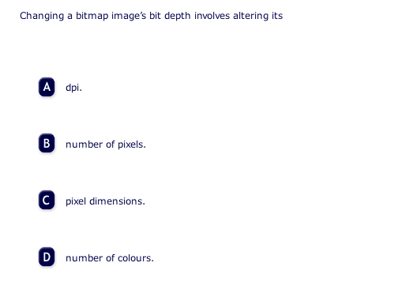

Question 19
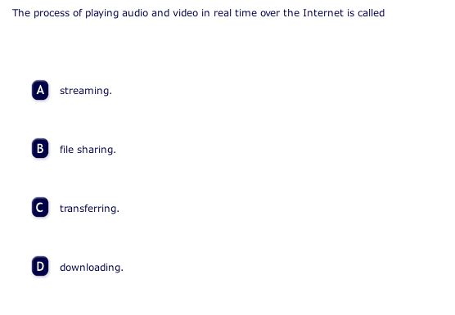

Question 20
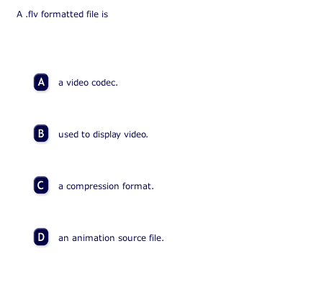

Short Answer questions: SECTION B (30 marks)
Question 1

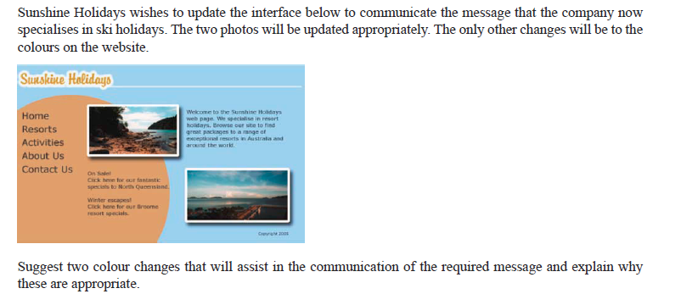
2 Marks
1.

2.

Question 2
- What is an appropriate file format for delivering sound online (1 mark)
- Give one reason why this format is appropriate (1 mark)

Question 3
Pseudocode is a way of expressing logics of programming structures. Given below is a pseudocode ( it is not a programming language)

- Identify the line of above pseudocode that has an error in its logic. (1 mark)

- Rewrite the line that you have identified with the correct pseudocode. (1 mark)

Question 4

Explain Two benefits of consistency on a website. (2 marks)

Question 5
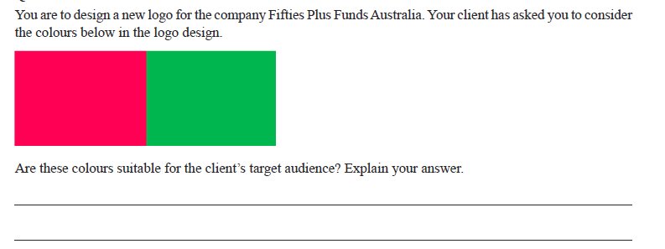
(2 Marks)
Question 6

You are in a group brainstorming session when someone suggests an idea that is not practical. Explain how you would respond. (1 mark)

Question 7

You are in a group brainstorming session to evaluate the above design for a rubbish recycling logo. Identify two positive aspects of the design and explain why these two aspects are positive. (2 marks)

Question 8
List two different sources that can be used to find information about 2D design.
(2 marks)
1.
2.

Question 9



The Yellow hat in Edward de Bono’s Six Thinking Hats creative technique focuses on the benefits and good points of the topic being discussed.

Identify and explain one example in relation to the above logo using yellow hat’s point of view. (2 marks)

Question 10


- Identify and explain one example of how the design communicates the theme of “all natural”. (1 mark)

- Identify and explain one example of how the design principle emphasis has been implemented in the web page design. (1 mark)

Question 11

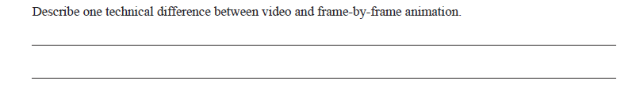
(2 marks)

Question 12
When devising a naming convention to be used in a large multimedia project what are two types of information that should be reflected in the actual file name. (2 marks)

1.
2.

Question 13

Consider each of the web pages shown below. They differ in the navigation system provided. Describe two advantages of the navigation system on the right. (2 marks)
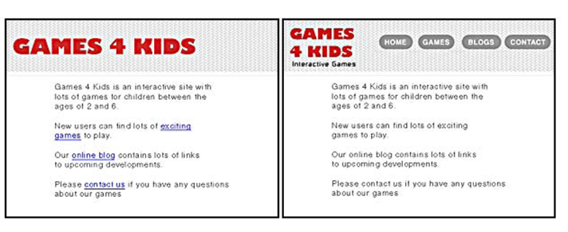

1.
2.

Question 14
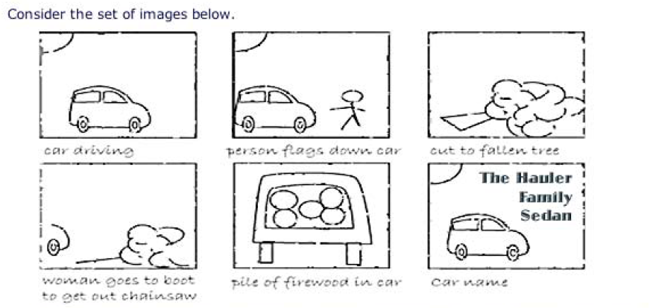

- What step in the production process is depicted by the set of images above. (1 mark)

1.

- Provide two reasons as to why this step is used. (2 marks)

1.
2.

Question 15

Identify components a. And b. Within the following URL

http://www.microsoft.com/helpfiles/help.htm

- Hostname. (1 mark)

- File or resource name. ( 1 mark)

SECTION C: practical task Spend about 60 minutes on this task

Website
Complete the Website using HTML Codes( No CSS is requires for this task). Use a table to organise your webpage.You are allowed to use W3Schools Resources for this task. All website files should be kept in “Friends of Steam” folder
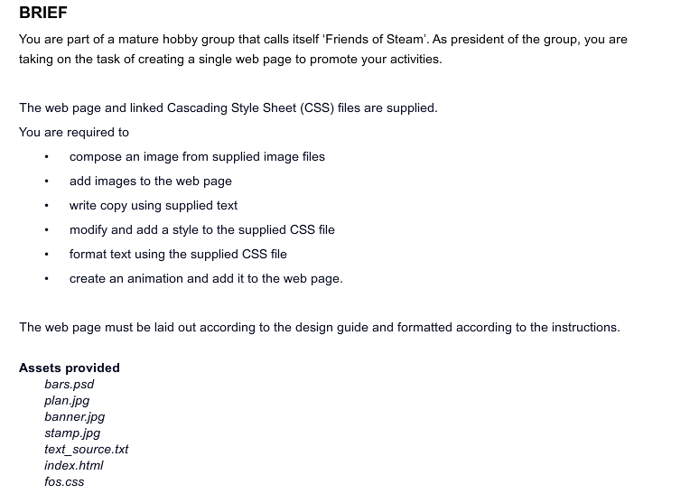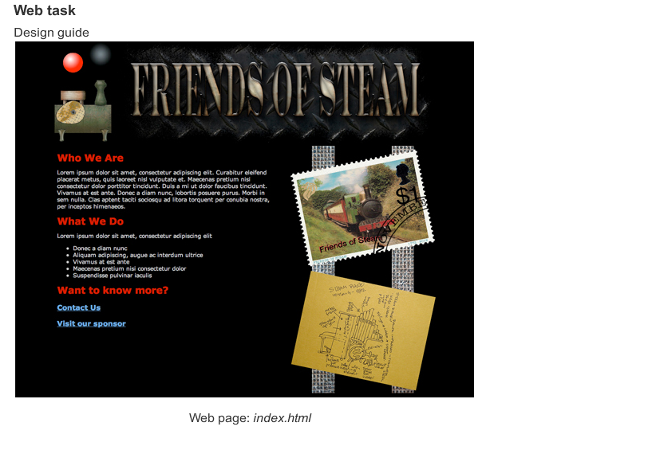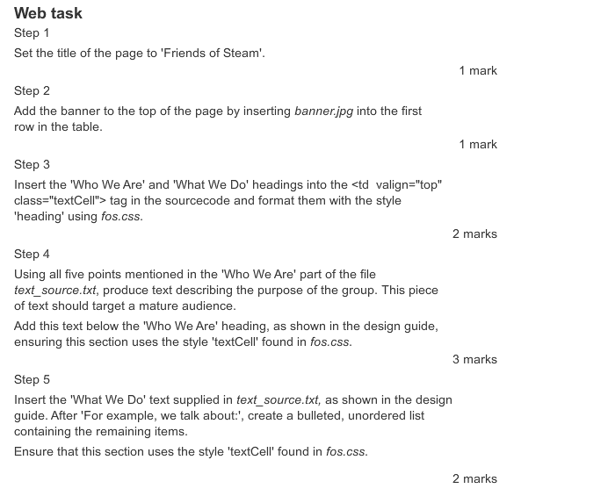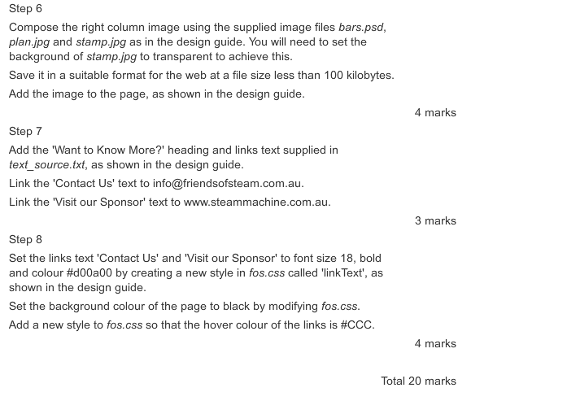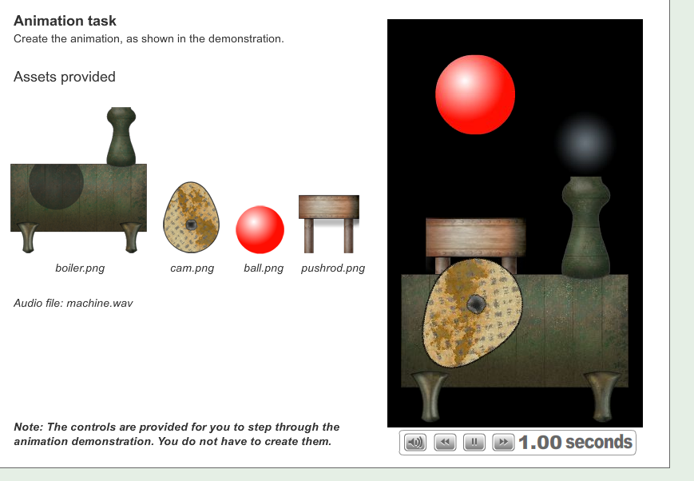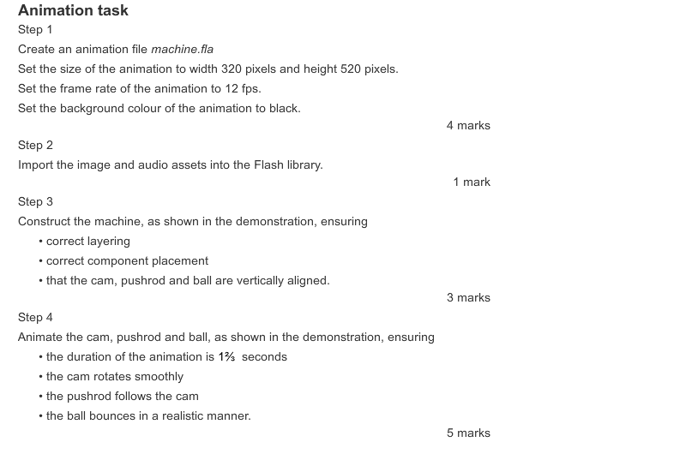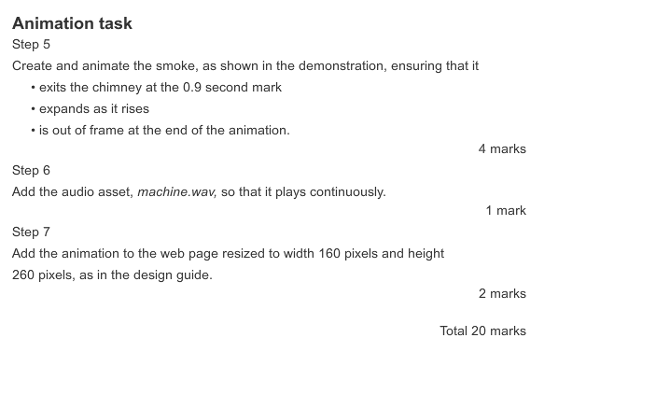

Thank you and enjoy.

Section A Multiple Choice Answer Sheet.

Name____________________________________________________________

Circle the letter that is the best answer
.
1 | A | B | C | D
2 | A | B | C | D
3 | A | B | C | D
4 | A | B | C | D
5 | A | B | C | D
6 | A | B | C | D
7 | A | B | C | D
8 | A | B | C | D
9 | A | B | C | D
10 | A | B | C | D
11 | A | B | C | D
12 | A | B | C | D
13 | A | B | C | D
14 | A | B | C | D
15 | A | B | C | D
16 | A | B | C | D
17 | A | B | C | D
18 | A | B | C | D
19 | A | B | C | D
20 | A | B | C | D

