SALESIAN COLLEGE CHADSTONE
NAME:______________________________

MATHS TEACHER’S NAME:_________________
MATHEMATICAL METHODS CAS
Test SAC 1

PART 1: NO Calculators and NO Notes are permitted.
Time allowed: 20 minutes
Total Marks = 18

Instructions:
Answer all questions in the spaces provided.
A decimal approximation will not be accepted if an exact answer is required.
In questions where more than one mark is available, appropriate working must be shown to gain full marks.
Unless otherwise indicated, the diagrams in this test are not drawn to scale.

Question 1.

Sketch the graph of the function y = 3 – 2│x – 1│ on the axes below.
Label axes intercepts and the vertex with their coordinates.

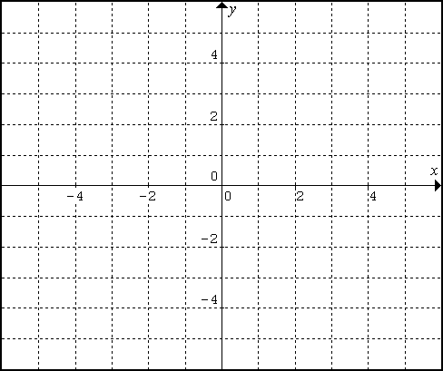

(3 marks)

Question 2.

For the function f : ( – ∞,– 2) →R , f(x) = $\frac{3}{x+2}−1$, find:

(a) the rule of the inverse function, f ^{– 1}

________________________________________________________________________________________________________________________________________________________________________________________

(2 marks)

(b) the domain of the inverse function, f ^{– 1}

____________________________________________________________________________________________

(1 mark)

Question 3.

Solve the equation 2 cos 2x = –$\sqrt{3}$ for x ε [– π, π ], giving exact values in terms of π.
______________________________________________________________________________________________________________________________________________________________________________________________________________________________________

(3 marks)

Question 4.

For $f:R^{−}→R,\text{ where }f(x)=\frac{3}{(2x+1)^{2}}−4$:
(a) state the equations of the asymptotes

__________________________________________________________________________________________________________________________________________

(1 mark)

(b) calculate the axial intercepts

__________________________________________________________________________________________________________________________________________

(2 marks)

(c) Hence, sketch the graph of f(x).

(1 mark)
Question 5.

State the sequence (in order) of transformations needed to obtain y = $\frac{3}{1−x}+3$, from $y=\frac{1}{x}$.

______________________________________________________________________________________________________________________________________________________________________________________________________________________________________
______________________________________________

(5 marks)

SALESIAN COLLEGE CHADSTONE
NAME:______________________________

MATHS TEACHER’S NAME:_________________
MATHEMATICAL METHODS CAS
Test SAC 1

PART 2: A Graphing Calculator and Notes are permitted.
Time allowed: 40 minutes
Total Marks = 5 + 22 = 27

MULTIPLE CHOICE QUESTIONS

Instructions:
Record your answer on the answer sheet provided
Questions are worth one mark each

Question 1.

The function f : [-3, b] →R, f(x) = 9 – 2x – x² will have an inverse if:

- b > – 1
- b = – 1
- b ≥ – 1
- b = 1
- b = 10

Question 2.

The maximal domain of the function f (x) = $−\frac{3}{\sqrt{4x−5}}$is:

- R⁺
- R
- $$\left\{x:x<\left.\frac{5}{4}\right\}\right.$$
- $$\left\{x:x≥\left.\frac{5}{4}\right\}\right.$$
- $$\left\{x:x>\left.\frac{5}{4}\right\}\right.$$

Question 3.

Part of the graph of a function with rule y = $\frac{a}{(x−b)^{2}}+c$ is shown below.

The values of a, b and c respectively are:
a b c
- 6 2 3
- 6 -2 3
- 24 2 3
- 24 -2 3
- 63 3 2

Question 4.

The value(s) of m such that the simultaneous equations (m+1)x – 2y = 7 and
3x + (2 – m ) y = 1 have no solutions are

- R⁺
- m ε R⁺
- m = $\frac{1+\sqrt{\text{33}}}{2}$ or m = $\frac{1−\sqrt{\text{33}}}{2}$
- m = 1 + $\sqrt{\text{33}}$ or m =1 – $\sqrt{\text{33}}$
- m = –1

Question 5.

Consider the system of linear equations shown below.

2x + y – 3z = 7
2x – z = –4
3x – 2y + 4z = 7

The solutions to x, y and z respectively are:

- $$\frac{1}{3},0,\frac{\text{70}}{3}$$
- $\frac{\text{29}}{3},\frac{\text{173}}{3},\frac{\text{70}}{3}$
- $−\frac{\text{29}}{3},\frac{\text{173}}{3},\frac{\text{70}}{3}$
- $\frac{−\text{29}}{3},\frac{\text{70}}{3}$
- 9.67, 57.67, 23.33

SALESIAN COLLEGE CHADSTONE
MATHEMATICAL METHODS CAS
Test SAC 1

SHORT ANSWER QUESTIONS

Instructions:
Answer all questions in the spaces provided.
A decimal approximation will not be accepted if an exact answer is required.
In questions where more than one mark is available, appropriate working must be shown to gain full marks.
Unless otherwise indicated, the diagrams in this test are not drawn to scale.

Question 1.

Find the value of c for which the coefficient of x⁴ in the expansion of (2x – c) ⁷ is 70.
________________________________________________________________________________________________________________________________________________________________________________________

(2 marks)

Question 2.

Sketch the graph of h(x) where h(x) = f(x) + g(x) on this graph.

(2 marks)
Question 3.

(a) Given that f: $[4,∞)→R,\text{ where }f(x)=\sqrt{x−4}$ and
g:$R→R,\text{ where }g(x)=x^{2}+3$, show that $f\left[g\left(x\right)\right]$ is not defined.
________________________________________________________________________________________________________________________________________________________________________________________

(3 marks)

(b) Define a restriction $g_{1}$ of g such that $f\left[g_{1}\left(x\right)\right]$ is defined.
________________________________________________________________________________________________________________________________________________________________________________________

(2 marks)

(c) State the greatest possible domain and range for$f\left[g_{1}\left(x\right)\right]$.
____________________________________________________________________________________________

(2 marks)

Question 4.

(a) Write 2 log ₂ x + log ₂ (x – 1) as a single logarithm.
__________________________________________________________________________________________________________________________________________

(1 mark)
(b) Find all real solutions to the logarithmic equation:
2 log ₂ x + log ₂ (x – 1) = log ₂ (22x – 40).
______________________________________________________________________________________________________________________________________________________________________________________________________________________________________
__________________________________________________________________________________________________________________________________________
__________________________________________________________________________________________________________________________________________
______________________________________________

(2 marks)

Question 5.

The volume of chlorine, C litres, in a swimming pool at time t hours after it was placed in the pool can be modelled by C(t) = C₀ e^{kt} , t ≥ 0. The volume of chlorine in the pool is decreasing. Initially, the volume of chlorine in the pool was 3 litres, 8 hours later the volume was 2.5 litres.

(a) State the value of C₀.
____________________________________________________________________________________________

(1 mark)

(b) Show that the exact value of k is $\frac{1}{8}{\text{log}}_{e}\frac{5}{6}$.
__________________________________________________________________________________________________________________________________________________________________________________________________________________________________________________________________________________________________________________________________

(1 mark)

(c) Exactly how many litres of chlorine were present in the pool 16 hours after the
chlorine was added to the pool?
____________________________________________________________________________________________
____________________________________________________________________________________________

(2 marks)

(d) Sketch the graph of C(t).

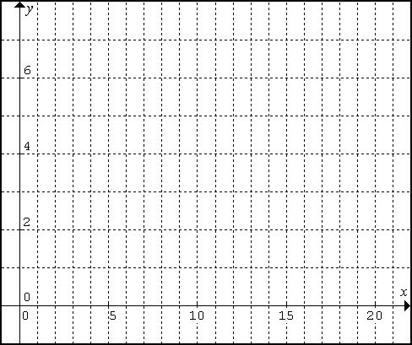

(2 marks)

(e) To the nearest minute, how long after the chlorine was added to the pool was
there 2 litres remaining?

____________________________________________________________________________________________
(2 marks)

ANSWER SHEET FOR PART 2
MULTIPLE CHOICE ANSWER SHEET

Student Name: _________________________

Teacher’s Name: _______________________

For each question, circle the letter which corresponds to your answer. Mark only one answer for each question. You are advised to use a pencil.

A B C D E

A B C D E

A B C D E

A B C D E

A B C D E

