

MARIAN COLLEGE
West Sunshine

Name:
Homeroom:
Teacher:

NOVEMBER EXAMS
2005
UNIT 2 GENERAL MATHEMATICS

Date: Thursday 17 November 2005
Reading Time: 8:50 am – 9:00 am
Writing Time: 9:00 am – 10:30 am

Question and Answer Booklet

Structure of Booklet
SECTION | Number of questions to be answered | Mark  Allocation | Individual  Score
Section A – Multiple Choice | 16 | 32
Section B – Short Answer | 9 | 40
Section C- Bonus Question | Choose I of 2 questions | 5
 |  | 72

Directions to students
Materials
Question and Answer Booklet, Multiple Choice Answer Sheet, pens, pencils, calculator, ruler and one double sided page of A4 help sheets.

The Task
- Please ensure that you write your name in the space provided at the top of this page.
- Read the questions carefully and answer them in the space provided on the answer sheet.
- When you remove the multiple choice answer sheet from the booklet, make sure you hand it up with the rest of the exam booklet.
- If you need more space, there are blank pages at the back of this booklet. Clearly indicate that your teacher needs to turn to the back of the booklet, and label the questions carefully.
- The formula sheet is attached to the back of the exam booklet and can be ripped off.
Name: _______________________
Teacher: _______________________

SECTION A: Multiple Choice Answer Sheet

Circle the correct answer on the answer sheet provided below. If you make a mistake put a cross through it and circle the correct answer.

Rip this sheet out but ensure that you put your name on it and that it is handed up with this exam booklet.

1. | A | B | C | D | E |  | 7. | A | B | C | D | E |  | 13. | A | B | C | D | E
2. | A | B | C | D | E |  | 8. | A | B | C | D | E |  | 14. | A | B | C | D | E
3. | A | B | C | D | E |  | 9. | A | B | C | D | E |  | 15. | A | B | C | D | E
4. | A | B | C | D | E |  | 10. | A | B | C | D | E |  | 16. | A | B | C | D | E
5. | A | B | C | D | E |  | 11. | A | B | C | D | E
6. | A | B | C | D | E |  | 12. | A | B | C | D | E

(32 marks)

SECTION A: Multiple Choice Questions

Answer these questions on the answer sheet provided on page 2. Each question is worth 2 marks.

Question 1
3 km converted to cm is:
A. 3000 m
B. 3000 cm
C. 300000 cm
D. 0.003 cm
E. 30000 cm

Question 2
Find the value of x in the diagram to the right.
A. 14.65 cm
B. 3.83 cm x
C. 10.24 cm 2.1 cm
D. 5.83 cm
E. 2.41 cm
3.2 cm

Question 3
A rectangular orchard has a width of 15 m and a diagonal measuring 40 m. The length of the orchard, to 2 decimal places, would be:
A. 42.72 m
B. 104.16 m
C. 1375 m
D. 74.16 m
E. 37.08 m

Question 4
A circular swimming pool has a radius of 25 m. The circumference, correct to 2 decimal places, of the pool is:
A. 25 m
B. 1963.50 m
C. 397.03 m
D. 3926.99 m
E. 157.08 m

Question 5
For the following right-angled triangle, choose the correct solution to determine the unknown angle:
A. sin θ = 12.7 D. cos θ = 12.7
8 8 8 12.7
B. sin θ = 8 E. none of the above
12.7 θ
C. tan θ = 8
12.7

Question 6
The magnitude of angle A (using the Sine Rule) in triangle ABC, where a = 15 cm, b = 10 cm and angle B = 30º is:
A. 48.59 º
B. 86.5 º
C. 101.41 º
D. 60 º
E. 50 º

Question 7
You are standing at the end of a shadow that a wall is making with the ground. The length of its shadow is 15.7 m and the angle of elevation of the sun is 50 degrees. Find the height of a wall (x), to the nearest metre.
A. 10 m
B. 12 m
C. 13 m
D. 18 m
E. 19 m

Question 8
The closest value of x is: 55 cm
- 1254 cm 40º
- 42 cm
- 35 cm 40 cm x
- 87 cm
- 57 cm

Question 9
The graph for the in-equation x ≥ –6 is represented by:

A. B. C. D. E.
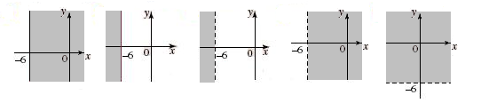
Question 10
The graph for the in-equation y ≤ –x is represented by:

A. B. C. D. E.
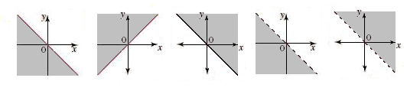

Question 11
The unshaded region which best represents the system of in-equations: x ≥ 0, y ≥ 0, x + y ≤ 8 and y – 2x ≤ 4; is shown in:

A. B. C. D. E.
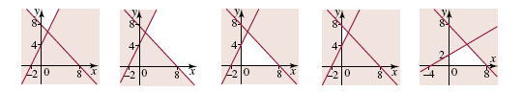

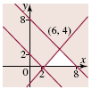
Question 12
The region required for a system of in-equations is given by the following graph. If the revenue (in dollars) is given by R = 4x + 3y, the maximum revenue will be:
A. $8
B. $32
C. $34
D. $36
E. $38

Question 13
What type of correlation is shown by the graph at the right?
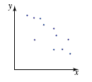
A. Strong positive correlation.
B. Moderate positive correlation.
C. No correlation
D. Moderate negative correlation
E. Strong negative correlation

Question 14
A researcher who counts the amount of time taken for production line workers to assemble a component and relates it to the number of weeks that each worker has spent on the production line finds that there is a correlations of -0.82 between the variables. She can conclude that:
A. The greater the number of weeks spent on the production line, the quicker the assembly of components.
B. The greater the number of weeks spent on the production line, the slower the assembly of components.
C. Production line assembly causes worker fatigue.
D. Many weeks doing the same task causes production line workers to become efficient.
E. Many weeks doing the same task causes production line workers to become bored and slow as a result.

Question 15
Which of the following graphs could possibly be the graph of the equation y = 15x – 200?

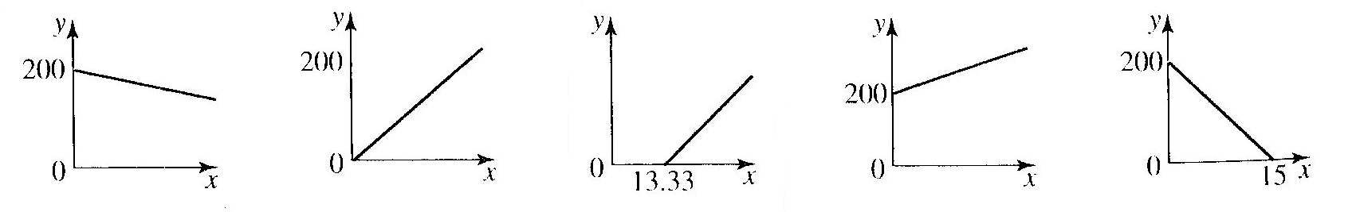
A. B. C. D. E.

Question 16
The following scatterplot would indicate that the q-correlation value would be:

A. 0 < q < 1
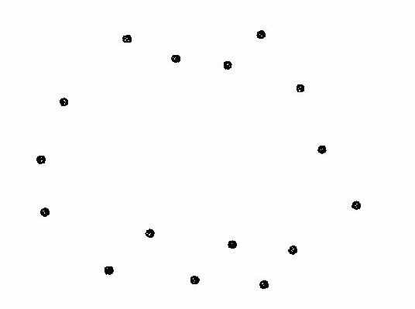
B. -1 < q < 0
C. q = 0
D. q = 1
E. q = -1

(32 marks)

End of Multiple Choice Section

SECTION B: Short Answer Questions

Answer the following questions in the space provided. If extra space is needed, two blank pages are provided at the back of this booklet. Make sure you clearly label that you have continued a question at the back of the exam booklet.

Question 1
A square with a side length of 7 cm is inscribed inside a circle of radius 8 cm, as shown below. Find the area of the shaded region.
8 cm
7 cm

(3 m)

Question 2
A conical tent has a base radius of 15 m and a side length of 8 m. Find the surface area of the canvas used to make the tent (including the floor), correct to 2 decimal places.

12
cm

9 cm

(3 m)

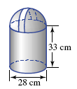
Question 3
The diagram on the right represents a new design for a rubbish bin.
a. Assuming the hemispherical lid lifts off, what is the volume of rubbish that the new bin can hold?

b. Now assume that the lid can also be totally filled with rubbish. What is the total volume of this new rubbish bin design?

(4 m)

Question 4
Find the value of the pronumeral, correct to 2 decimal places:

32º14’
7.5 cm
x

(2 m)

Question 5
A boat sails 8 km due north and then 6 km due west.
a) Draw a diagram representing the course of the boat.

(1 m)

b) Determine the distance of the boat from the starting point.

(2 m)

c) Determine the bearing of the boat from its starting point.

(2 m)
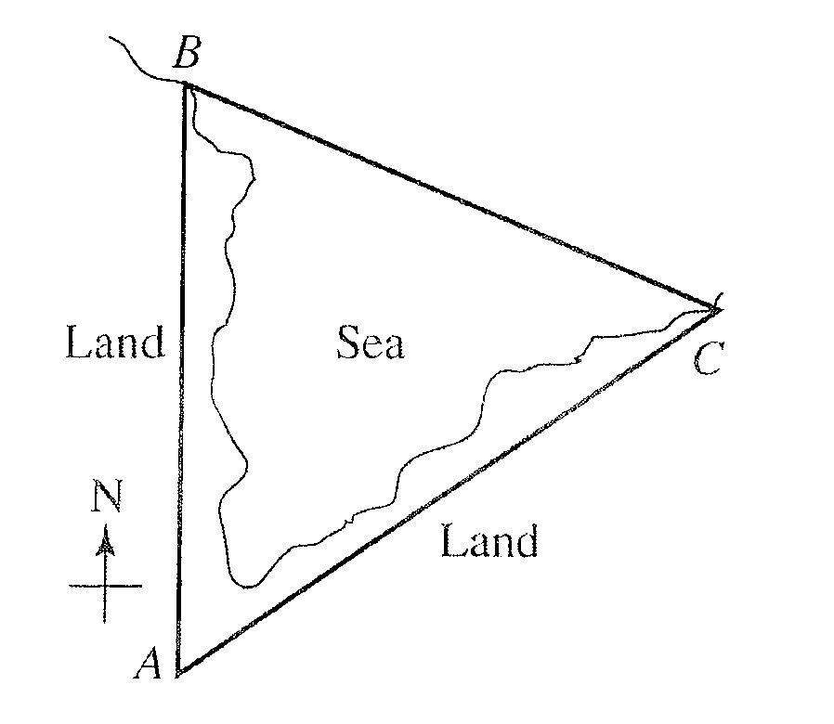
Question 6
A triathlon requires the competitors to run 230 m along a shore line from the point marked A, directly north to a point B on the shore. From point B they swim across to point C on the edge of the shore. They cycle 260 m from point C directly to the starting point A. The bearing of C from A has been recorded as 074º.

a) Write down the value of angle A.

Angle A =

(1 m)

b) Find the distance the competitors had to swim, to the nearest metre. (Use the Cosine Rule).

(2 m)
Question 7
Sketch, and shade where necessary, the following in-equations:

a) x ≥ 2 b) y ≤ -3

(1 m) (1 m)

c) 2x + y ≤ -4 d) y ≥ x

(3 m) (1 m)

Question 8
The following system of linear inequations is shown on the sketch below.
x + y ≤ 10
x – y ≤ 4 y 2x-y=-1
2x – y ≥ -1 10 feasible region
x ≥ 0
y ≥ 0
A
x-y=4

B

1 E
D C
-0.5 4 10 x

x+y=10

-4

a) Determine the coordinates of the missing vertices of the feasible region.

Vertex | Objective z = 3x – y
A
B (7,3)
C (4,0)
D (0,0)
E

(2m)

b) Determine the maximum and minimum values of z = 3x – y, and the x and y values for which they occur.

(2 m)
Question 9
The following table gives the adult return air fares between some Australian cities.

City | Distance (km) | Price ($)
Melbourne – Sydney | 713 | 580
Perth – Melbourne | 2728 | 1490
Adelaide – Sydney | 1172 | 790
Brisbane – Melbourne | 1370 | 890
Hobart – Melbourne | 559 | 520
Hobart – Adelaide | 1144 | 820
Adelaide – Melbourne | 669 | 570

The scatterplot of this data is shown below:

a) Find the q-correlation for the data and interpret it in terms of the variables in the question.

(5 m)
b) i) Calculate the two points $({\overline{x}}_{1},{\overline{y}}_{1})$ and $({\overline{x}}_{2},{\overline{y}}_{2})$for the two-mean regression line.
ii) Use these points to plot the line on the graph above.

(4 + 1 m)

End of Short Answer Section

SECTION C: Bonus Question

Answer only ONE of the following two questions. DO NOT answer both questions.

Bonus Question One
Three circles of radii 4 cm, 5 cm and 8 cm are placed so that they just touch each other. A triangle is formed by joining their three centres.
  - Draw the triangle with its side lengths labelled clearly.
  - Find the three angles of the triangle.
  - The area of the triangle, correct to 3 decimal places. Note: the area of a non-right angle triangle can be calculated using Heron’s formula (see formula sheet).

4 cm
5 cm
8 cm

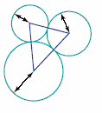

(5 m)
Bonus Question Two
Pepi manages two street stands in the city. One is in Xenon Street and the other is in Yarra Street. These street stands sell newspapers and magazines.
On average, per hour, each stand sells
Xenon Street: 20 newspapers and 2 magazines
Yarra Street: 15 newspapers and 4 magazines
In total, at least 900 newspapers and at least 160 magazines must be sold each week.
Let x be the number of hours per week the Xenon Street stand operates
y be the number of hours per week the Yarra Street stand operates
This information can be expressed as Constraints 1 to 4.
Constraint 1: 20x + 15y ≥ 900
Constraint 2:
Constraint 3: x ≥ 0
Constraint 4: y ≥ 0

a) Write out Constraint 2: _______________________

b) Correctly shade the graph below to clearly show the feasible region.

c) Write down the coordinates of the point of intersection A in the graph below.
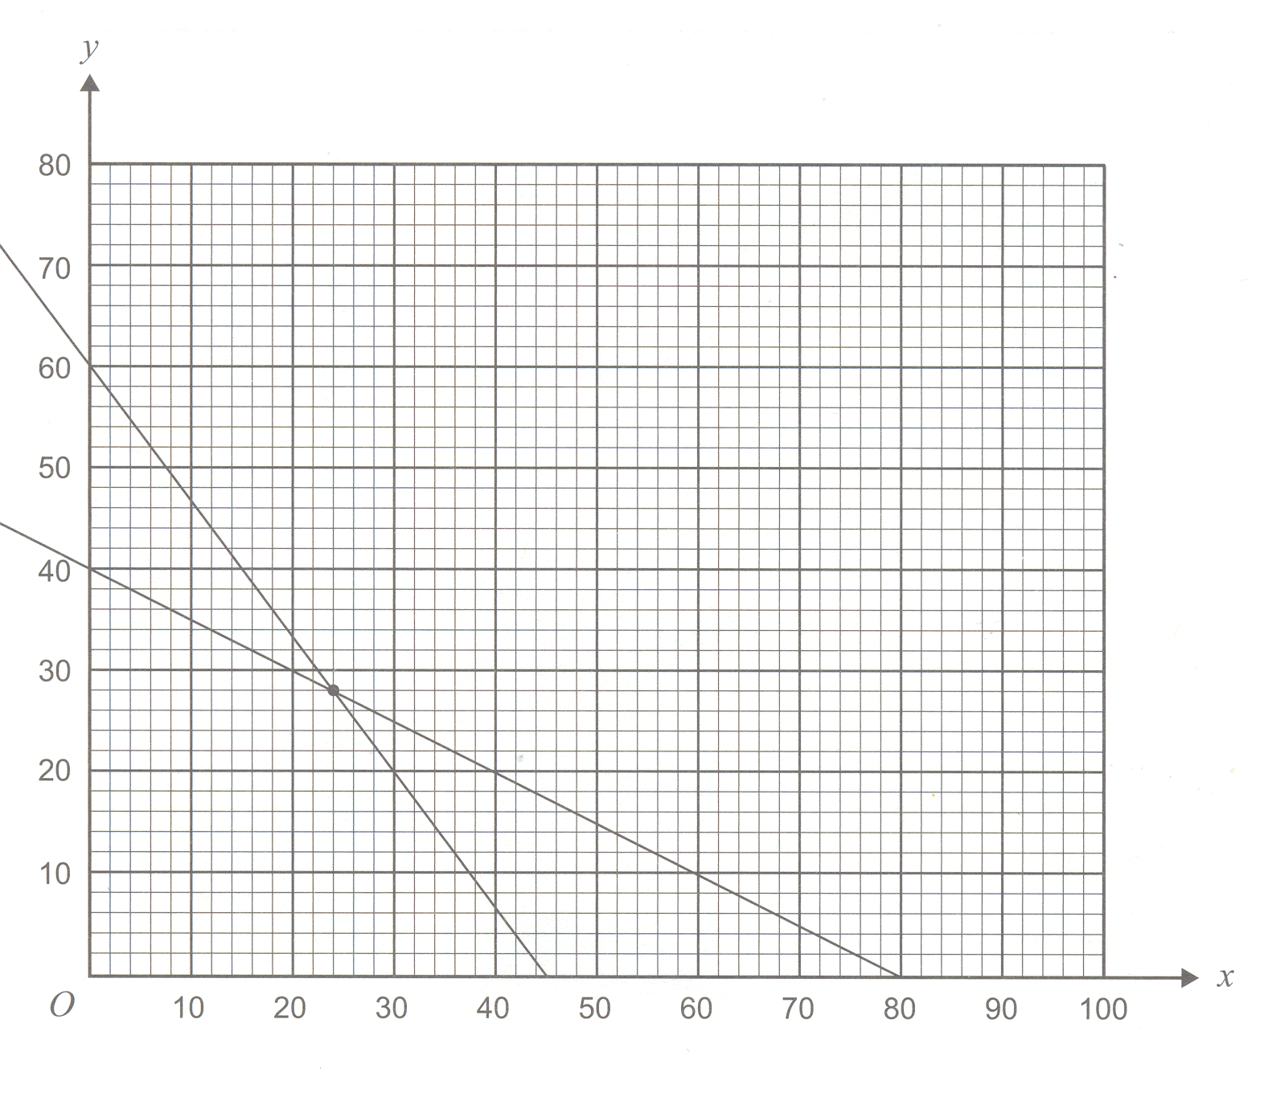

Constraint 1

Constraint 2

A

d) The cost, per hour, of operating each stand is
Xenon Street $100
Yarra Street $70
Let C be the total cost of operating the two street stand for one week.
Write an equation for C in terms of x and y.

C = __________________________________

e) Given the vertices listed below and your answer to part c) above, what is the minimum total cost of operating the street stands for one week?

Vertices | Objective C =
A
B (80,0)
C (0,60)

(5 m)

End of Bonus Section
This page has been left blank in case you need extra space for working out.
Please clearly mark which question you are answering.
This page has been left blank in case you need extra space for working out.
Please clearly mark which question you are answering.

End of Exam

The formula sheet begins on the next page and can be detached from the exam booklet.

Formula Sheet

Pythagoras’ Theorem c² = a² + b²

Circumference C = 2πr

Area
Sqaure | A = l² | Trapezium | A = ½ (a + b) h
Rectangle | A = l × w | Circle | A = πr²
Triangle | A = ½ bh | Parallelogram | A = bh

Shape | Total Surface Area | Volume
Cube | TSA = 6l² | V = l³
Rectangular Prism | TSA = 2(lw + lh + wh) | V = lwh
Cylinder | TSA = 2πr(r + h) | V = πr²h
Sphere | TSA = 4πr² | V = ⁴/₃ πr³
Cone | TSA = πr (r + s) or πr (r + l) | V = ¹/₃ πr²h

Trigonometric Ratios

sin θ = opposite
hypotenuse
hypotenuse
cos θ = adjacent
opposite
hypotenuse

tan θ = opposite
adjacent θ
adjacent

The Sine Rule

a = b = c
sin A sin B sin C

The Cosine Rule

a² = b² + c² – 2bc.cosA or cos A = b² + c² – a²
2bc

Heron’s Formula

Area = √ s(s – a)(s – b)(s – c) where s = ½ (a + b + c)

Statistics Formulae

 | ungrouped | grouped
Mean | ∑ x  n | ∑ fx  n
Standard Deviation | 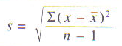 | 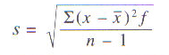

q – correlation = (a + c) – (b + d)
a + b + c + d

