
Marian College
West Sunshine

Name: _______________________
Teacher: _______________________

General Mathematics Unit 1
Exam
2004

Date: Tuesday 8 June 2004
Reading Time: 8:50 am – 9:00 am
Writing Time: 9:00 am – 10:30 am

Structure of Booklet

SECTION | Number of questions to be answered | Mark  Allocation | Individual  Score
Section A – Multiple Choice | 20 | 40
Section B – Short Answer | 12 | 70
 |  | 110

Directions to students

- Please ensure that you write your name in the space provided at the top of this page.
- Read the questions carefully and answer them in the space provided on the answer sheet.
- If you remove the multiple choice answer sheet from the booklet, make sure you hand it up with the rest of the exam booklet.
- If you need more space, there are blank pages at the back of this booklet. Clearly indicate that your teacher needs to turn to the back of the booklet, and label the question carefully.
Name: _______________________
Teacher: _______________________

SECTION A: Multiple Choice Answer Sheet

Circle the correct answer on the answer sheet provided below. If you make a mistake put a cross through it and circle the correct answer.

If you rip this sheet out, ensure that you put your name on it and that it is handed up with this exam booklet.

1. | A | B | C | D | E |  | 8. | A | B | C | D | E |  | 15. | A | B | C | D | E
2. | A | B | C | D | E |  | 9. | A | B | C | D | E |  | 16. | A | B | C | D | E
3. | A | B | C | D | E |  | 10. | A | B | C | D | E |  | 17. | A | B | C | D | E
4. | A | B | C | D | E |  | 11. | A | B | C | D | E |  | 18. | A | B | C | D | E
5. | A | B | C | D | E |  | 12. | A | B | C | D | E |  | 19. | A | B | C | D | E
6. | A | B | C | D | E |  | 13. | A | B | C | D | E |  | 20. | A | B | C | D | E
7. | A | B | C | D | E |  | 14. | A | B | C | D | E

(20 marks)

Formula Sheet

 | ungrouped | grouped
Mean | ∑ x  n | ∑ fx  n
Standard Deviation | 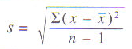 | 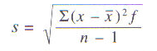

SECTION A: Multiple Choice Questions

Answer these questions on the answer sheet provided on page 2. Each question is worth 2 marks.

Question 1
The collar size of shirts worn by the pupils in a class is recorded. The most precise way of describing the data collected would be as:
A. continuous
B. categorical
C. nominal

D. ordinal
E. discrete

Question 2
x | f
1 | 3
2 | 5
3 | 2
4 | 4
5 | 2
The mean of the data set is closest to:

A. 2.5

B. 5

C. 2.8

D. 4
E. 2

Question 3 needs changing
The box plots shown below summarise the test scores for two classes of students. Class X and Class Y:
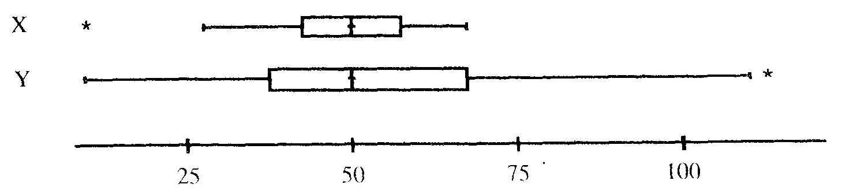

From the box plots we can say that, in general:
A. Class X scored better than Class Y.
B. Class Y scored better than Class X.
C. Class X scores are more variable than Class Y scores.
D. Class Y scores are more variable than Class X scores.
E. The scores for the two classes are about the same.

Question 4
Find the median of the data, represented by the following stem-and-leaf plot:

Key: 6 | 2 = 6.2
Stem | Leaf
6  6*  7  7*  8  8* | 2  5 6 9  1 1 2 3 3 4  5 5 6 7 8 8 9  0 0 1 4  7 9

A. 75
B. 75.7
C. 7.55
D. 7.5
E. 0.75

Question 5
The solution of 2y – 4 = 2y is:
5
A. y = 0.8
B. y = -0.33
C. y = -2.5
D. y = -0.5
E. y = 0.33

Question 6
When v = u + at is transposed to make a the subject, a is equal to:
A. v – u
t
B. v – t - u
C. v – t
u
D. v – u
t
- v – u
t

Question 7
The period, in seconds, of a swinging pendulum of length l metres, is given by T = 2л l
g
where g = 9.80. The period, in seconds, of a pendulum of length 8 cm is closes to:
A. 0.05
B. 0.18
C. 0.57
D. 5.13
E. 5.68

Question 8
The solution to the pair of simultaneous equations y = 2x – 7 and 3x + y = 8 is :
A. (-3, -13)
B. (-7, 8)
C. (-15, -37)
D. (3, 1)
E. (3, -1)

Question 9

Question 10

A.
B.
C. 4 ¹/₇
D. 27
E. 29

Question 11
If m is the subject of the formula y = mx + c, then m is equal to:
A. m = yc
x
B. m = x
y – c
C. m = y – c
x
D. m = y + c
x
E. m = c
y – x

Question 12
If 7 times a number subtracted from 52 gives 3, then the number is:
A. -7
B. 7
C. 8
D. 7
E. 7 ⁶/₇
Question 13
The formula for conversion of temperatures between degrees Celsius (ºC) and degrees Fahrenheit (ºF) is F = ⁹/₅C + 32. If C = 55 ºC then F =
A. 99 ºF
B. 105.4 ºF
C. 131 ºF
D. 62.6 ºF
E. none of the above

Question 14
Which is the solution of the simultaneous equations y + x = 2 and y – x = 4?
A. (-1, 3)
B. (1, -3)
C. (3, 5)
D. (3, -1)
E. (3, 1)

Question 15
Which of the following graphs best depicts a strong negative correlation between variables?
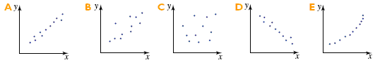

Question 16
What type of correlation is shown by the graph at the right?
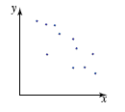
A. Strong positive correlation.
B. Moderate positive correlation.
C. No correlation
D. Moderate negative correlation
E. Strong negative correlation

Question 17
A researcher who counts the amount of time taken for production line workers to assemble a component and relates it to the number of weeks that each worker has spent on the production line finds that there is a correlations of -0.82 between the variables. She can conclude that:
A. The greater the number of weeks spent on the production line, the quicker the assembly of components.
B. The greater the number of weeks spent on the production line, the slower the assembly of components.
C. Production line assembly causes worker fatigue.
D. Many weeks doing the same task causes production line workers to become efficient.
E. Many weeks doing the same task causes production line workers to become bored and slow as a result.

Question 18
Which of the following graphs could possibly be the graph of the equation y = 15x – 200?

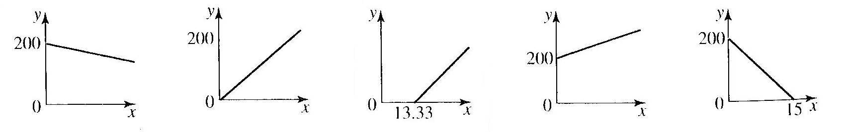
A. B. C. D. E.

Question 19
The following scatterplot would indicate that the q-correlation value would be:

A. 0 < q < 1
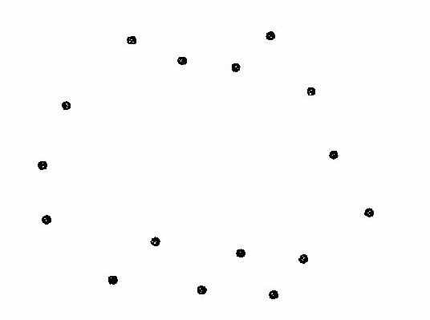
B. -1 < q < 0
C. q = 0
D. q = 1
E. q = -1

Question 20
Mary calculates the q-correlation coefficient for the data shown in the scatter diagram as 0.2.
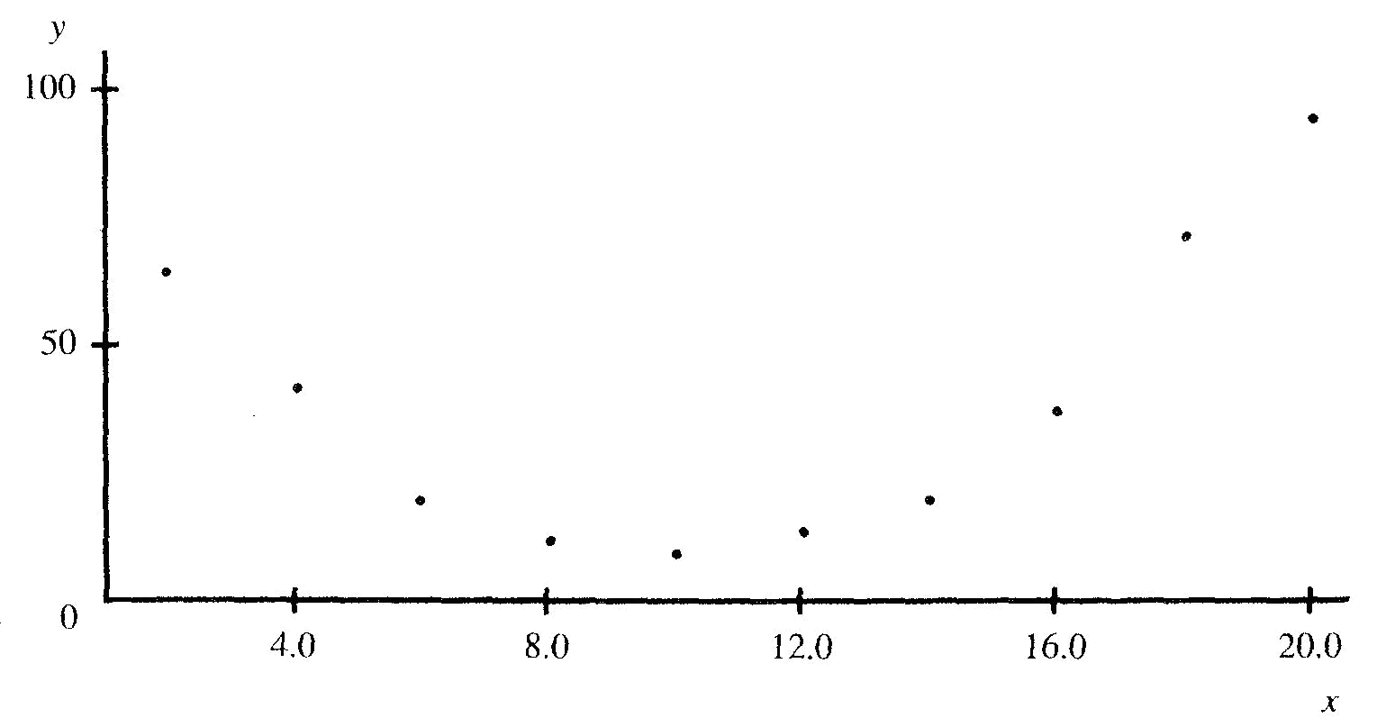
We may best interpret this by saying:
A. There is only a weak relationship between X and Y.
B. There is obviously a relationship between X and Y, so Mary’s calculation must be wrong.
C. A relationship exists between X and Y but it is not linear.
D. Knowing X does not tell us much about the corresponding value of Y.
E. There is a positive association between X and Y.

End of Multiple Choice Section

SECTION B: Short Answer Questions

Answer the following questions in the space provided. If extra space is needed, two blank pages are provided at the back of this booklet. Make sure you clearly label that you have continued a question at the back of the exam booklet.

Question 1

The following data set represents the number of siblings for a sample of students in a school.
0 3 2 1 0 2 3 2 1 2 5 3 1 0 2 3 2 1 6 3 2 5 3 0 2 3 1 0 1 1 1 4 3 2 5 4 2 0 1 1 2 3 2 1 4 5 2 1

Construct a frequency table for the data set and include both a relative frequency column, stated to three decimal places where necessary, and a percentage frequency column, stated to one decimal place where necessary.

(3 marks)

Question 2
The data set shown represents the heights of the players in the under 16 football squad at the local football club.
Class interval | Frequency
130- | 3
140- | 3
150- | 4
160- | 12
170- | 4
180- | 2

a) Draw a cumulative frequency curve then use it to find:

(4 marks)

b) an estimate for the median

(2 marks)

c) an estimate for the IQR

(3 marks)
Question 3

Draw a boxplot for the following data set.
2, 3, 5, 5, 5, 6, 8, 9, 10, 11, 12, 15

(7 marks)

Question 4

Using your graphics calculator, find the five-figure summary for the following data set and draw a boxplot.
1, 4, 6, 3, 2, 4, 5, 7, 8, 9, 10, 2, 5, 6, 7, 4, 5, 3, 5, 1, 7, 9, 6, 9, 2, 4, 8, 10, 11, 15, 17, 19, 13, 12, 14, 16, 17

(2 marks)

Question 5
The formula to calculate the simple interest earned is given by I = PrT
100
Where I is the interest on a sum of money, P, invested for T years at an interest rate of r% per annum.

a) Find the interest earned if $850 is invested for 3 years at a simple interest rate of 3% per annum

(2 mark)

b) Find the interest rate if the simple interest earned on $620 invested for 4 years is $62

c) How long will it take $500 to earn $50 interest if the interest rate is 3.5%? Round your answer up to the next month.
(3 marks)

Question 6
Solve each of the following sets of simultaneous equations.

a) 2x + y = 4 b) 3x – 2y = 10
y = x – 1 5x – 2y = 18

(2 marks)

Question 7
In each of the following, define an appropriate variable, express the information as an equation and solve the problem.

a) My mother is twice as old as I am. If the sum of our ages is 45 years, what is my age?

b) Tim spent two nights at a hotel and five nights at a motel, for a total cost of $750. If the motel costs twice as much per night as the hotel, find the cost of one night’s accommodation at the motel.

(2 marks)
Question 8

(2 marks)

Question 9

(5 marks)
Question 10

(4 marks)

Question 11
Find the value of the q correlation coefficient from the following scatterplots.

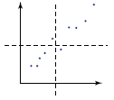
a)

(3 marks)

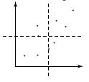
b)

(3 marks)

Question 12
The following table gives the adult return air fares between some Australian cities.

City | Distance (km) | Price ($)
Melbourne – Sydney | 713 | 580
Perth – Melbourne | 2728 | 1490
Adelaide – Sydney | 1172 | 790
Brisbane – Melbourne | 1370 | 890
Hobart – Melbourne | 559 | 520
Hobart – Adelaide | 1144 | 820
Adelaide – Melbourne | 669 | 570

The scatterplot of this data is shown below:

a) Find the q-correlation for the data and interpret it in terms of the variables in the question.

(5 marks)
Question 12 (cont.)

b) Calculate the two-mean regression line.

(6 marks)

c) Suggest at least two reasons for why the points on the scatterplot are not perfectly linear.

(2 marks)
End of Short Answer Section

End of Exam
This page has been left blank in case you need extra space for working out.
Please clearly mark which question you are answering.

This page has been left blank in case you need extra space for working out.
Please clearly mark which question you are answering.

