OXLEY COLLEGE

MATHEMATICS

END-OF-YEAR-EXAMINATION, 2003

YEAR 11 GENERAL MATHEMATICS B TIME: 1½ HOURS

TEACHER: MISS VANDERKRUK SECTION A: 21 MARKS
SECTION B: 69 MARKS

TOTAL MARKS: 90 MARKS

INSTRUCTIONS OF STUDENTS:

- Graphical Calculators may be used.
- Complete Section A on the Answer Sheet provided.
- Complete Section B in the spaces provided on the exam paper, ensuring that you show all working outs neatly.
- Make sure your answer is clearly shown.
- All pages of the examination paper to be submitted.
- Students are allowed to have one double-sided A4 page of notes.

Section A Multiple Choice ( 21 marks )

The solution to the equation $\frac{2x}{5}−3=−1$ is:
A −2
B 2
C −3
D 3
E 5

2 | The number of tins of Milo are counted each week over a period of 6 months in a supermarket. The data formed by this survey would be an example of:  A continuous data  B discrete data  C nominal data  D ordinal data  E categorical data.
3 | The cumulative frequency distribution table shows the weights (in kg) of students.  The cumulative frequency column (from top to bottom) is:  A 2, 4, 7, 3, 2  B 2, 6, 13, 16, 18  C 2, 4, 11, 14, 16  D 2, 3, 7, 4, 2  E none of these.
4 | The heights of germinating bean seeds, in centimetres, were recorded by a scientist, in a stem and leaf plot as shown below:  Stem Leaf  0 1 3 7  1 2 5 8 8  2 2 2 6 7 8 9  3 3 7  The lower quartile Q₁, median Q₂ and upper quartile Q₃ respectively are:  A Q₁ =10, Q₂ = 21, Q₃ = 28  B Q₁ =12, Q₂ = 22, Q₃ = 28  C Q₁ =13, Q₂ = 22, Q₃ = 37  D Q₁ =0, Q₂ = 22, Q₃ = 33  E none of these.
5 | An agriculturist administered different amounts of fertiliser on trial plots of sugar cane. The number of tons of sugar produced was recorded. When graphing the data, the independent variable (put on the x-axis) is:  A amount of fertiliser  B number of tons of sugar  C both are independent  D both are dependent  E the graph could not be drawn.
6 | It has been recorded that there is a correlation coefficient of −0.87 between the exchange rate and the number of tourists coming to the country.  A The exchange rate causes the tourists to come to the country.  B The exchange rate prevents tourists coming to the country.  C There is evidence to show that tourists cause the fluctuations in the exchange rate.  D There is evidence to show that the greater the exchange rate, the lower the number of tourists.  E There is evidence to show that the  lower the exchange rate, the greater  the number of tourists.
7 | This figure shows the two points (2, 16) and (6, 4) on the regression line drawn.  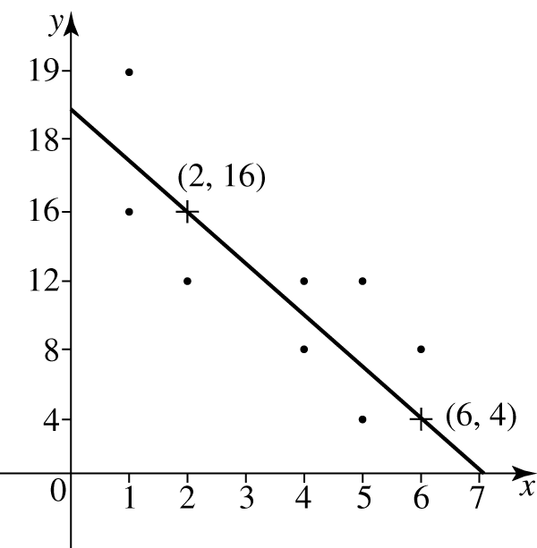  The gradient of this regression line can be computed by:  A $\frac{\text{16}−4}{6−2}$  B $\frac{\text{16}−6}{4−1}$  C $\frac{\text{16}−4}{2−6}$  D $\frac{\text{16}−6}{4+1}$  E none of these.
8 | For the scatter above, the value of the  q-correlation coefficient using the formula $q=\frac{(a+c)−(b+d)}{a+b+c+d}$ is:  A q cannot be found  B $q=\frac{(0+0)−(2+3)}{0+2+0+3}$  C $q=\frac{0+2+0+3}{(2+1)−(1+1)}$  D $q=\frac{(0+1)+(1+1)}{2+0+0+0}$  E $q=\frac{(0+0)+(2+3)}{0+2+0+3}$
9 | Consider this scatterplot:  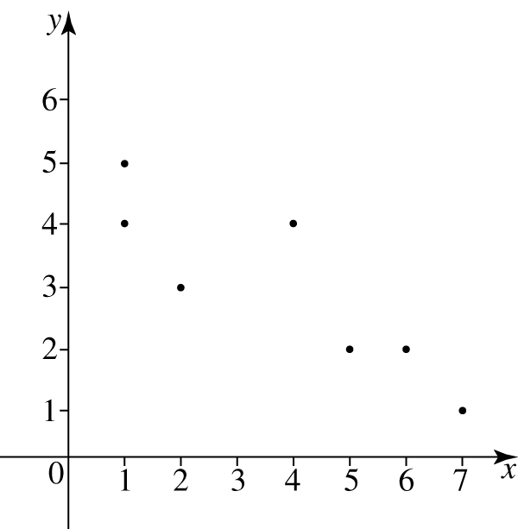  The median of the x-values is:  A 1  B 2  C 3  D 4  E 5
10 | A taxi meter is adjusted to charge fares (F) for the distance travelled (d) in kilometres according to the equation:  F = 1.5d + 3.50  The distance covered on a fare of $14 is:  A 5 km  B 7 km  C 20.5 km  D 24 km  E none of these.
11 | The angle θ to the nearest degree, is:  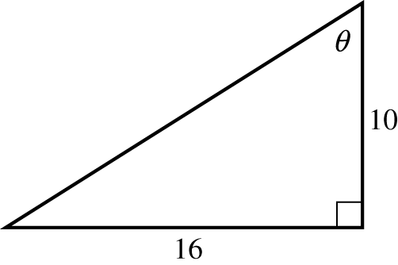  A 32°  B 38°  C 51°  D 58°  E 60°
12 | From a vertical fire tower 70 m high, an observer records the angle of depression to a small fire as 5°.  The distance of the fire from the foot of the tower to the nearest metre is:  A 6 m  B 70 m  C 350 m  D 800 m  E 803 m
13 | A bearing of 290°T is the same as:  A N20°W  B S20°W  C S70°W  D N70°W  E N20°E
14 | The smallest angle to the nearest degree is:  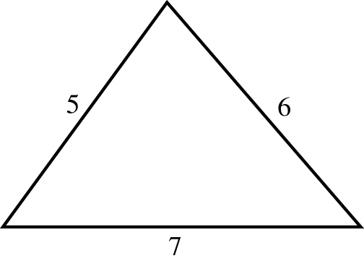  A 31°  B 44°  C 57°  D 63°  E 78°
15 | The area of the triangle is:  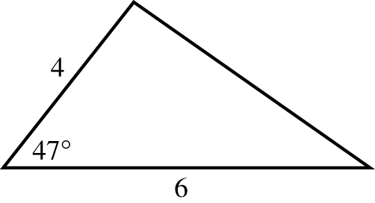  A 5.9 square units  B 8.8 square units  C 11.5 square units  D 13.2 square units  E 17.6 square units
16 | The next two questions refer to the following information.  A manufacturer of fans produces 2 different models, deluxe and budget. Total production is 120 units per week. The company has firm orders for 30 deluxe and 20 budget fans per week. The profit on each deluxe model is $13 and on each budget model the profit is $8.  Given x represents the number of budget fans, y represents the number of deluxe fans, and P represents the profit. The constraints describing this problem are:  A $x≤\text{20}, y≤\text{30}, x+y≥\text{120}$  B $x≥\text{30}, y≤\text{20}, x+y≥\text{120}$  C $x≤\text{20}, y≤\text{30}, x+y≤\text{120}$  D $x≥\text{20}, y≥\text{30}, x+y≥\text{120}$  E $x≥\text{20}, y≥\text{30}, x+y≤\text{120}$
17 | The objective function for the profit is:  A $P=\text{13}x−8y$  B $P=\text{13}x+8y$  C $P=8x+\text{13}y$  D $P−8x+\text{13}y=0$  E $P=5(x+y)$
18 | The maximum value of the objective function, P, where $P=x+3y$ for the feasible region is:  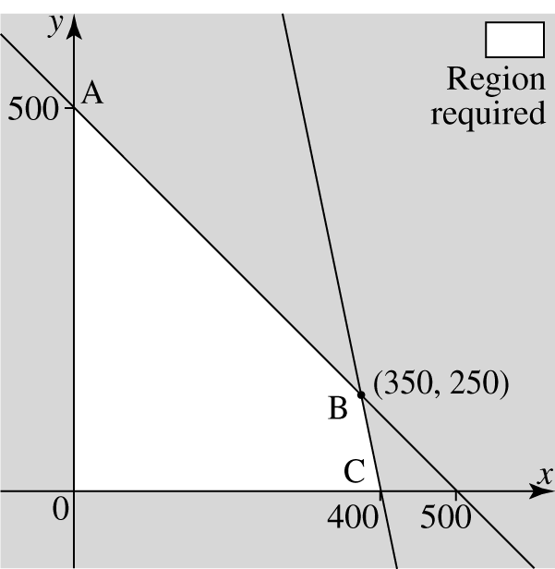  A 400  B 500  C 1000  D 1100  E 1500
19 | The region required for the inequation $x≤5$ is:  A  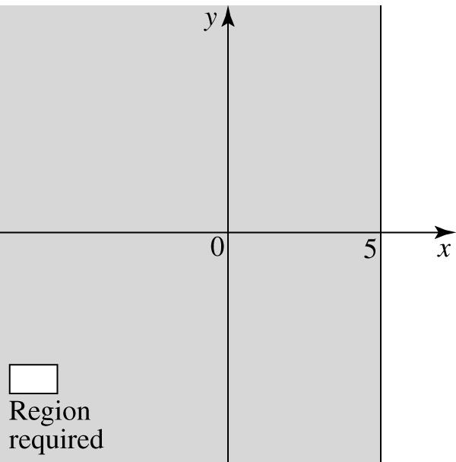  B  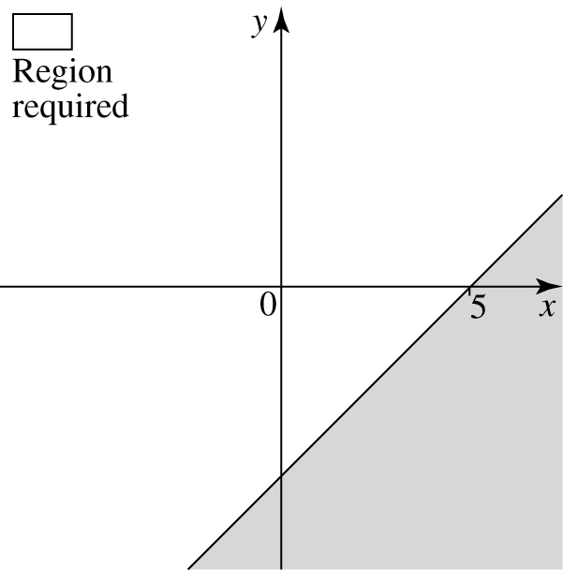  C  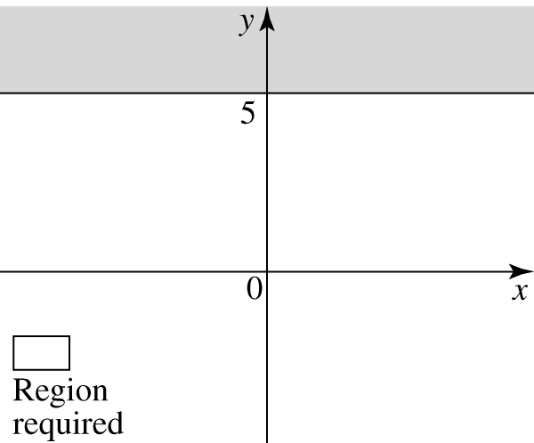  D  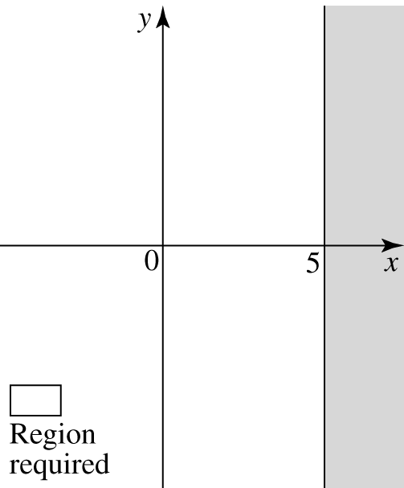  … continued next page
E
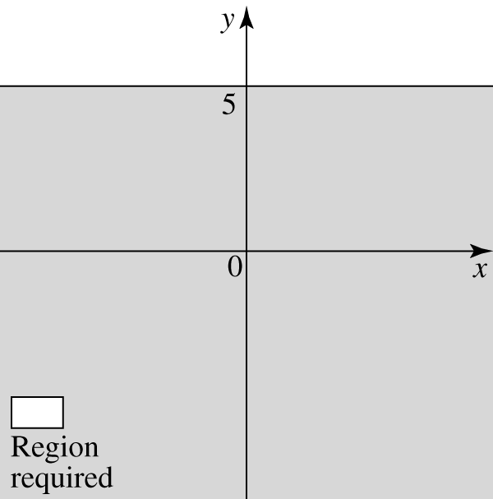

20 | The 5th term of the sequence  t_{n} = 2 × 3^{n−1} is:  A 30  B 64  C 83  D 162  E 483
21 | What is the common difference of an arithmetic sequence where the first term is 4 and the 7th term is −8?  A −1  B −2  C −4  D −6  E −12

Section B Short/Extended answer (69 MARKS)

 | Solve the following equation:  $$\frac{(2x−1)}{3}=4$$ | 2
 | The cost of 2 hamburgers and a bottle of coke is $7.50. The difference between 3 hamburgers and 2 bottles of coke is $6. Express this information as simultaneous equations. (You do not need to solve them) | 2
 | Solve the pair of simultaneous equations using the elimination method:  2x − 3y = 5 and  3x + y = 2 | 3
 | Sketch the graphs of y − x = 2 and y = −2x + 1 and hence state the coordinates of the point of intersection  .  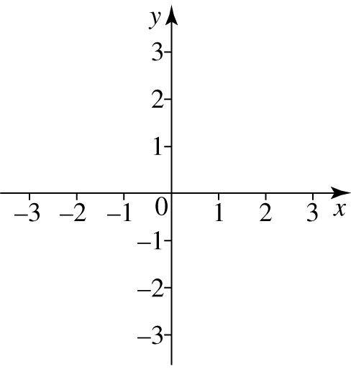 | 4
 | A survey was conducted on car colours. This table shows the results of the survey.  - What kind of data is this?  - Construct a dot plot of the data.  - Calculate the percentage frequency of blue cars. | 4
 | A biologist recorded the reaction times, in seconds, of 12 people, as follows:  Group 1: 4, 8, 6, 6, 4, 5, 4, 8, 12, 10, 8, 10.  a) For this information complete the middle column.  b) The right hand column represents the statistics of another group of 12 people  Prepare a back to back boxplot of the information for both groups  c) What kind of distributions are the two groups (eg negatively skewed…)  - Compare the two groups central tendencies  - Compare the two groups measures of spread | 14
   | Group 1 | Group 2
  Mode |  | 5
  Mean |  | 6.08
  Minimum |  | 3
  Q₁ |  | 5
  Median, Q₂ |  | 5.5
  Q₃ |  | 7
  Maximum |  | 10
  IQR |  | 2
  Standard Deviation |  | 2.06
  Range |  | 7
8 | This table shows the micrograms of insecticide used in a test and the number of flies surviving after half an hour.  - Which is the independent variable?  - Plot the data upon a scatter graph.  c) Using your calculator, find Pearson’s Correlation coefficient (r) and the equation for the linear regression line. State the type of correlation and draw a suitable conclusion based on the value of r. | 6
9 | This figure shows the regression line drawn on the scatterplot showing the length of femur in centimetres and the height of the skeleton in centimetres as drawn by a forensic scientist.  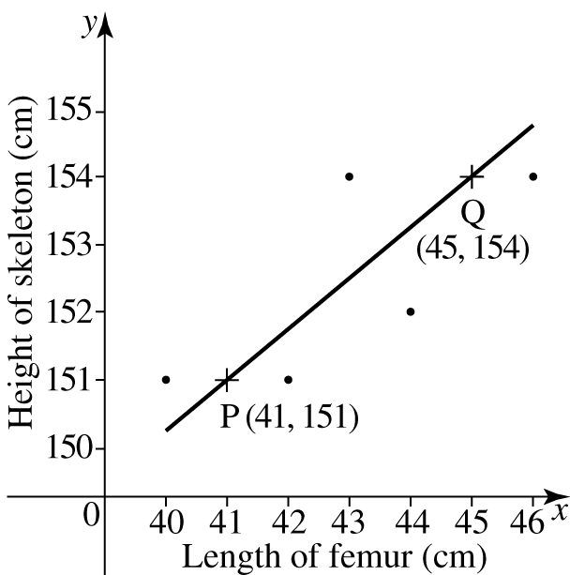  The coordinates of two points on the regression line are P(41, 151) and Q(45, 154).  - Find the gradient of the regression line.  - Find the equation of the regression line.  - A forensic scientist was going to use this scatterplot and its regression line to determine the height of a person who had a femur 50cm long. Find this height and make a comment about how reliable his calculation could be. | 6
10 | A slide 3m long makes an angle with the ground of 32º11’. Find the length of the ladder to the top of the slide. (Give your answer to 1 decimal place) | 3
11 | A cross-country runner starts at checkpoint A and runs for 8 km on a bearing of 50°T to reach checkpoint B, then heads directly east for 10 km to checkpoint C, as the diagram below shows. How far is checkpoint C from the starting point A? (Hint: You may want to redraw the diagram, including only the essential information) Give your answer to the nearest whole number.  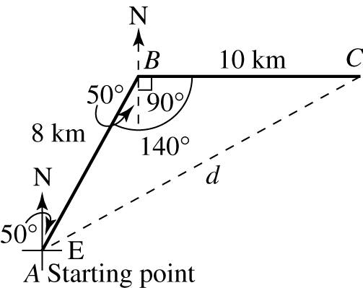 | 4
12 | In a triangular property, labelled ABC, a = 110m, c = 130m and C = 35°. Find the values of A and B. | 4
13 | Sketch the inequality x < 5 | 2
14 | Given the constraints $x≥0, y≥0, 2x+y≤6, y≥2$,  a) Sketch the system of inequations all on the same graph  b) Using your graph list the boundary coordinates of the feasible region.  c) Determine the maximum value of the objective function z = 5x - y | 9
15 | The linear recursion relation is given by t_{n} =t_{n−1} − 3, t₁ = 7.  Write down the first 4 terms of the relation. | 1
16 | The amount of money put into a bank account each week is given by the sequence  t_{n}:{$2, $5, $8, …}  a) Explain why it is an arithmetic sequence  b) Find the rule (functional or general definition) for this sequence  c) Using your rule find which term will be $434  d) Find the sum to 100 terms of this sequence (ie how much has been put into the account after 100 weeks) | 5

END OF EXAMINATION
ANSWER SHEET

SECTION A MULTIPLE CHOICE SECTION

Circle the most suitable alternative

- A B C D E

- A B C D E

- A B C D E

- A B C D E

- A B C D E

- A B C D E

- A B C D E

- A B C D E

- A B C D E

- A B C D E

- A B C D E

- A B C D E

- A B C D E

- A B C D E

- A B C D E

- A B C D E

- A B C D E

- A B C D E

- A B C D E

- A B C D E

- A B C D E

