OXLEY COLLEGE

GENERAL MATHEMATICS B

EXAMINATION

Time: 1 ½ hrs.

Section A: 35
Section B: 25

Total Marks: 35 + 25 = 60

Teacher: Miss H. Ruhnau

INSTRUCTIONS:

- Clearly write your name on each sheet of paper used for your answers.

- Answer the multiple Section A on the answer sheet provided at the back of this examination booklet.

- For the extended answer Section B it is important to show full working out to achieve full marks.

- Clearly show your answer by circling or highlighting the final answer.

- Graphical calculators may be used.

- Write all answers correct to 2 decimal places unless stated otherwise.

- One A4 page of notes is allowed.

SECTION A – Multiple Choice

1. $\frac{5\text{.}8−3\text{.}2}{1\text{.}5+1\text{.}7}$ is equal to:

A 0.5 B 0.08125 C 0.8125 D 3.4333 E 4.8

2. 8.256 correct to 1 decimal place is:

A 8.1 B 8.2 C 8.3 D 8.5 E 9.0

3. 0.04273 correct to 3 significant figures is:

A 0.04 B 0.043 C 0.0427 D 0.04273 E 0.0428

4. A standard brick is 12.5 cm high. The number of layers of bricks required for a 4 m high wall is:

A 30 B 32 C 33 D 34 E 35

5. The ratio $1\frac{1}{3}$ : $1\frac{1}{2}$ in its simplest form is:
A 2 : 3 B 4 : 3 C 3 : 4 D 9 : 8 E 8 : 9

6. If 2 : 7 = 3 : x , then x is:
A $\frac{6}{7}$ B 10 C 10.5 D 21 E 63

7. Amazing Amber decided to share a big bag of lollies between 3 of her friends in the ratio 2:3:5. The difference between the largest and smallest share of lollies is:

A 12 B 18 C 30 D 36 E 42

8. 15% of $320 is:

A $0.48 B $4.80 C $48 D $480 E $15

9. Marvellous Matthew's $80 increased by 16%. The new amount is:

A $12.80 B $15.80 C $67.20 D $92.80 E $96

10. Caring Candy bought a camera on special as it was discounted from $180 to $150. The percentage discount is closest to:

A 16 % B 17 % C 20 % D 22 % E 23 %

11. Playful Paul decided he would help out at home and took up cooking. He went and purchased from Rosy Rebecca a 5-piece cookware set. It was reduced by 15 % to $212.50. The original cost was:

A $244.40 B $237.50 C $227.50 D $250 E $240

12. Breath taking Brenton earns a $210 per week plus 8% commission on all sales he makes. If Brenton’s earnings for the week were $600, his sales totalled:

A $651 B $810 C $878.85 D $4875 E $7500

13. Lovely Lauren is paid as follows:
- $12.80 per hour for the first 38 hrs
- time and half for next 2 hrs
- double time thereafter.
If Lovely Lauren worked for 43 hours in a week, her total earnings for the week were:

A $486.40 B $524.80 C $550.40 D $601.60 E $614.40

14. Rollicking Rachal invested $10 500 in a simple interest account at the rate of 10.5% per annum for 9 months. The interest amount earned would be:
A $\frac{\$\text{10} \text{500}×\text{10}\text{.}5×\frac{9}{\text{12}}}{\text{100}}$ B $\frac{\$\text{10} \text{500}×\text{10}\text{.}5×9}{\text{100}}$ C $\frac{\$\text{10} \text{500}×\text{10}\text{.}5}{\text{100}}$

D $\frac{\$\text{10} \text{500}×\text{10}\text{.}5×3}{\text{100}}$ E $10 500 × 10.5 × 9
15. Enthusiastic Esther earned $1450 in interest when she invested $20 000 for 9 months. The annual rate of interest was:

A 7.25% B 8% C 9.67% D 10% E 10.5%

16. Mighty Michelle invested a sum of money, which earned $750 simple interest at the rate of 6% per annum over 2 years. The amount invested was:

A $88.80 B $6250 C $3125 D $2125 E none of these.

17. Melissa the Magnificent invested $8200 at the rate of 4.5% earned $738 simple interest. The period of investment was:

A 6 months B 1 year C 2 years D 3 years E 2 years 6 months

18. Amicable Amy invested $12 000 at 8% per annum compounded quarterly for 3 years. At the end of its term the amount (to the nearest dollar) will be:

A $2880 B $14 880 C $14 950 D $15 000 E $15 219

19. Tristan the Terrific also had an investment of $12 000 at the rate of 6.15% per annum, compounded quarterly, calculated it would reach $15 000 close to:

A 7 year B 6 years C 5 years D 3 years E 4 years
20. Pleasant Peter's laser printer was purchased for $790. It has an expected lifetime of 6 years and zero residual (scrap) value. The amount of depreciation to be allowed per year, in dollars, assuming a straight-line depreciation, is:

A $790 B $212 C $306.67 D $98.37 E $131.67

21. This is a graph of cost (C) and revenue (R) for Crazy Chris and Rambling Roslyn's retail company.

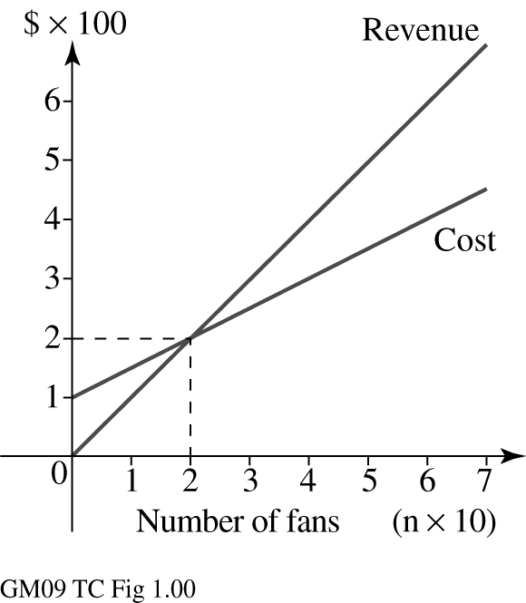
The fixed daily costs are:

A $100
B $200
C $300
D $400
E $500

22. For question 21, how many fans need to be sold to break even?

A 200 B 100 C 30 D 10 E 20

23. To plot the graph of 6x − 2y = 6, this table of values is constructed:

The missing x and y values are:
A x = −2, y = 6 B x = 2, y = 6 C x = 2, y = −6
D x = −2, y = −6 E x = 6, y = 2

24. The gradient of the line shown is:

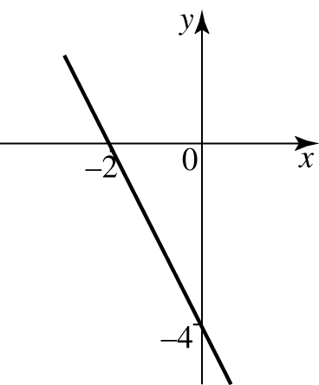
A −2
B $−\frac{1}{2}$ C $\frac{1}{2}$
D 2 E none of these.

25. The equation of the line which passes through the points (−4, 7) and (1, −3) is:

A y = 2x + 1 B y = −2x + 1 C y = −2x − 1
D y = 2x −1 E y = −x − 1

26. Which of these is the graph of 3x + y + 3 = 0?

A B C
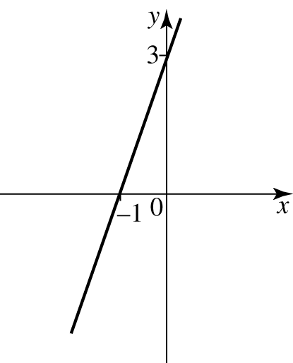
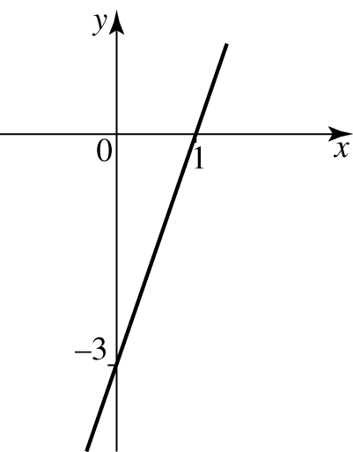

D E
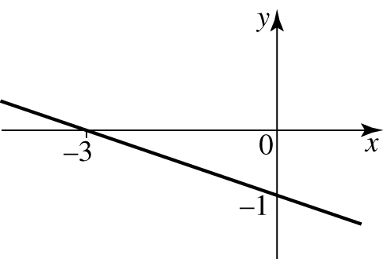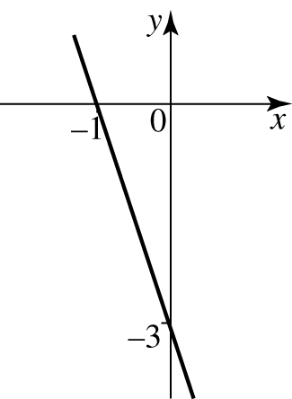
27. The equation 14x − 7y − 28 = 0 rewritten in the form y = mx + c is:

A y = 2x − 4 B y = 2x + 4 C y = −2x + 4
D y = −2x − 4 E y = 4x − 2

28. The coordinates of the x and y intercepts with the axes for the equation 3x − 5y = 15 are:

A (−5, 0) , (0, −3) B (5, 0) , (0, 3) C (5, 0) , (0, −3)
D (−5, 0) , (0, 3) E (3, 0) , (0, 5)

29. A taxi company has its fare meter adjusted to read a fixed charge of $3.50 plus an additional charge of $1.20 for each kilometre. The distance travelled when the taxi fare paid is $9.50 is:

A 3 km B 4 km C 5 km D 6 km E 7 km

30. The temperature T of a room t minutes after the air conditioner is turned on is shown by this graph:
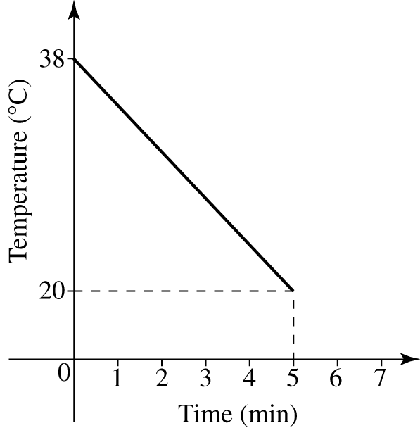
The rule connecting temperature T and time t minutes is:

A T = −3.6t
B T = −3.6t − 38 C T = 3.6t − 38
D T = 3.6t + 38 E T = −3.6t + 38

31. The equation of a ‘best fit line’ on a scatter plot showing weight in kilograms against height in centimetres of a physical education class is:

Weight = 0.55 × height − 25

The expected weight of a student who is 170 cm tall is:

A 60 kg B 65.8 kg C 68.5 kg D 70 kg E 72.5 kg

32. The perimeter of a rectangle with area 54 cm² and one side 9 cm is:

A 15 cm B 30 cm C 36 cm D 63 cm E 81 cm

33. The area of a 1.2 metre wide path around a lawn 20 m × 16 m is:

A 40.8 m² B 81.6 m² C 92.16 m² D 163.2 m² E 412.16 m²

34. The height of this shape is:
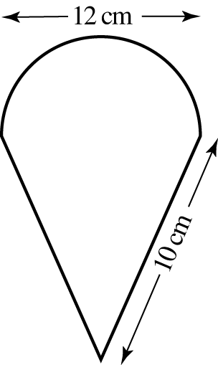

A 6 cm
B 8 cm
C 11 cm
D 12 cm
E 14 cm

35. The shaded area is closet to:
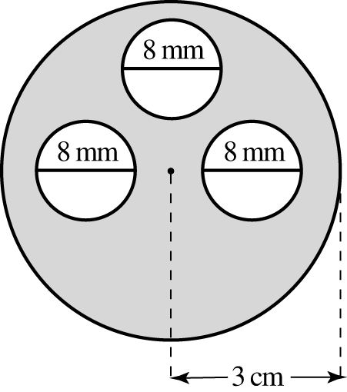

A 2023 mm²
B 2224 mm²
C 2626 mm²
D 2677 mm²
E 2726 mm²

END OF SECTION A

SECTION B – Extended Answer Section

1. If A = 2π(r + h), rearrange this equation into the form r =
(2 marks)

2. Answer the following for the linear equations (a) 3x + 4y = 12 and (b) y = 2x – 5

(i) find the x and y intercepts as two sets of coordinate points,
(ii) find the gradient (slope) of each graph,
(iii) graph each on separate axes.

(4+2+4 = 10 marks)

3. If $50 000 was invested for 3 years compounded monthly at a rate of 6.5 % p.a., calculate the following:

(i) the final amount of the investment to the nearest dollar ($)after 3 years,
(ii) the amount of interest earned

If the principal amount ($50 000) was invested for 3 years still at a rate of 6.5 % p.a. but
not compounded monthly, calculate:

(iii) the amount of interest earned at the end of the term to the nearest dollar ($),
(iv) the final amount of the investment.
(2+1+2+1 = 6 marks)

4. A pyramid has a square base of length 10 cm. The length of the slant edge is 10.3 cm. Draw a neat diagram of the shape and then calculate the total surface area of the pyramid:
(2 marks)

5. A cylindrical drum containing purified water on a yacht has a radius of 40 cm and a height of 1.5 m. Calculate the following:

- the surface area of the cylinder,
- the total capacity (total volume) of the cylinder,
- if the drum was only three quarters full, now find the volume of water in it.

(2+2+1 = 5 marks)

END OF SECTION B AND END OF EXAMINATION

Section A - Multiple Choice Answer Sheet Teacher: ______________________

Name: _____________________________

1. __________ 11. __________ 21. __________ 31. __________

2. __________ 12. __________ 22. __________ 32. __________

3. __________ 13. __________ 23. __________ 33. __________

4. __________ 14. __________ 24. __________ 34. __________

5. __________ 15. __________ 25. __________ 35. __________

6. __________ 16. __________ 26. __________

7. __________ 17. __________ 27. __________

8. __________ 18. __________ 28. __________

9. __________ 19. __________ 29. __________

10. __________ 20. __________ 30. __________

Marks: /35

