SOLUTIONS GMF UNIT 2 PAPER 2 2005
1. Networks [12 marks]
The map shows six campsites A, B, C, D, E, F which are joined by paths. The numbers by the paths show lengths in kilometres of sections of the paths.

(1)

i. Highlight the edges on the graph above to demonstrate the minimum length of cable required to complete this task.
ii. State the length of the path.

Length = 6+5+5+4+4=24 km (2)
- A walker follows the route A-B-A-F-E-D-C-E-F-A
- How far does this person walk?

Length = 45 km (1)
- Explain why this route is not a Hamiltonian circuit?
A Hamiltonian circuit must only visit each vertex once (1) but the listed circuit
visits A, E and F twice (1)
- Write down a route which a walker could follow which is a Hamiltonian circuit.
ABCDEFA (2)
- State the distance travelled if a camper were to follow the route in iii.

33 km (1)
- Is it possible to start at A and return to A going along each path exactly once? Explain
with a clear reason.

No, it is not posible as both C and F are vertices with odd degree.(1) For an Euler
Circuit to exist all vertices must be of even degree.(1)

- What is the maximum number of people per day who can travel from A to C using the paths and directions as shown in graph?
The maximum number of people each day is 100 (2)
2. Geometry & Trigonometry [16 marks]
- Show by calculation that the size of angle POQ is 45º.
$∠\text{POQ}=\frac{{\text{360}}^{∘}}{8}={\text{45}}^{∘}$ (1)

- Write down the length of ON.
25cm (1)
- Write down the size of angle PON.
$∠\text{PON}=\frac{{\text{45}}^{∘}}{2}=\text{22}⋅5^{∘}$ (1)
- What is the length of PQ in centimetres correct to one decimal place?
$\begin{aligned}\text{tan}\text{22}⋅5^{∘}=\frac{x}{\text{25}} \\ x=\text{25}\text{tan}\text{22}⋅5^{∘} \\ x=\text{10}⋅\text{36}\end{aligned}$ (1) (1)
PQ=2 x 10·36 = 20·7cm
- Find the area of the glass in the octagonal window. Give your answer correct to the nearest square centimetre.
$\begin{aligned}\text{Area}=\frac{1}{2}×\text{20}⋅7×\text{25}×8 \\ \text{Area}=\text{2070} {\text{cm}}^{2}\end{aligned}$
(1)
(1)
Nick is 172 cm tall. What is the height of the lighthouse in metres, correct to one decimal place?
$\begin{aligned}\frac{x}{\text{172}}=\frac{\text{40}}{2} \\ x=\text{3440} \\ \text{Height}=\text{34}⋅4 \text{metres}\end{aligned}$
(1)
(1)
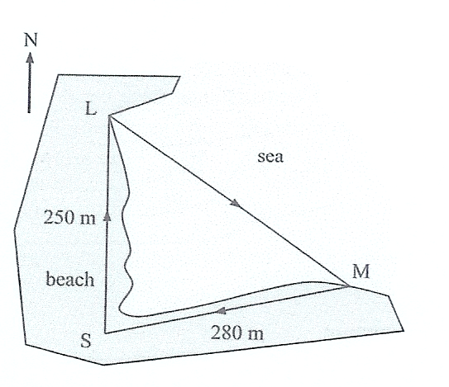
78º
- L is due North of S and the bearing of M from S is 078ºT
Label (1)

- Find the total length of the training course. Give your answer correct to the nearest metre.
(1)
$\begin{aligned}s^{2}={\text{280}}^{2}+{\text{250}}^{2}−2×\text{280}×\text{250}\text{cos}{\text{78}}^{∘} \\ s^{2}=\text{111792}\text{.}\text{36} \\ s=\text{334}⋅\text{35}\end{aligned}$
Total = 334+280+250
Total = 864 metres
(1)

(1)

- What is the bearing of M from L? Give your answer correct to the nearest degree.

$\begin{aligned}\frac{\text{sin}L}{\text{280}}=\frac{\text{sin}{\text{78}}^{∘}}{\text{334}} \\ \text{sin}L=\frac{\text{280}\text{sin}{\text{78}}^{∘}}{\text{334}} \\ L={\text{sin}}^{−1}\left(\frac{\text{280}\text{sin}{\text{78}}^{∘}}{\text{334}}\right) \\ L=\text{55}\text{.}1^{∘} \\ \text{Bearing} = \text{180}−\text{55}⋅1^{∘} \\ \text{Bearing} = {\text{125}}^{∘}T\end{aligned}$
78º
(1)
(1)
(1)

3. Linear Graphs [14 marks]
- If John produces and sells 5 tables:

Cost = 5 x 52+1000=$1260 (1)

Income = 152 x 5 = 760 (1)

- If John produces x dresses of this design, write down an expression for his total costs, C dollars, in terms of x:
(4)
C = 52x + 1000x (2)
- Write down an expression for his income in terms of x:

I = 152x (1)
- see graph to the right
- Hence, or otherwise find how many tables he needs to produce and sell, to break even.
$\begin{aligned}\text{52}x+\text{1000}=\text{152}x \\ \text{100}x=\text{1000} \\ x=\text{10}\end{aligned}$
Therefore 10 tables are required to break even. (2)
- Calculate the profit John will make from producing 20 tables:
C=52 x 20 + 1000 = 2040 (1)
I = 152 x 20 = 3040 (1)
Profit = 3040 - 2040 = $1000 (1)

4. Linear Programming [16 marks]
Let x be the number of hours per week that the factory in Melbourne makes chairs
Let y be the number of hours per week that the factory in Wangaratta makes chairs
- If the constraint for production time in Melbourne is$x≤\text{40}$, write down a constraint for the production time in Wangaratta.
$y≤\text{35}$ (1)
- Given that two of the constraints will be $x≥0 \text{and} y≥0$, construct the inequalities that define the other constraints.
Production of standard chairs: $\text{20x }+\text{ 20y}≥\text{400}$ (1)
Production of deluxe chairs: $\text{8x }+\text{ 4y}≥\text{120}$ (1)
Production of convertible chairs: $\text{4x }+\text{ 24y}≥\text{160}$ (1)
- If the operating costs in Melbourne are $80 per hour and in Wangaratta $60 per hour, determine the objective function for the operating costs, C($)

Costs = 80x+60y (2)
- Draw a graph of the complete set of constraints, including shading. Clearly label the corner points of this region, as well as all other relevant information.
(4)
- Complete the table to show the value of the objective function at each of the corner point.
Corner Points |  | Cost
x | y | C=$\text{80}x+\text{60}y$
0 | 30 | 1800
0 | 35 | 2100
40 | 35 | 5300
40 | 0 | 3200
16 | 4 | 1520
10 | 10 | 1400
[4 marks]
- What is the lowest possible operating cost whilst still satisfying customer demand?
$1400.
[2 marks]

