HAILEYBURY

GENERAL MATHEMATICS F
EXAMINATION 2
ANALYSIS TASKS
UNIT 2, 2005
Student Name..............................................
Teacher’s Name..............................................

INSTRUCTIONS
Reading time: 15 minutes
Writing time: 90 minutes

Question | 1 | 2 | 3 | 4 | TOTAL
Marks | 12 | 16 | 14 | 16 | 58
Subtotal

Directions to students
You must attempt all questions in this examination and record your answers in the spaces provided.
A graphics calculator may be used.
You may bring to the examination four pages (two A4 sheets) of pre-written notes.
1. Networks [12 marks]
The map shows six campsites A, B, C, D, E, F which are joined by paths. The numbers by the paths show lengths in kilometres of sections of the paths.

i. A telephone cable is to be laid to enable each camp site to phone the other camp sites. For environmental reasons, it is necessary to lay the cable along the existing paths. Highlight
the edges on the graph above to demonstrate the minimum length of cable required to complete this task.

ii. State the length of the cable required.

[2 marks]

- A walker follows the route A-B-A-F-E-D-C-E-F-A.

- How far does this person walk?

- Explain why this route is not a Hamiltonian circuit?

- Write down a route a walker could follow that is a Hamiltonian circuit.

- State the distance travelled if a camper did follow the route in iii.

[2 + 1 + 2 + 1= 6 marks]

- Is it possible to start at A and return to A going along each path exactly once? Explain with a clear reason.

[2 marks]

- The National Park Authority limits the number of people per day who can walk along each of the paths connecting the camp sites as shown in the following graph. Note that due to a landslide CE has been blocked and cannot be used.

What is the maximum number of people per day who can travel from A to C using the paths and directions as shown in graph?

[2 marks]
2. Geometry & Trigonometry [16 marks]
Lee and Nick are staying in the seaside township of Eagle Point which is famous for the octagonal window in its lighthouse door. The window in the door is in the shape of a regular octagon, as shown in detail below. PQ is the bottom of the window whose diagonals meet at O. The height of the window is 50 cm.
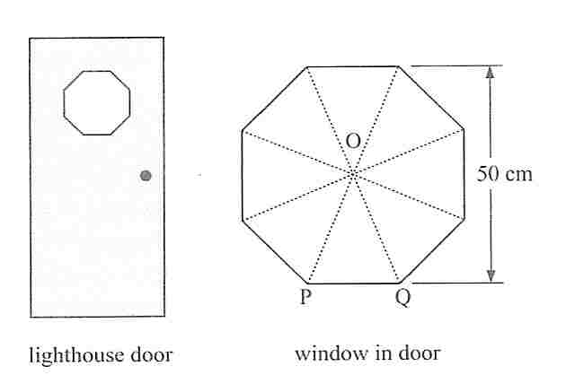

- Show by calculation that the size of angle POQ is 45º.
______________________________________________________________________________________________________________________________________________________________
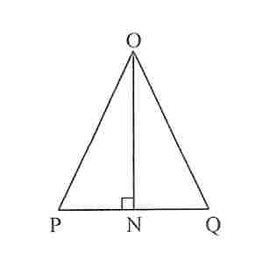
[1 mark]
- In triangle POQ, N is the midpoint of PQ.

- Write down the length of ON.
_______________________________________________________________________________
[1 mark]
- Write down the size of angle PON.
_______________________________________________________________________________
[1 mark]
- What is the length of PQ in centimetres, correct to one decimal place?

[2 marks]
- Find the area of the glass in the octagonal window. Give your answer correct to the nearest square centimetre.

[2 marks]

At midday, the lighthouse casts a shadow directly onto a level road leading to the lighthouse. Lee measures the length of the shadow by pacing, and finds that it is 40 paces long when measured from the centre of the base of the lighthouse. When Nick stands on the road, Lee finds that Nick's shadow is two paces long as shown in the diagram below:
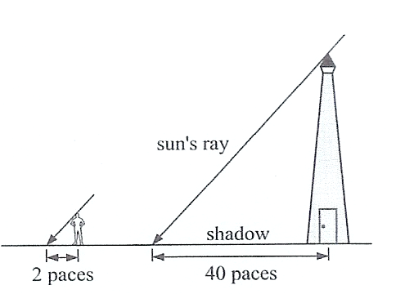

Nick is 172 cm tall. What is the height of the lighthouse in metres, correct to one decimal place?
_________________________________________________________________________________________________________________________________________________________________________________________________________________________________________________________________________________________________________________________________________________________________________________________________________________________________________________________________________________________________________________________________________________________________________
[2 marks]

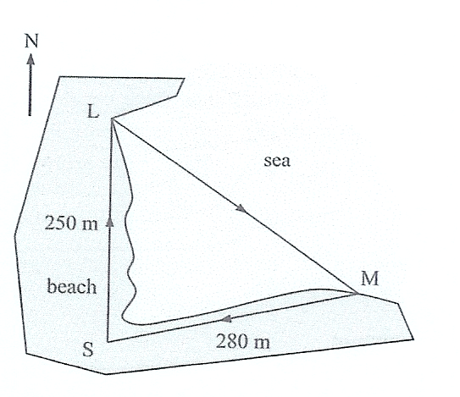
The Eagle Point Surf Club has set up a training course which requires participants to run 250 metres along the beach from the starting point S to a point L on the shore. They then swim across an inlet to a point M on the opposite shore before running 280 metres directly back to the starting point S as shown.

- L is due North of S and the bearing of M from S is 078ºT.
Label this angle on the diagram above.
[1 mark]

- Find the total length of the training course. Give your answer correct to the nearest metre.

[3 marks]
- What is the bearing of M from L? Give your answer correct to the nearest degree.

[3 marks]
3. Linear Graphs [14 marks]
John is a carpenter. For each type of table that he produces he carefully calculates the cost of materials for each table and the overhead costs of production.
For a particular design he has calculated his overhead costs at $1000 and the cost of materials for each table at $52. Each table sells for $152.

- If John produces and sells 5 tables:

Cost =

Income =
[1+1=2 marks]
- If John produces x dresses of this design, write down an expression for his total costs, C dollars, in terms of x:

C = x + x
[2 marks]
- Write down an expression for his income, I dollars, in terms of x:

I = x
[1 mark]
- Use the grid below to draw a graph for cost and income on the same set of axes. Clearly label the each graph. Ensure all relevant information is shown.

[4 marks]
- Hence, or otherwise find how many tables he needs to produce and sell, to break even.

[2 marks]
- Calculate the profit John will make from producing 20 tables.

[3 marks]

4. Linear Programming [16 marks]
A manufacturer makes furniture at two factories, one in Melbourne and the other in Wangaratta.
Let x be the number of hours per week that the factory in Melbourne makes chairs.
Let y be the number of hours per week that the factory in Wangaratta makes chairs.
The following constraints effect production:
- In Melbourne, 40 hours per week are available for making chairs
- In Wangaratta, 35 hours per week are available for making chairs
- If the constraint for production time in Melbourne is$x≤\text{40}$, write down a constraint for the production time in Wangaratta.

[1 mark]
- At the Melbourne factory, 20 standard, 8 deluxe and 4 convertible chairs can be made per week
- At the Wangaratta factory, 20 standard, 4 deluxe and 24 convertible chairs can be made per week

In terms of x and y, the number of each type of chair that can be made in a week is given in the table below:

Type | Number produced in a week
Standard | 20x + 20y
Deluxe | 8x + 4y
Convertible | 4x + 24y

To meet demand, the manufacturer must produce at least 400 standard, 120 deluxe and 160 convertible chairs each week.

- Given that two of the constraints will be $x≥0 \text{and} y≥0$, construct the inequalities that define the other constraints.
Production of standard chairs: ________________________________________
Production of deluxe chairs: ________________________________________
Production of convertible chairs:________________________________________
[3 marks]
- If the operating costs in Melbourne are $80 per hour and in Wangaratta $60 per hour, determine the objective function for the operating costs, C($).

_____________________________________________________________
[2 marks]
- Draw a graph of the complete set of constraints, including shading. Clearly label the corner points of this region, as well as all other relevant information.
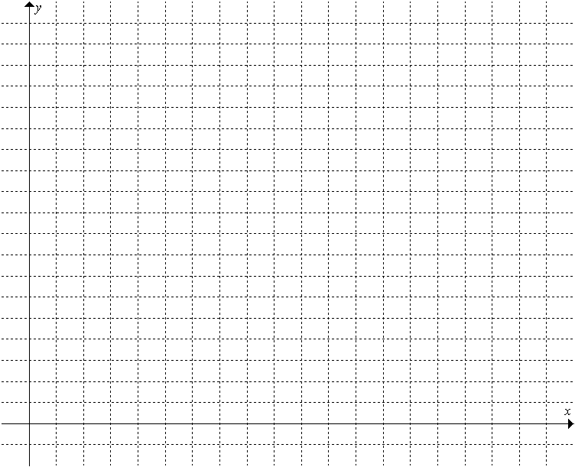
[4 marks]
- Complete the table to show the value of the objective function at each of the corner points.
Corner Points |  | Cost
x | y | C=__________________
[4 marks]
- What is the lowest possible operating cost that will satisfy customer demand?

_____________________________________________________________
[2 marks]
END OF EXAMINATION

