HAILEYBURY

GENERAL MATHEMATICS F - UNIT 1, 2005

EXAMINATION 2 - ANALYSIS TASKS

Student’s Name..............................................

Teacher’s Name.............................................

INSTRUCTIONS

Reading time: 15 minutes
Writing time: 90 minutes

Question | 1 | 2 | 3 | 4 | 5 | 6 | TOTAL
Marks | 10 | 10 | 7 | 16 | 16 | 8 | 67
Subtotal

Directions to students
You must attempt all questions and write your answers in the spaces provided.

A graphics calculator may be used.

You may bring to the examination four pages (two A4 sheet) of pre-written notes.

1. Applications of Arithmetic

In a particular state it was decided that a secondary school with 576 students should have 24 teachers and that this ratio should be used for every school in the state.

a. Calculate the ratio of students to teachers in its simplest form.

[1 mark]
- The principal of another school wanted to find whether 35 teachers was the correct number for 858 students or whether more teachers would be needed.

  - Show that there aren’t enough teachers.

[2 marks]
  - By using the ratio, how many more teachers will be needed?

[2 marks]

Lindsay borrows $12000 to buy a machine for his factory. He agrees to pay 15% p.a. and to repay the debt in full in three years time.

- Calculate the amount to be repaid if simple interest is charged.

[2 marks]
- Calculate the amount to be repaid if interest is compounded quarterly.

[3 marks]

2. Linear Relations and Equations

- Suppose that P represents Penny’s age.

- How old will she be in 7 years time?

- Write an expression to represent twice her age.

- Write an expression to represent twice her age in 7 years time.

- What is Penny’s age if twice her age in 7 years time is 48?

[1+1+1+1 = 4 marks]

b. In a particular week, a manufacturer sells 1 table and 6 chairs and receives $480. In the following week, 2 tables and 6 chairs were sold for a total of $600. The accountant Bob is trying to find the selling price of each item.

- Set up a pair of simultaneous equations, where:

  - $x represents the cost of a table and
  - $y represents the cost of a chair

- Graph the two lines on the axes below.

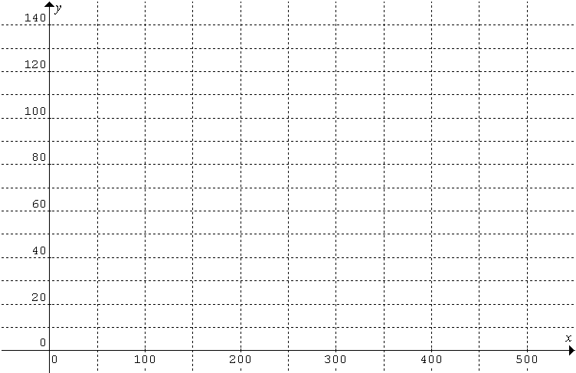

- Find where the two lines intersect and hence state the price of one chair and one table.

[2+2+2 = 6 marks]

3. Co-ordinate Geometry

Sam is going out on a fishing trip on his boat. He has left the following information with the life guards as he has been having motor trouble and wants to be sure someone will know where to find him if he has any trouble.

Leaving the dock at D(2,0), sailing to reef at R(4,6).

Plot the points given on a carefully scaled graph

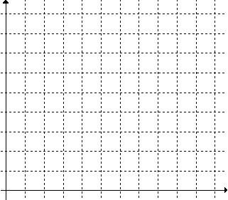

- Find the equation that describes the path that Sam will have to follow from the dock to the reef.

- How far will Sam travel from the Dock to the reef?

- At 6pm Sam had not returned so a search party is sent out. If Sam were found exactly halfway between the dock and the reef, what would be his coordinates?

[3+2+2 = 7 marks]

4. Univariate data

a. The wind speeds, in knots, for 30 days were recorded as follows:
15, 22, 14, 12, 21, 34, 19, 11, 13, 0, 16, 4, 23, 8, 12,
18, 24, 17, 14, 3, 10, 12, 9, 15, 20, 5, 19, 13, 17, 11.
- Complete the table below using class intervals of 5:
Interval | Tally | Frequency | Cumulative Frequency
0 – 4
5 - 9
- Plot the cumulative frequency curve for the wind speeds.
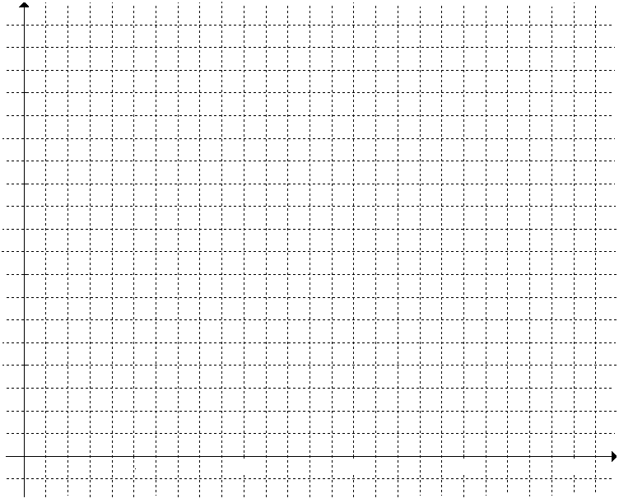
[3+2 = 5 marks]
b. An investigator recorded the number of hours 30 similar batteries lasted in a toy. Her results are given below.

3 16 18 19 19 21 21 22 23 24 25 25 25 26 26
27 27 27 28 29 29 31 31 32 32 33 33 34 49 52

- Construct a stem plot for the data listed above:

- Calculate the five-figure summary for the data.

- Showing all working, find any outliers.

- Draw a boxplot.

- Comment on the shape of the distribution.

[4+3+3+1 = 11 marks]

5. Bivariate Data

To test the effect of the driving instructions on a driving skill, ten randomly selected learner drivers were given a driving test. The number of hours of instruction for each learner was also recorded. The results are displayed in the table below.

Hours | 19 | 2 | 5 | 9 | 16 | 4 | 19 | 26 | 14 | 8
Test Score | 32 | 12 | 17 | 19 | 23 | 16 | 28 | 36 | 30 | 23

- Construct a scatterplot on the grid below:

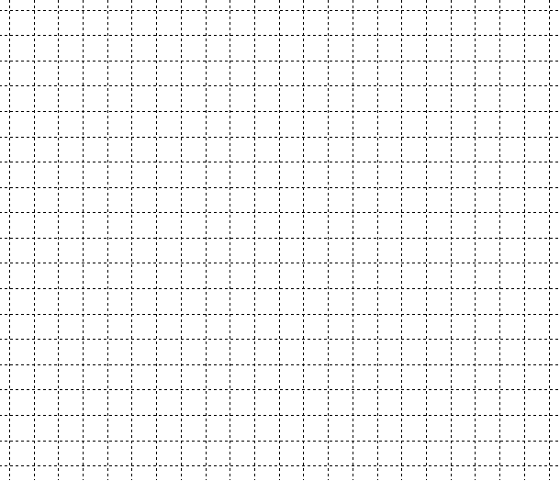

- Calculate the q-correlation co-efficient.

- Comment on the relationship between the number of hours of instruction and test score.

- Find the least squares regression line and state its equation below.

- Draw the least squares regression line on the scatter plot.

f. If a learner driver completes 12 hours of instruction what would be his expected test score?

[4+4+1+2+3+2 = 16 marks]
6. Measurement
a. A silo for storing wheat is constructed as shown below:

- Find the volume of the silo.

- If the outside of the silo is to be painted, what surface area needs to be painted? Assume the silo is completely closed on all sides.

- For ease of construction the farmer who owns the silo decides to store his wheat in a completely cylindrical silo, which has the same height and radius of the original design. Find the percentage increase in volume of the new silo compared to the original.

[3+3+2 = 8 marks]

