

HAILEYBURY

GENERAL MATHEMATICS F – UNIT 2
EXAMINATION 1

FACTS, SKILLS AND APPLICATIONS

Term 4, 2005

Reading time: 15 minutes
Writing time: 1 hour 30 minutes

NAME: ________________________________________

Teacher’s Name: ________________________________________

This examination consists of 40 multiple-choice questions each worth 1 mark.

All questions are to be answered on the answer sheet provided.
All working should be done on the blank pages opposite the question.
An approved calculator and an approved graphics calculator may be used.
Two A4 pages (4 faces) of prepared notes may be brought into this examination.
A formula sheet is provided.

SECTION A – MULTIPLE-CHOICE
(1 Mark Per Question)

1. Which one of the following graphs has an Euler circuit?
A. B.

C. D.

E.

The number of edges for a complete graph with 5 vertices is:

  - 4
  - 5
  - 10
  - 15
  - 20

3. For the directed graph shown, which vertex cannot be reached from P?

- Q
- T
- S
- R
- U

4. The shortest path between A and B is:

17
- 16
- 15
- 14
- 13

5. A connected graph with 15 vertices divides the plane into 12 regions. The number of edges connecting the vertices in this graph will be:
- 15
B. 23
C. 24
D. 25
E. 27

6. For the graph shown, which of the following paths is a Hamiltonian circuit?
A. ABCDCFDEFAEA
B. AEFDCBA
C. AFCDEABA
D. ABCDEA
E. AEDCBAF

7. A gas pipeline is to be constructed to link several towns in the country. Assuming the pipeline construction costs are the same everywhere in the region, the cheapest network formed by the pipelines would form:

- a Hamiltonian circuit
- a Euler circuit
- a minimum length spanning tree

- a Euler line
- a complete graph

8. The maximum flow in the network linking S and T is:

- 9
- 10
- 11
- 12
- 13

9. The sum of the degrees of the vertices on the graph shown is:

- 12
- 13
- 14
- 15
- 16

10. Which one of the following is a spanning tree for the graph shown here?

A. B.

C. D.

E.

11. The minimum number of edges for a graph with seven vertices to be connected is:

- 4
- 5
- 6
- 7
- 21

12. The cost ($C) of renting a truck is given by the formula $C=1⋅5x+\text{20}$ where x is the number of kilometres travelled. A person is charged $320 for the rental of a truck. The number of kilometres travelled was:

- 100
- 120
- 200
- 400
- 500

y
13. The equation of the line passing through the point (2, 3) and
parallel to the x-axis is given by:
(2, 3)
- $$x+y=5$$
- $$y=3$$
- $$x=2$$
x
- $$x−y=−1$$
- $$3x=2y$$

$y=3x−1$14. Which one of the following points lies on both the lines with equation and the line with equation $4x+2y=8$?

- (0, 0)
- (0, 4)
- (2, 0)
- (1, 2)
- (2, 1)

15. The unshaded region shown represents the inequation:
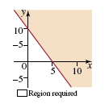
- $x+2y≥\text{10}$
- $x+2y≤\text{10}$
- $2x+y≥\text{10}$
- $2x+y≤\text{10}$
- $2x−y≥\text{10}$

16. If the objective function is Profit = x + 2y then the values of x and y which maximise profit are:

- (5, 18)
- (12, 8·2)
- (12, 15·2)
- (12, 8·3)
- (0, 20)

17. At a fruit farm the cost of strawberries is $3.00 per punnet and the cost of raspberries is $2.50 per punnet. A supermarket wishes to purchase no more than 150 punnets and wishes to pay no more than $400. If x punnets of strawberries and y punnets of raspberries are purchased, a pair of inequations which satisfies these constraints is:

- $2x+4y≤\text{400}, 5x+6y≤\text{400}$
- $$x+y≤\text{150}, x+y≤\text{400}$$
- $$6x+5y≤\text{800}, x+y≤\text{150}$$
- $$5x+6y≤\text{800}, x+y≤\text{150}$$
- $$6x+5y≤\text{800}, 2x+2y≤\text{150}$$

$4x+3y≤\text{12}\text{.}$18. Consider the inequation

For the three points (0, 0), (3, 0) and (0, 4), which of the following statements is true?

- (3, 0) and (0, 4) are the only ones in the required region
- (0, 0) and (3, 0) are the only ones in the required region
- (0, 4) and (0, 0) are the only ones in the required region
- (0, 0) is the only one in the required region
- All three are in the required region

$5x+3y≤\text{40} \text{and} \text{25}x+\text{16}y≤\text{200}$
19. The intersection point of the boundaries of the linear inequations is:
- (–40, 80)
- (–4, 8)
- (8, –4)
- (8, 0)
- The lines do not intersect.

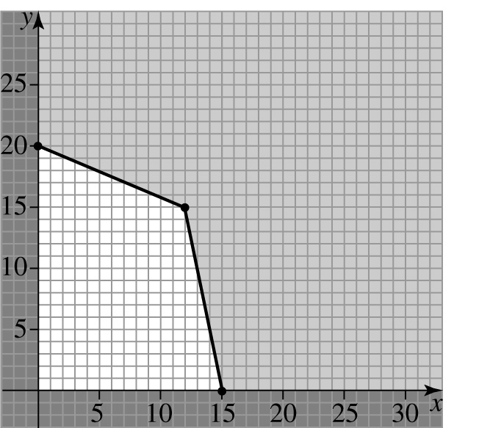
20. A linear programming problem has a solution region indicated by the non-shaded area in the figure below:

If the objective function is Z = 1·8x + 2·4y, then its maximum value over the solution region is:
- 27
- 48
- 56·7
- 57·6
- 59·4

Questions 21 and 22 refer to the linear programming problem defined by the constraints:

x ≥ 10
y ≥ 0
x + y ≤ 32

21. The corner points of the solution region are:
  - (0, 10), (0, 0), (10, 22)
  - (10, 0), (0, 0), (22, 10)
  - (10, 0), (32, 0), (10, 22)
  - (0, 10), (0, 32), (10, 22)
  - (10, 10), (0, 32), (22, 10)

22. If the objective function is Z = 3x + 4y, then the maximum value of Z under the constraints is:
- 70
B. 88
C. 96
D. 118
E. 128

23. The conventional bearing S55°E is the same as:
- 305°T
- 215°T
- 125°T
- 055°T
- 235°T

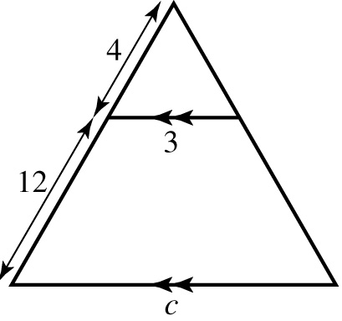
24. In the triangle shown, the value of c is:

- 3
- 6
- 9
- 12
- 4

25. Which shape has internal angles of 60º and external angles of 120º?

- equilateral triangle
- hexagon
- pentagon
- square
- octagon

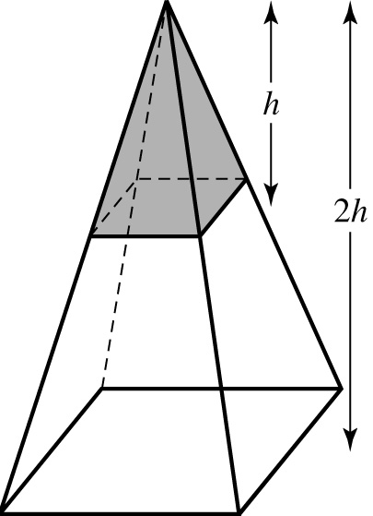
26. The ratio of the shaded volume to the unshaded volume is:
- 1 : 7
- 1 : 8
- 1 : 9
- 1 : 26
- 1 : 27

27. Find the value of x in the figure:
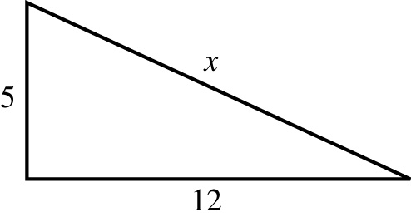
- 10·91
- 4
- 1·414
- 13
- 9·162

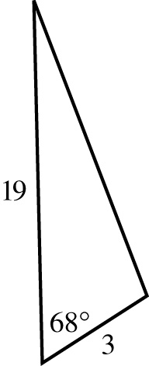
28. The area of the given figure is:

A. 26·4
B. 27·4
C. 28·4
D. 29·4
E. 52·8

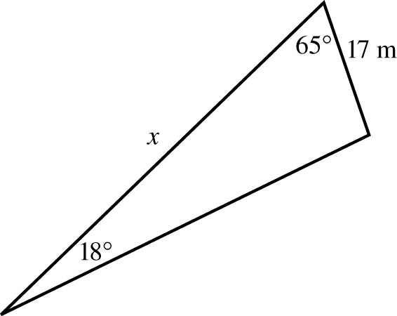
29. Find x in the figure to the nearest whole number.
- 43
- 50
x m
- 55
- 62
- 68

30. In the triangle ABC the magnitude of $∠\text{BAC}$ is:

- 30º
- 60º
- 75º
- 90º
- 150º

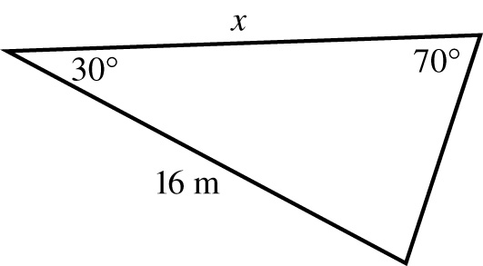
31. Find x, to the nearest whole number.
x m

  - 35
  - 43
  - 10
  - 17
  - 18

32. The size of the angle marked θ is:

- 53º 7'
- 36º 52'
- 38º 39'
- 51º 20'
- 51º 34'

33. What is the angle a pole makes with the ground if it reaches a height of 50 cm above the ground and is 100 cm long?

- 0º
- 30º
- 45º
- 60º
- 90º

34. A 30 cm long straw is the longest that can fit into a cylindrical can with radius of 9 cm. The height of the can, in cm, is closest to:

- 28
- 29
- 24
- 34
- 12

35. The value of pº is:

- $${\text{40}}^{∘}32^{'}$$
- $${\text{49}}^{∘}$$
- $${\text{49}}^{∘}28^{'}$$
- $${\text{120}}^{∘}$$
- $${\text{130}}^{∘}32^{'}$$

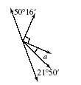
36. The value of aº is:

- $${\text{17}}^{∘}54^{'}$$
- $${\text{18}}^{∘}54^{'}$$
- $${\text{19}}^{∘}$$
o
- $${\text{21}}^{∘}50^{'}$$
- $${\text{28}}^{∘}20^{'}$$

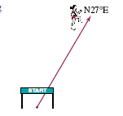
37. The bearing required to return to the starting line in this situation would be:

A. N 27 º S
B. N 27 º E
C. S 27 º W
D. N 27º W
E. S 27º E
38. In a triangle ABC, c = 5, b = 9 and Aº = 43º. Which of the following statements are correct?

(i) With the information given we can find the area of the triangle ABC
(ii) With the information given we can find angle B
(iii) With the information given we can find side length a

- i and ii only
- i and iii only
- ii and iii only
- i, ii and iii
- only i

39. Given that the height of an isosceles triangle is 10 metres and the unique angle of the triangle is 30º, what is the base length of the triangle (to 2 decimal places)?

A. 5·10 m
B. 5·18 m
C. 5·36 m
D. 2·68 m
E. 3·97 m

40. To find the the distance across a large excavation, measurements were found as shown in the diagram. The distance, AB, across the excavation is closest to:

- 75 m
- 74 m
- 100 m
- 120 m
- 140 m

GENERAL MATHEMATICS F - UNIT 2 - 2005

ANSWER SHEET

Name: Teacher:

Circle the correct answer.

1. A B C D E 21. A B C D E
2. A B C D E 22. A B C D E
3. A B C D E 23. A B C D E
4. A B C D E 24. A B C D E
5. A B C D E 25. A B C D E
6. A B C D E 26. A B C D E
7. A B C D E 27. A B C D E
8. A B C D E 28. A B C D E
9. A B C D E 29. A B C D E
10. A B C D E 30. A B C D E
11. A B C D E 31. A B C D E
12. A B C D E 32. A B C D E
13. A B C D E 33. A B C D E
14. A B C D E 34. A B C D E
15. A B C D E 35. A B C D E
16. A B C D E 36. A B C D E
17. A B C D E 37. A B C D E
18. A B C D E 38. A B C D E
19. A B C D E 39. A B C D E
20. A B C D E 40. A B C D E

