HAILEYBURY

GENERAL MATHEMATICS FURTHER UNIT 2
ANALYSIS EXAM 2004

Student Name..............................................
Teacher’s Name..............................................

INSTRUCTIONS
Reading time: 15 minutes
Writing time: 90 minutes
Question | 1 | 2 | 3 | 4 | 5 | 6 | TOTAL
Marks | 14 | 9 | 11 | 12 | 15 | 11 | 72
Subtotal

Directions to students
You must attempt all questions in this examination and record your answers in the spaces provided.
A graphics calculator may be used.
You may bring to the examination four pages (two A4 sheets) of pre-written notes.
NOTE: All answers should be expressed correct to 1 decimal place where applicable.

1. Linear Graphs and Modeling [14 marks]
A helicopter can be hired using one of two plans. If C₁ is the cost of hiring a helicopter using Plan 1, C₂ is the cost of hiring a helicopter on Plan 2 and d is the distance travelled in kilometres, then :
$$C_{1}=\text{210}+1⋅6d$$
$$C_{2}=\text{300}+1⋅1d$$
- (i) State the fixed charge for each plan:
Plan 1________________
Plan 2________________
- What feature of the graph is represented by the fixed charge?
____________________________________________________________
[2+1=3 marks]
- (ii) State the per kilometre charge for each plan:
Plan 1________________
Plan 2________________
- What feature of the graph is represented by the per kilometre charge?
____________________________________________________________
[2+1=3 marks]
- (i) Using algebra find for what distance travelled is the hire charge the same for both models.
_________________________________________________________________________________________________________________________________________________________________________________________________________________________________________________________________________________________________________________________________________________________
  - For this distance what is the hire charge?
_______________________________________________________________________________________________________________________________________________________________________________________________________________
[2+1=3 marks]

- Draw a graph for each model on the same set of axes. Clearly label each model. Ensure all relevant information is shown.
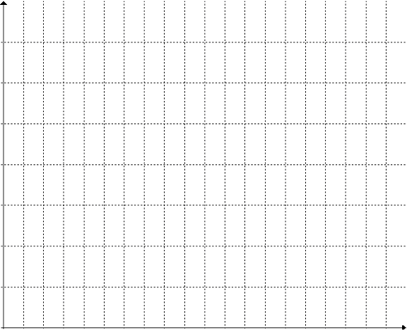
[4 marks]
- For what distances is the first model cheaper?
________________________________________________________________________________________________________________________________________________
[1 mark]
2. Shape and Measurement [15 marks]
A solid cuboid ABCDEFGH, as shown in the given diagram, has side lengths
$$\begin{aligned}\overline{\text{AB} } = 1⋅3 m \\ \overline{\text{BC} } = 1⋅2 m \\ \overline{\text{BF} } = 0⋅8 m\end{aligned}$$

The cuboid is to be wrapped in a special adhesive covering, the cost of which is $25 per square metre.

- Calculate the surface area of the cuboid, giving your answer in square metres.
________________________________________________________________________________________________________________________________________________________________________________________________________________________________________________________________________________________________
[3 marks]
- It is assumed that an allowance of 10% must be made in the surface area for wastage. Find the amount of wrap that is actually needed.
________________________________________________________________________________________________________________________________________________
[1 marks]
- What is the cost of covering the cuboid?
________________________________________________________________________________________________________________________________________________
[1 mark]
- If this cuboid is a model of a larger cuboid, three times its size, use ratios to find the volume of the larger cuboid.
________________________________________________________________________________________________________________________________________________________________________________________________________________________
[2 mark]

- It is decided to drill into the cuboid and fit a length of thin wire into the drilled hole. The hole is to be drilled from point A to point G in a straight line (a very capable tradesperson is going to do the drilling). Find the length of the wire that is needed to fit exactly from point A to point G. Give all answers in metres.
________________________________________________________________________________________________________________________________________________________________________________________________________________________________________________________________________________________________________________________________________________________________________________________________________________________________________________________________________________________________________________________________________________________________________________________________
[2 marks]
3. Trigonometry [12 marks]
A yacht starts from a point A and sails for 3km in a direction of N38ºE to a point B. At B, it alters its course to a direction of N42ºW and sails for 4.6km until it reaches a point C.
a) Draw a diagram showing all the information given

N

[2 marks]
b) Find the value of angle $∠\text{ABC}$.
________________________________________________________________________________________________________________________________________________________________________________________________________________________
[1 mark]
c) The yacht stops at C and sails straight back to the start, point A. What is the distance travelled straight from C to A?
________________________________________________________________________________________________________________________________________________________________________________________________________________________________________________________________________________________________________________________________________________________________________
[3 marks]
d) What is the true bearing of A from C?
________________________________________________________________________________________________________________________________________________________________________________________________________________________________________________________________________________________________________________________________________________________________________________________________________________________________________________________________________________________________________________________________________________________________________________________________
[3 marks]
e) What is the compass bearing of C from A?
________________________________________________________________________________________________________________________________________________________________________________________________________________________
[2 marks]
4. Geometry [12 marks]

In a cross-sectional view of a beehive it can be seen that it is made up of regular hexagonal compartments.

a) Calculate the interior angle for a regular hexagon.

[2 marks]

b) Given that $∠\text{OAB}$ is 60º, find the height of $Δ\text{AOB}$?

[2 marks]

c) Find the height of $\overline{\text{AO}}$.

[2 marks]

d) Find the area of $Δ\text{AOB}$ and hence the area of one complete hexagonal compartment.

[3 marks]

e) In a beehive tray there are 500 hexagonal compartments. Each compartment is 12 mm deep.

(i) Find the volume of honey that would be stored in a single compartment.

[1 marks]

(ii) Find the volume of honey collected from one tray. Express your answer in cm²

[2 marks]

5. Linear Programming [15 marks]
A manufacturer provides two types of clock radios, type x is a battery operated clock radio and type y is one that plugs into a power source.
- No more than 8 type x clock radios can be sold per day.
- No more than 5 type y clock radios can be sold per day.
- Production is restricted by the availability of materials to a total of no more than 12 clock radios per day.
- It takes 1 hour to make a type x clock radio. It takes 2 hours to make a type y clock radio. The machinery used to manufacture the radios can operate for a maximum of 16 hours per day.

  - Given that two of the constraints will be: $x≥0,y≥0$ .
Construct the inequalities that define the other constraints.

Daily sales type x: ________________________________________
Daily sales type y: ________________________________________
Materials: ________________________________________
Machinery hours: ________________________________________
[4 marks]
b) If the profit on each type x clock radio is $9 and each type y clock radio is $27, determine the objective function for the profit, P($)
_____________________________________________________________ [1 mark]
c) Using the constraints in b), graph the constraints and determine the feasible region. Clearly label the corner points of the feasible region, as well as, all other relevant information.
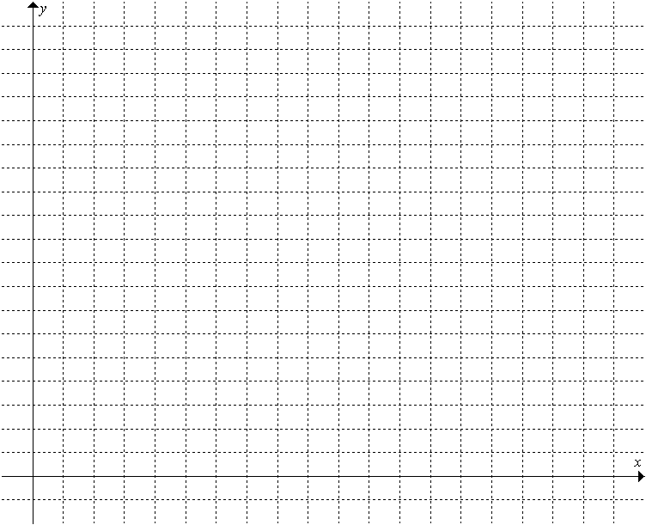
[4 marks]
d) Complete the table to show the value of the objective function at each of the corner point.
Corner Points |  | Profit
x | y | P=__________________
[4 marks]
e) What is the maximum profit that can be made and how many of each type of clock radio must be sold to realize that profit?
_______________________________________________________________________
[2 marks]
6. Networks [11 marks]
In a state forest there are six campsites, Angel Valley, Booming Falls, Crater Face, Dewey Seat, Echidna Spike and Fearful Drop. The campsites have walking tracks linking them to various other campsites. The diagram below represents the walks and campsites:

Booming Falls
Crater Face
20
15
24

8
Angel Valley
16
Dewey Seat

15
Fearful Drop

8
26
All distances are in km
7

Echidna Spike

A group of fitness fanatics from Zoom Fitness Club wish to complete a run that includes each of the paths.

a) Starting and finishing at Angel Falls, plan a course for the runners so that each path is covered exactly once. Include in your answer the length of this course.

[2 marks]

b) What type of path is this?

[1 mark]

c) If the path from Fearful Drop to Dewey Seat is removed explain why the person planning the course will need to start and finish at different sites.

[2 marks]

d) The park rangers wish to install emergency telephones at each site. This will require a cable network to be installed between each site. On the diagram below indicate the minimum spanning tree that will allow all sites to be connected.

Fearful Drop
Angel Valley
Booming Falls
Dewey Seat
Echidna Spike
Crater Face

[3 marks]

e) What is the length of cable required to allow all sites to be connected by telephone?

[1 mark]

f) Describe the shortest path from Angel Valley to Dewey Seat and state it's length.

[2 marks]

