**Article prepared by Engineers Australia**

Full STEaM ahead: Girls designing an inclusive society

Monday, 7 November 2016

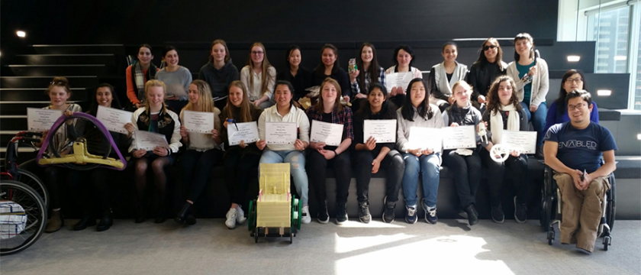

Victorian female primary and high school students recently participated in engineering workshops designing assistive devices for people with disabilities.

Over 50 female Years 5, 9 and 10 students participated in the FULL STEaM AHEAD program, combining engineering and disability enablement technologies, hosted by Akorn Educational Services and Enable Development at Engineers Australia’s Victorian facility.

During this hands-on interactive science, technology, engineering, arts, and mathematics (STEaM) program, students learnt that the development of most technology-related products, services and systems require the involvement of an engineer.

Engineers Australia’s Victoria Division Manager, Herve Carlos said it was a pleasure to host the workshops, designed to encourage more females to pursue a career in engineering.

“Women are under-presented when it comes to engineering, and it is something that we need to address, ” Mr Carlos said.

"These workshops prove that girls have just as much creativity as boys when it comes to providing solutions.  We need more girls in engineering!"

The Year 5 students from schools around the state participated in one-day workshops designing public toilets for users with disabilities, parents with infants and the elderly.

In a week-long workshop, the Years 9 and 10 students were given a brief to design and make a prototype for an assistive device.

Students used wheelchairs, crutches, white canes, and specially designed goggles to simulate mobility and visual impairments and experience first-hand the barriers that a person with a disability may face.

Whilst brainstorming the design requirements for a public toilet, the Year 5 students identified accessibility, privacy, hygiene, sustainability, independence, safety, information and gender as significant issues.

The students then built model bathrooms to meet the design requirements and presented their final products, explaining how the features met the needs of the users.

The secondary students first conducted research on what might help a person with a disability, what was already in the marketplace and brainstormed ideas for a new assistive device.

As students worked through the design process, they considered requirements such as ease of use, comfort, safety, appropriateness of materials, surface protection, suitable sizes and shapes, fixings, connections and fabrication methods.

They sketched ideas, made computer-generated drawings and used a range of materials to create a prototype or proof of concept.

At the end of the workshop, the secondary students presented their innovations to their teachers, principals, parents and representative from Engineers Australia.

CEO of Enable Development Huy Nguyen said STEM education initiatives that have strong societal purpose have a higher engagement of female participation.

“The opportunity provided by the topical subject of disability will allow young women to connect real world application to what they are learning at school in STEM subjects,” Mr Nguyen said.

One secondary student who participated said the program will influence her engagement in STEM subjects as it demonstrated how engineering and technology can be used to help people in need.

Another student said the program inspired her even more to become an engineer, specifically a pharmaceutical engineer.

“This program motivated me to work harder in maths, science and technology at school so I can become an engineer,” she said.

***Image: Future engineers? Years 9 and 10 student participants of the FULL STEaM AHEAD Program after receiving their certificates of participation, with Huy Nguyen and Angela X. Li from Enable Development, courtesy of Akorn Educational Services.***