Product Design Manufacturing Challenge 2007

Earlier this year students from six secondary schools in Melbourne’s North West were invited to join a pilot project led by Kangan Batman TAFE. This commonwealth funded project is designed to engage Year 10-12 secondary students with product design, visualisation and production tools in a real world manufacturing context.

In this project students have had an opportunity to come up with ideas for a design, whilst learning a range of drawing, design skills and modelling techniques. A group of students have attended Kangan Batman TAFE to take part in training sessions using CAD software, Catia. With expert advice from one of Australia’s leading design and technology companies Invetech and prototyping company ARRK, students are assured their designs are well on their way to being realised in a manufacturing environment.

This project will conclude with an Expo where all schools will present their final products to the public and judges will select the best design with the potential to be manufactured.

The Expo will be held on Monday 29th October 2007 from 9-4pm. All Design, Technology, VCAL, VET teachers, students and career advisors should attend.

Location: Hume Global Learning Centre, 1093 Pascoe Vale Road, Broadmeadows

Schools and Industry who are interested in being involved in 2008 should contact: Gail Bray: 9094 3051 | 0412468363 | email: gbray@kangan.edu.au

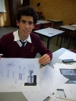 |  | 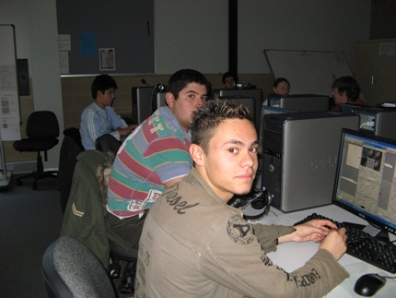
Students from Penola College have fun sketching ideas. |  | Students from Kangan Batman TAFE attend a CAD workshop
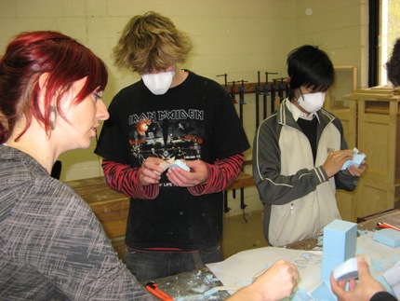 | 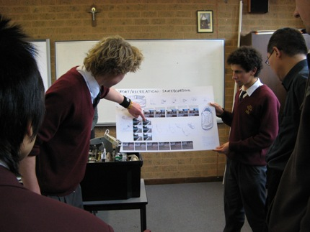
Students from Penola Catholic College, Roxburgh College and Kangan Batman TAFE attend a foam workshop | Students from Penola Catholic College present their concepts to Invetech.

