Software Development

Unit 3 Outcome 1

Programming Practice
School Assessed Coursework (SAC) Part 2

Outcome statement
On completion of this unit, the student should be able to interpret designs and apply a range of functions and techniques using a programming language to develop working modules.
Task Conditions
Allowed resources: Teacher-provided designs, open book
Time allocated to this task: 2 periods
Marks allocated: [See the bottom of this document]
Task Outline
Using the module requirements and provided designs, students are required to produce working software modules. They are also required to test each of their modules to ensure that they function correctly.
Task Summary
You are required to produce a folio of modules, using only the provided requirements and designs.
You will need to debug and test the modules and their associated applications to ensure they function as expected and are free of errors, using the test table provided. The marking scheme can be found on the last page.
Problem statement
The average daily house hold usage of electricity depends on the number of people in the house hold and whether the house uses gas or electricity to heat their hot water. The table below shows the average daily usage for Victoria.
Number of occupants | Electric hotwater  ( daily kwh) | Gas Hot water  ( daily kwh)
1 | 13.1 | 10.6
2 | 16.3 | 13.9
3 | 18.3 | 15.8
4 | 21 | 18.6
5 | 23.1 | 20.6
6 | 25.3 | 22.8

Part 1
Write a program to allow a user to enter the number of occupants in their house and whether they use Gas or Electric hot water.
They should then enter their actual daily usage to compare it to the table above.
The message they should receive is as per below
If they are under the average daily use- they should receive a congratulatory message
If they are less than 1 over the average then suggest they should increase their home insulation
If they are 1 or more over then suggest increase their home insulation and switching off their second fridge.
Part 2
Assume your household maintains its current daily usage for 3 months ( 91 days), calculate the usage charge and total charge including the supply charge. As per the table below.
A kwh is 1000 watts of power used in 1 hour.
﻿Residential Single Rate GST inclusive Units
First 1,000 kWh / 91 days 22.066 c/kWh
Consumption > 1,000 kWh / 91 days 22.594 c/kWh
Supply Charge 86.493 c/day
Display their Bill showing supply charge, Usage charge and total charge.

Designs Provided
GUI mockup
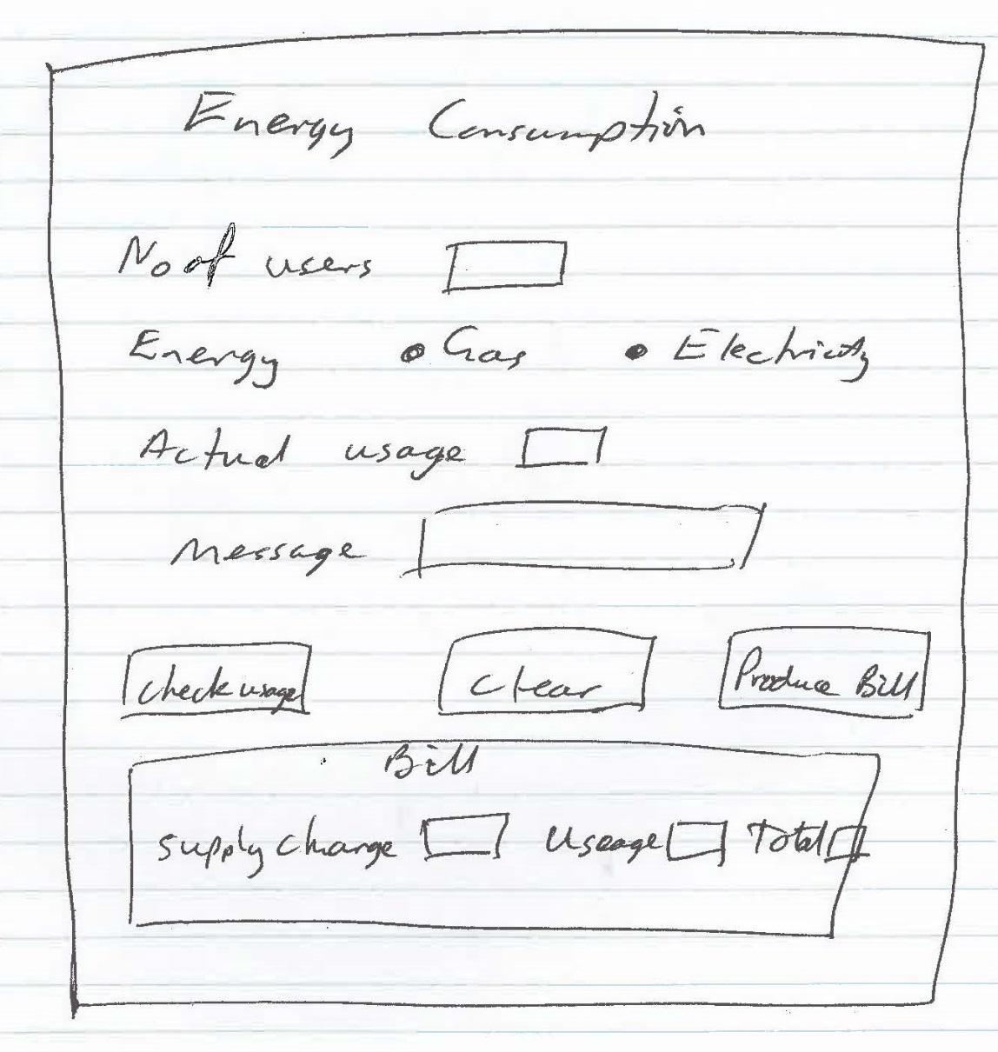
Algorithm for bill calculation
Start
Input usage
Calculate usage for 3 months
If usage <=1000 then
Usage_charge = 22.066 x usage/100
Else
Usage_charge=22.594 x usage/100
Endif
Total_charge=Usage_charge+ Supply_charge x91 /100
Display supply_charge, usage_charge, Total_charge
End

Marking Scheme
Each task will be assessed using the provided performance descriptors and table below.

 | Not shown | Low | Medium | High
Interpretation of provided designs to produce working modules | 0 | 2 | 5 | 8
Data types and structures used | 0 | 1 | 2 | 3
Processing features used | 0 | 1 | 2 | 3
Test data and testing table produced | 0 | 1 | 2 | 4
Internal documentation evident | 0 | 0 | 1 | 2
Subtotal | /20

