Task 1:

Create a Graphical User Interface that enables a user to enter the data in the following data dictionary, and clears the file.

Field | Data Type | Description | Identifier | Domain(range or values)
Customer F Name | string | This is the customer’s first name. | strCustFirstName
Customer L Name | string | This is the customer’s last name. | strCustLastName
Customer house number | int | This is the house number. | intHouseNumber | Only a whole number.
Customer street name | string | This is the customer’s street name. | strStreetName
Customer suburb | string | This is the customer’s suburb. | strSuburb
Customer postcode | int | This is the customer’s postcode. | intPostcode | Between 3000-3999
Customer phone number | string | This is the customer’s phone number | strPhoneNumber

Task 2
Create a module that will swap two objects, when two values are declared and the module swaps the contents of each text based object.

Pseudocode
Begin (procedure Swap –ItemA, ItemB)
Temp temp A
ItemA ItemB
ItemB temp
End

Task 3 Create a program for either of the following sort algorithms:
- Bubble Sort
begin BubbleSort(list)

for all elements of list
if list[i] > list[i+1]
swap(list[i], list[i+1])
end if
end for

return list

end BubbleSort

- Quick Sort
- procedure quickSort(left, right)

- if right-left <= 0
- return
- else
- pivot = A[right]
- partition = partitionFunc(left, right, pivot)
- quickSort(left,partition-1)
- quickSort(partition+1,right)
- end if

- end procedure

Task 4: Create the code for the following design. You can use code from other tasks to help.
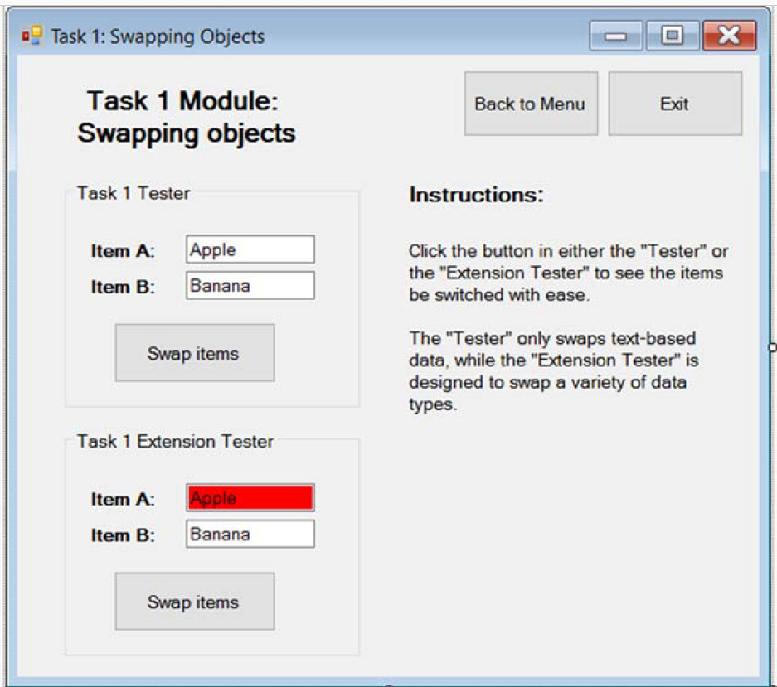
Task 5:

