Unit 3 Outcome 1 – 2017
Outcome 1 On completion of this unit the student should be able to interpret designs and apply a range of functions and techniques using a programming language to develop working modules. To achieve this outcome the student will draw on key knowledge and key skills outlined in Area of Study 1.
Key skills
• interpret designs to develop working modules that meet these requirements
• use a range of data types and structures
• use appropriate processing features of a programming language
• select and use appropriate techniques to test the functionality of modules
• document the functioning of modules through the use of internal documentation.

Task 1:
Create a Graphical User Interface that enables a user to enter the data in the following data dictionary, and clears the file.

Field | Data Type | Description | Identifier | Domain(range or values)
Customer F Name | string | This is the customer’s first name. | strCustFirstName
Customer L Name | string | This is the customer’s last name. | strCustLastName
Customer house number | int | This is the house number. | intHouseNumber | Only a whole number.
Customer street name | string | This is the customer’s street name. | strStreetName
Customer suburb | string | This is the customer’s suburb. | strSuburb
Customer postcode | int | This is the customer’s postcode. | intPostcode | Between 3000-3999
Customer phone number | string | This is the customer’s phone number | strPhoneNumber

Task 2
Create a module that will swap two objects, when two values are declared and the module swaps the contents of each text based object.

Pseudocode
Begin (procedure Swap –ItemA, ItemB)
Temp temp A
ItemA ItemB
ItemB temp
End

Task 3
Create a module for the following inputs and outputs:

Inputs: Customer First Name, Customer last Name, Customer phone number, customer delivery address (including house number, street name, suburb and post code),

Outputs: All of the inputs and a welcome message to the customer for ordering from them.

Task 4
Create a program for either of the following sort algorithms:
- Selection sort
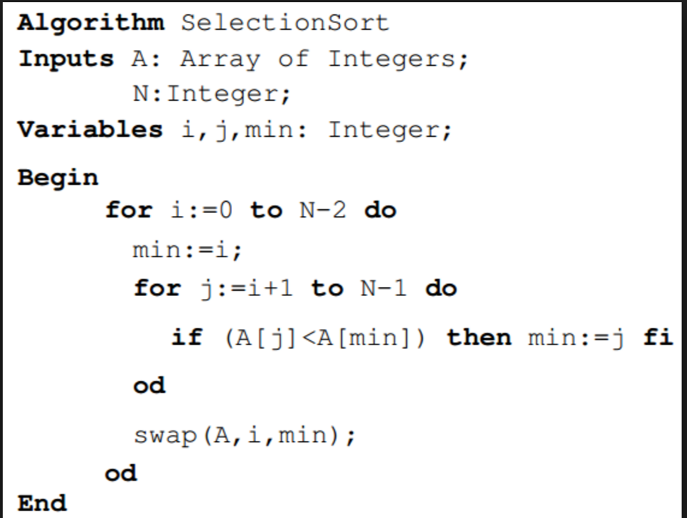
or

selectionSort(array a)
//Search for the minimum element and adds to the sorted sub array
for i in 0 -> a.length - 2 do
minIndex = i

//Find minimum element in the remaining sub array and update the minIndex
for j in (i + 1) -> (a.length - 1) do
if a[j] < a[minIndex]
minIndex = j

//Swap the minimum value find with the first element of unsorted subarray
swap(a[i], a[minIndex])
or

- Quick Sort
- procedure quickSort(left, right)

- if right-left <= 0
- return
- else
- pivot = A[right]
- partition = partitionFunc(left, right, pivot)
- quickSort(left,partition-1)
- quickSort(partition+1,right)
- end if

- end procedure

Task 5: Create the code for the following design. You can use code from other tasks to help.

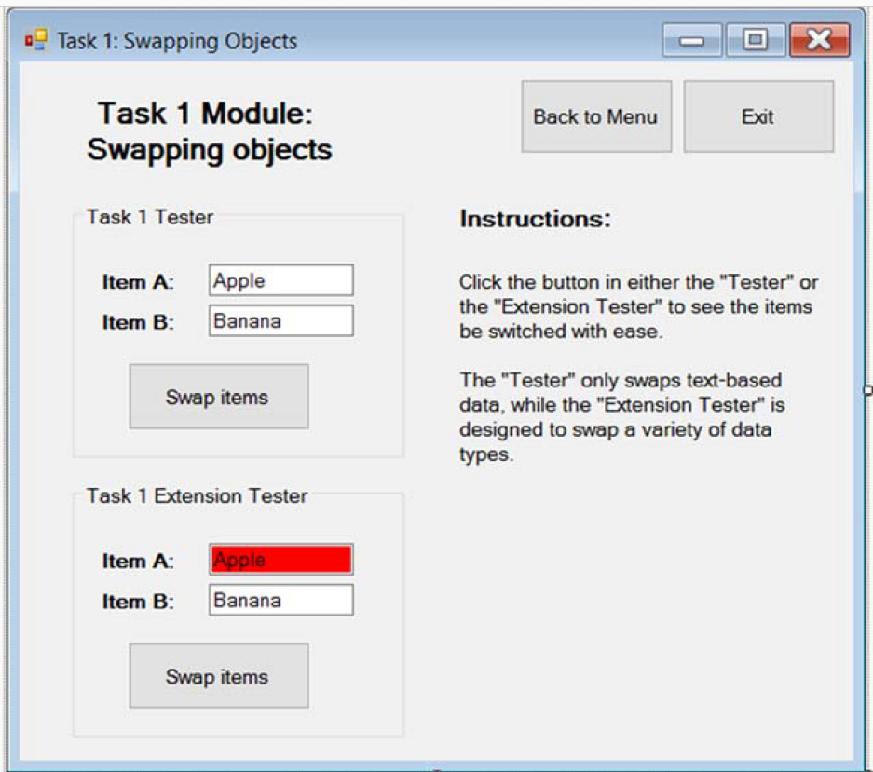

Task 6:
Create a program for the following design:
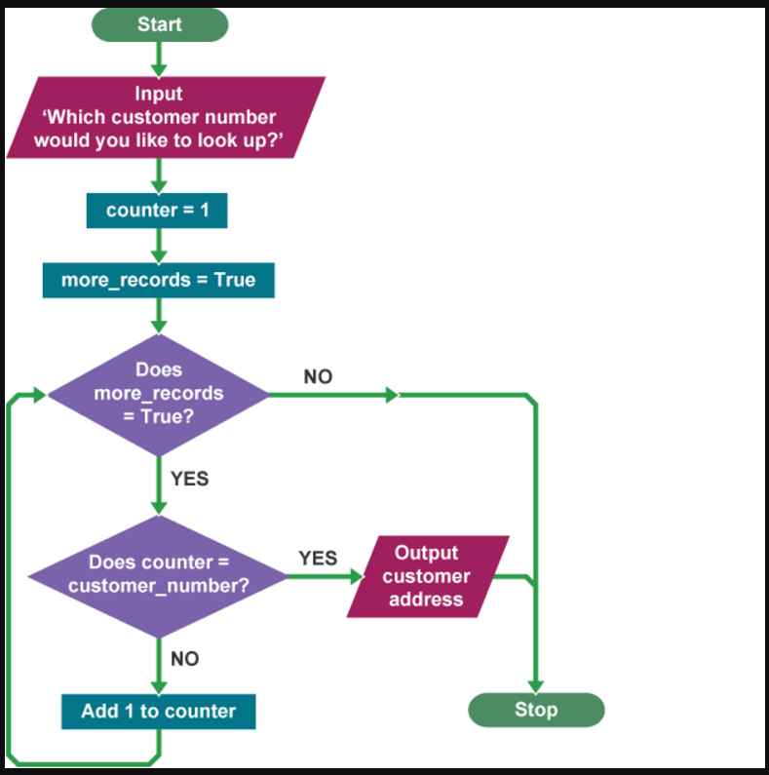

Task 7:
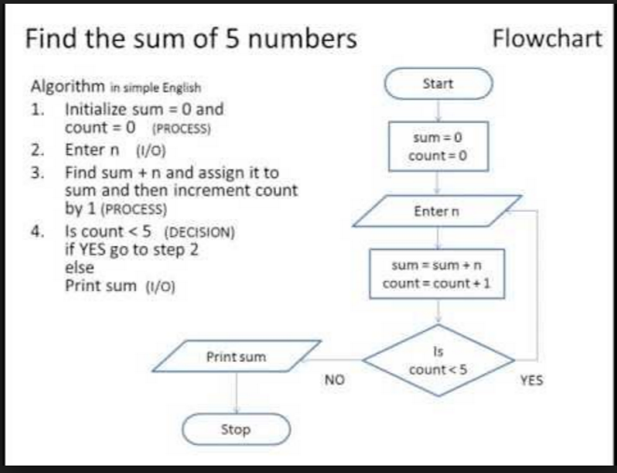

Task 8:

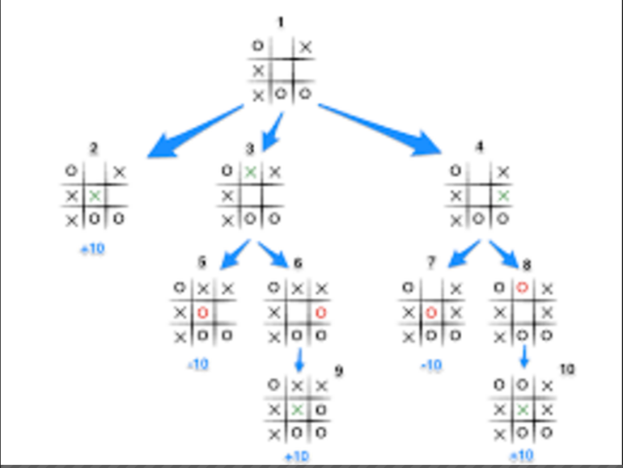

Task 9:
Create a simple calculator using the following design, you do not need to add the advanced features but can as an extension.
