Using an Array to collect Temperatures
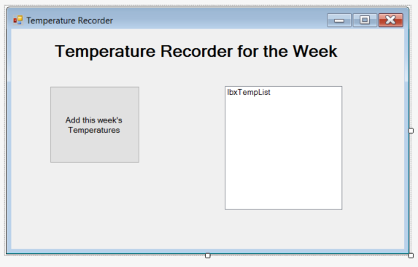

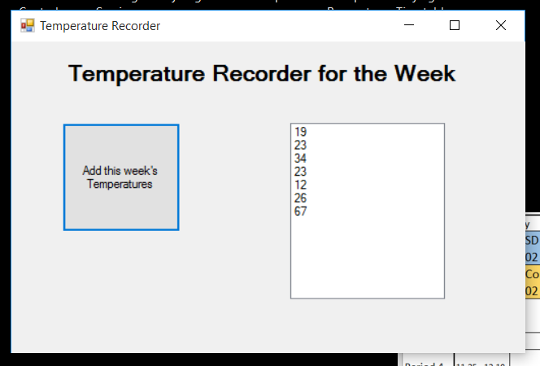
Temperatures (7)

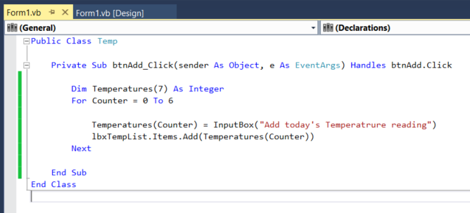

Temperatures (7) = [19], [23], [34], [23], [12], [26], [67]

Using a Multi-Dimensional Array (Dictionary) to store Dates and Temperatures

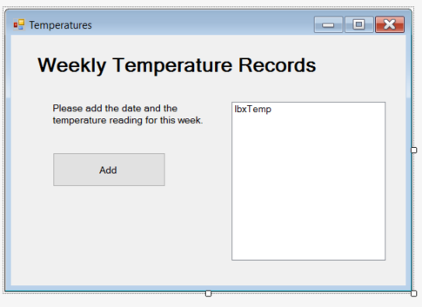

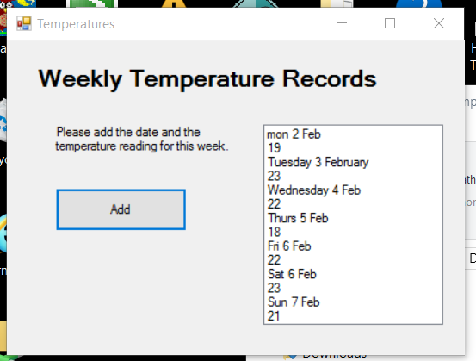

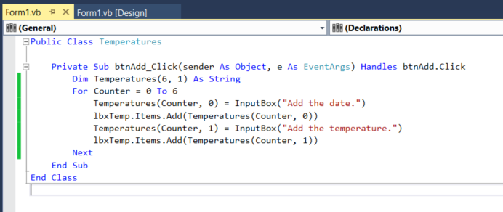
Temperatures(6,1)
[0,0] Mon 2 Feb | [0,1] 19
[1,0] Tuesday 3 February | [1,1] 23
[2,0] Wednesday 4 Feb | [2,1] 22
[3,0] Thurs 5 Feb | [3,1] 18
[4,0] Fri 6 Feb | [4,1] 22
[5,0] Sat 6 Feb | [5,1] 23
[6,0] Sun 7 Feb | [6,1] 21

