Layers of   
an application



**PRESENTATION LAYER**

This is the ‘front-end’ of the graphical user interface of the application. It allows the user to take actions, input data and query for information.



**LOGIC LAYER**

This processes the business logic of the application: running code that does any calculations, validation, logical decisions, data processing/sort/search, etc.

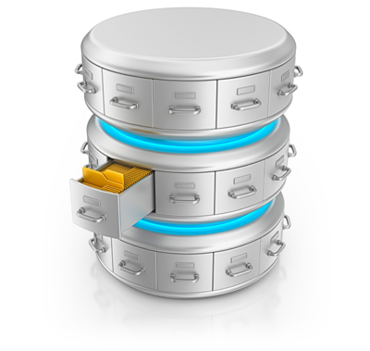

**DATA STORAGE**

Information/files/code is stored here.

On request, the required data or files are sent back along the query.

Layers of an application



**PRESENTATION LAYER**

This is the ‘front-end’ of the graphical user interface of the application. It allows the user to take actions, input data and query for information.

**LOGIC LAYER**

This processes the business logic of the application: running code that does any calculations, validation, logical decisions, data processing/sort/search, etc.





**DATA STORAGE**

Information/files/code is stored here.

On request, the required data or files are sent back along the query.