Bacchus Marsh Grammar SD U4 O2 task
The task
On completion of this unit the student should be able to analyse and explain the dependencies between two information systems and evaluate the controls in place in one information system to protect the integrity of its source data.

Time allowed: 70 minutes. (10 minutes reading time, 60 minutes writing time.)
Task conditions: This is a closed book task. There is to be no access to texts, internet or other resources. All answers are to be written in the spaces provided.

Case Study
Balliang North Grammar (BNG)
BNG is a large P–12 school comprising of over 200 staff members and 2000 students. The main goal of the school is to provide a quality education at an affordable price.
It has a large hybrid network which consists of some 100 Windows PCs, 200 staff Windows based laptops and 1500 student Chromebooks and a number of servers. There are two physical servers hosting 15 virtual servers. Data is backed up nightly onto tapes and these are stored on site and reused after two weeks of nightly backups. There is a fibre optic backbone around the school connecting the many switches where wireless access points (using 802.11n protocol) are connected via Cat6 cable to service the 1500 Chromebooks and staff laptops. Both staff and student passwords have to meet a strict password policy. BNG uses a firewall to restrict access to the school network from outside, but staff are able to VPN into the school network from home. Staff are able to access Synergetic using the web so they can access student data from home.
Information systems
BNG has two main information systems
- Synergetic- student administration database
- Timetabler – timetable and daily organisation database
The objectives of the information systems are-
- To provide efficient and accurate information to staff, students and parents.
- To minimise the number of programs that staff have to interface with.
- To maximise the security and integrity of all student data.
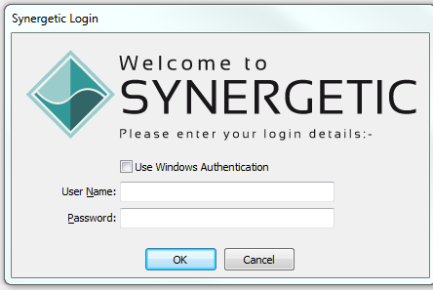
The Student Administration System, Synergetic, stores and manages all student-related information, such as personal information, parent/guardian contact information, medical information and all other data collected during their time at BNG. Staff use Synergetic to mark attendance rolls and to write end of term reports. Teachers have to log into Synergetic with their network username and password. Students do not have access to Synergetic. Teachers can login using a Windows client program or using a web interface. Parents can log into a parent portal to access reports and fee information.
The Timetable program called Timetabler manages all teacher and student timetables. It also handles daily changes to the timetable that occur due to extracurricular activities and teacher absences. To generate the timetable, students submit subject preference forms and these are collated and entered into Timetabler to assist with generating the timetable each year. Staff do not have to log into Timetabler to access their timetables. Students do not have access to Timetabler, so their timetables have to be exported via pdf and emailed to students. This process becomes problematic if there are timetable or room changes.
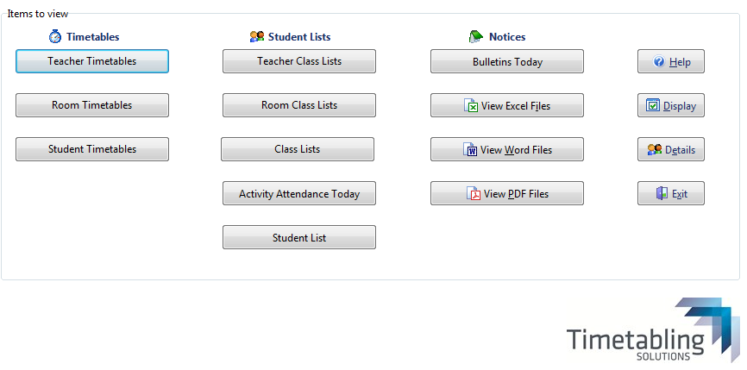
Timetabler interface
BNG have identified the need to allow students to access this information. In an effort to reduce paper handling BMG would like to adopt an online subject preference system which will feed into the Timetabler program to assist with the development of the timetable.
Data from the Timetabler program is exported as a csv file and this file is then imported into Synergetic. This happens twice each term and is a manual process with the timetable manager responsible for the exporting and importing operation. The fields in the exported file don’t always match the required fields in Synergetic causing some classes to miss students and when it is time to write reports not all subject information is accurate.
List of students
Timetable &
classes
Synergetic
Timetabler
Subject
preferences
Online preference program

Student timetables
Student reports

Fig 1

Write a report which addresses the following.
Describe the importance of the two main information systems described, in the running of a successful school.
_________________________________________________________________________________
_________________________________________________________________________________
_________________________________________________________________________________
_________________________________________________________________________________
3 marks
Describe how staff and students interact with the information systems in terms of input and output.
System | Staff | Students
Synergetic | Input  Output | Input  Output
Timetabler | Input  Output | Input  Output
8 marks
How does the diagram (fig 1) fit in with the objectives of the information systems?
Objective 1 _______________________________________________________________________
_________________________________________________________________________________
Objective 2 _______________________________________________________________________
_________________________________________________________________________________
Objective 3________________________________________________________________________
_________________________________________________________________________________
3 marks
Describe the interdependencies of the different programs in the diagram (fig 1).
_________________________________________________________________________________
_________________________________________________________________________________
_________________________________________________________________________________
_________________________________________________________________________________
_________________________________________________________________________________
_________________________________________________________________________________
3 marks
Describe the impact of an error in the output of any of the programs in (fig 1).
_________________________________________________________________________________
_________________________________________________________________________________
2 marks

Discuss the security of data at BNG under the following areas
- Discuss the importance of data security with reference to relevant legislation.
_____________________________________________________________________________
_____________________________________________________________________________
_____________________________________________________________________________
2 marks
- How is the school meeting the requirements of this legislation?
_____________________________________________________________________________
_____________________________________________________________________________
_____________________________________________________________________________
2 marks

- What are the consequences if the school does not meet this requirement?
_____________________________________________________________________________
_____________________________________________________________________________
1 mark

Data Management Practices
- From the last paragraph of the case study, explain how data management practices might influence the integrity of data utilised by BNG.
_____________________________________________________________________________
_____________________________________________________________________________
_____________________________________________________________________________
_____________________________________________________________________________
2 marks

- Explain how the issues raised in (a) could be addressed to improve the integrity of data
_____________________________________________________________________________
_____________________________________________________________________________
_____________________________________________________________________________
_____________________________________________________________________________
2 marks

- Give an example of what a line of data from a csv file would look like.
_____________________________________________________________________________
1 mark

- Explain a benefit of exporting the data file as a csv as compared to an XML file
_____________________________________________________________________________
_____________________________________________________________________________
1 mark

Networking
- Discuss by referencing specific aspects of the school network, how the computer network will assist in meeting any two of the information system objectives.
_____________________________________________________________________________
_____________________________________________________________________________
_____________________________________________________________________________
_____________________________________________________________________________
2 marks

- Describe how a VPN works and a VPN would assist staff to write reports securely.
_____________________________________________________________________________
_____________________________________________________________________________
_____________________________________________________________________________
2 marks
- Identify two threats to the security of the BNG computer network and describe how these threats could be mitigated (minimised).
_____________________________________________________________________________
_____________________________________________________________________________
_____________________________________________________________________________
_____________________________________________________________________________
4 marks

- Suggest any improvements which could be made to improve the security of the network.
_____________________________________________________________________________
_____________________________________________________________________________
_____________________________________________________________________________
_____________________________________________________________________________
2 marks

Total / 40 marks

