School-assessed Coursework Pop Quiz
Section | Number of questions | Number of questions to be answered | Number of marks | Number of marks awarded
 | 10 | 10 | 20
 |  | Total
Question 1 (1 mark) 2012
When investigating an existing information problem, a use case diagram is developed. At which stage of the problem-solving methodology does this occur?
- design
- analysis
- evaluation
- development

Question 2 (1 mark) 2012
Bill is writing a new software application for a small real estate company. Four real estate agents from the company all want an application on their mobile phones that allows them to access the data les back at the office while they are out. Each agent has a different model/make of phone.
To obtain information to help Bill write the software requirements specification (SRS), the most appropriate action for him to take is to
- interview all four real estate agents.
- observe one real estate agent at work.
- survey at least four clients to nd out what they would like.
- interview at least four clients to nd out what they would like.
Question 3 (1 mark) 2012
One of the purposes of an SRS is to provide
- the breakdown of a problem into its component parts.
- the user with instructions for operating the new software.
- information to other programmers about how a program works.
- criteria for evaluating whether or not the solution requirements have been met.

Question 4 (1 mark) 2013
In data flow diagrams, various symbols are used to represent different features. Which one of the following is the symbol for a data store?
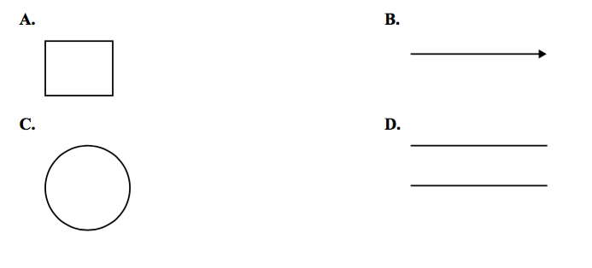

Question 5 (1 mark) 2013
An application is designed that will record a person’s heart rate every 10 minutes and keep a record of the heart rate readings for a week.
What would be the functional requirements for this software?
- The application is reliable and stores the heart rates for a week.
- The application records the heart rates and stores them for a week.
- The application is easy to turn on and off, and keeps accurate readings.
- The application records the heart rates and provides a user-friendly screen.

Question 6 (2014)
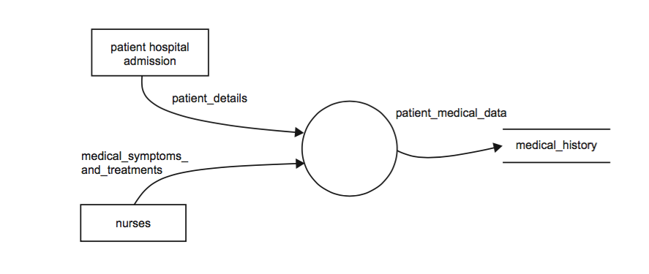
Which one of the following statements best describes what is shown in the diagram above?
- Two data flows are combined in a data store and sent to a file.
- A process reads data from two data stores and combines them into a medical history.
- A patient is admitted into a hospital and their medical details are recorded in a hospital le.
- Two processes move patient information to a data store which then sends it to an entity called medical_history.
Question 7 (2014)
A football club wants to create an electronic version of its membership records. The functional requirements of the software solution include
- being easily maintained.
- storing all member details.
- retrieving a record in less than a second.
- displaying records in an easy-to-read format.
Question 8 (2 marks) (2015)
Explain the purpose of the SRS document.

Question 9 (4 marks) (2014)
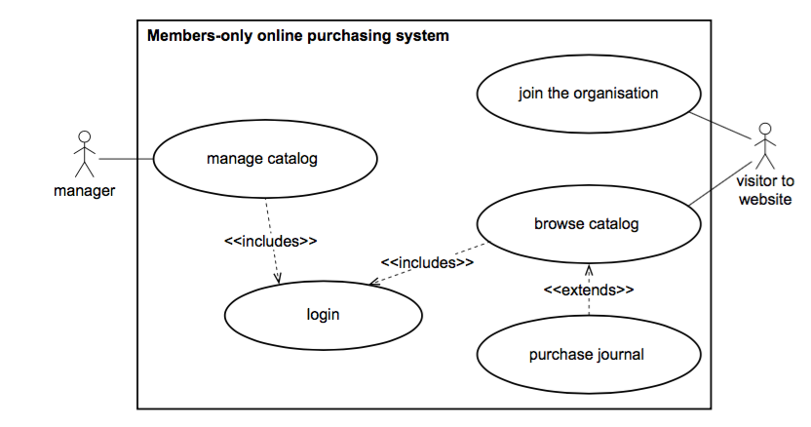
An organisation publishes a monthly journal that it sells online to its members. The following use case diagram shows the organisation’s online purchasing system.

- What does the diagram suggest that any visitor to the website can do? 1 mark

- What does the diagram suggest that the manager must do before the manager is able to manage the catalog? 1 mark

- Describe the difference between a visitor’s interaction with the ‘login’ use case and their interaction with the ‘purchase journal’ use case. 2 marks

Question 10 (8 marks) (2014)
- As part of her analysis, Nicole has begun a data flow diagram (DFD; Diagram 1) and a context diagram (Diagram 2)
Diagram 1:
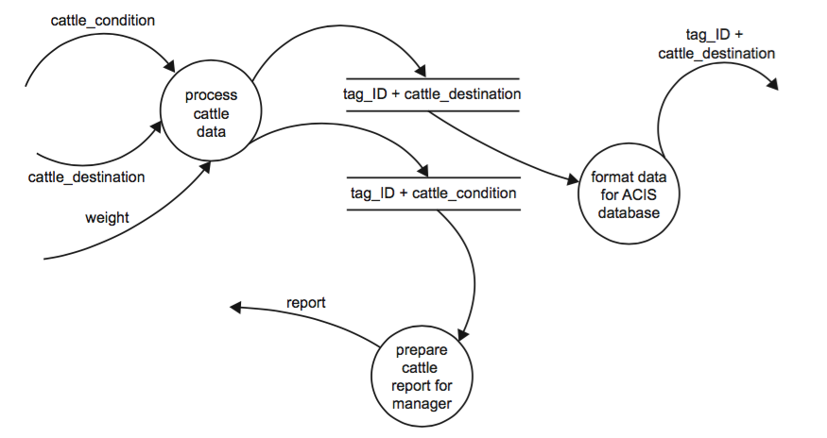
Diagram 2:
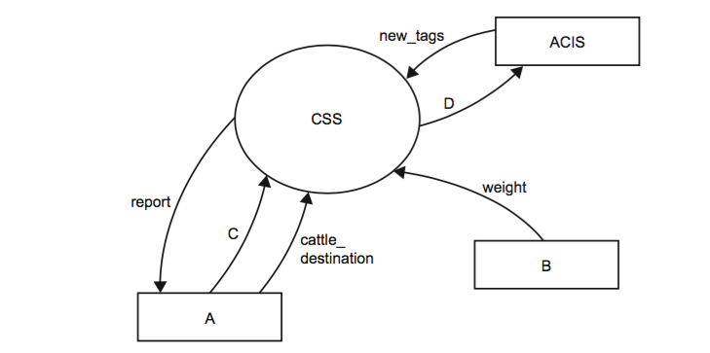
Using the information in the DFD, complete the context diagram by writing the labels for B, C and D below. 3 marks
A - Manger | B
C | D
- Sally continues her analysis by drawing a context diagram and she has started a data flow diagram (DFD). List the entities involved. 2 marks

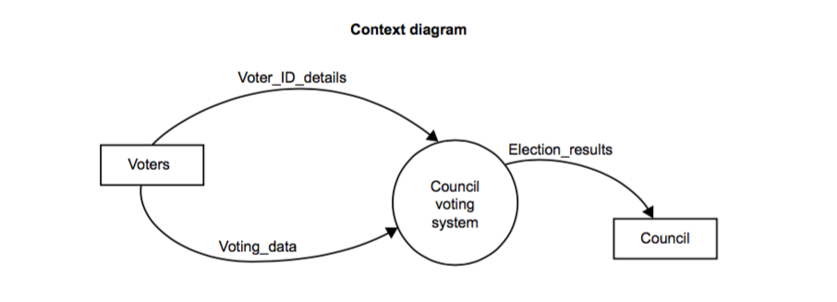
- There are three processes:
Process A – Allocate votes to candidates
Process B – Prepare reports for each candidate
Process C – Check voter eligibility and record votes

From these processes, select the correct two for the circles labelled 1 and 2 in the DFD below. Write your answers in the circles.
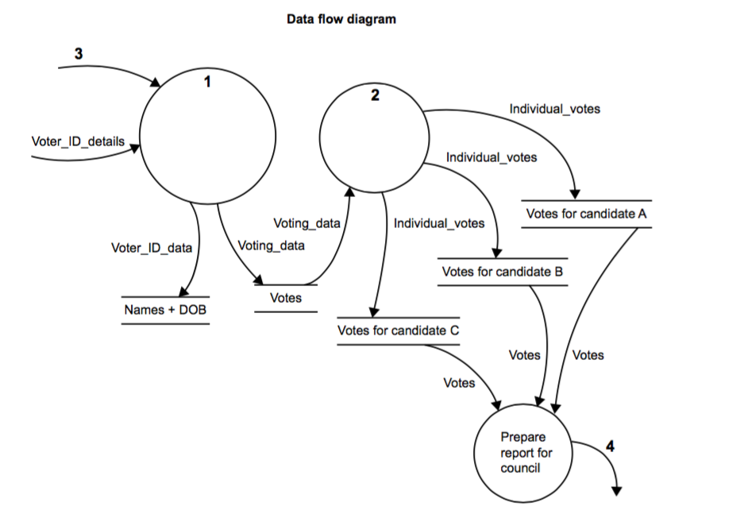
2 marks

