# headschl

# Users:claudia.graham:Documents:images:popQuiz2.jpg

# School-assessed Coursework Pop Quiz

|  |  |  |  |  |
| --- | --- | --- | --- | --- |
| Section | Number of questions | Number of questions to be answered | Number of marks | Number of marks awarded |
|  | 10 | 10 | 20 |  |
|  |  | Total |  |  |

**Question 1 (1 mark)**

Project management requires the precise scheduling of tasks throughout the duration of a project. Within this schedule, there will be tasks that must be completed before others can begin.

The project management term for this is

1. dependency.
2. critical path.
3. milestone.
4. resource.

**Question 2 (1 mark)**

In addition to identifying, scheduling and monitoring tasks, what other key factors should be considered when managing a project?

1. time, cost, programs
2. time, resources, people
3. people, procedures, cost
4. people, programs, processes

**Question 3 (1 mark)**

When planning software projects, it is necessary to identify, schedule and then monitor

1. resources, people, time and tasks.
2. resources, people and documentation.
3. tasks, time, people and documentation.
4. tasks, resources, documentation and systems.

**Question 4 (1 mark)**

The Big Computer Company (BCC) has a project involving the creation of a new application for The Small Book Store (SBS). Simon works for BCC. He has just finished installing a new application at SBS’s head office Cheryl works for SBS. She watches Simon run a series of tests on the new system. At the end of the tests Cheryl signs a document agreeing that the system has passed all the tests.

Cheryl’s signing of the test document marks a project milestone. This means that

1. a major point in the project has been reached.
2. a major delay in the project has been avoided.
3. a dependency in the project has been completed.
4. no further work can happen until another task is complete.

Use the following Gantt chart to answer the next two questions



**Question 5 (1 mark)**

In the table above the critical path consists of tasks

1. 1, 2, 4 and 5
2. 1, 3, 4 and 5
3. 1, 2, 5 and 6
4. 1, 2, 4 and 6

**Question 6 (1 mark)**

In the table above how many tasks can run over time without affecting the completion date?

1. one
2. two
3. three
4. four

Use the following Gantt chart to answer the next question

|  |  |  |  |  |  |  |  |  |  |  |  |  |  |  |
| --- | --- | --- | --- | --- | --- | --- | --- | --- | --- | --- | --- | --- | --- | --- |
| Task | Description | Time in days | | | | | | | | | | | | |
| 1 | 2 | 3 | 4 | 5 | 6 | 7 | 8 | 9 | 10 | 11 | 12 | 13 |
| A | Take photos. |  |  |  |  |  |  |  |  |  |  |  |  |  |
| B | Film video clip. |  |  |  |  |  |  |  |  |  |  |  |  |  |
| C | Record music. |  |  |  |  |  |  |  |  |  |  |  |  |  |
| D | Create credits. |  |  |  |  |  |  |  |  |  |  |  |  |  |
| E | Edit video clip. |  |  |  |  |  |  |  |  |  |  |  |  |  |
| F | Show video to test audience. |  |  |  |  |  |  |  |  |  |  |  |  |  |

**Question 7 (1 mark)**

In the table above, Task C – Record music is a predecessor for:

1. Task D.
2. Task F.
3. Task E.
4. Tasks D, E and F.

**Question 8 (4 marks)**

Define the following

Critical Path

|  |
| --- |
|  |
|  |

Slack Time

|  |
| --- |
|  |
|  |

Milestone

|  |
| --- |
|  |
|  |

Dependency

|  |
| --- |
|  |
|  |

**Question 9 (5 marks)**

Kirsten plans to set up the parking infringement monitoring system (PIMS). She decides that buying the dedicated computer for the council office and the bluetooth printer as well as setting them up will take four days; writing, testing and debugging the software for the dedicated computer will take 25 days; writing, testing and debugging the application for the mobile phones will take 20 days; and testing the whole system and making sure it works will take seven days.

1. 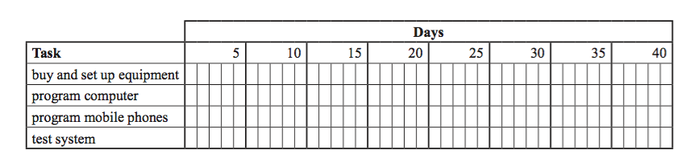Complete the Gantt chart below to show how the four tasks could be completed within 40 days.

(4 marks)

1. The task ‘test system’ cannot begin until both programming tasks are completed. Show how this situation is represented on the Gantt chart above.   (1 mark)

**Question 10 (4 marks)**

1. Explain the benefits of using a tool such as a Gantt chart to assist with project management.

(2 marks)

|  |
| --- |
|  |
|  |
|  |
|  |

1. Explain how it can be used to monitor a project. (2 marks)

|  |
| --- |
|  |
|  |
|  |
|  |