XML in VB.Net
Two (main) ways to use XML in .Net:
- XML Streams
- Working with the DOM

Working with XML Streams
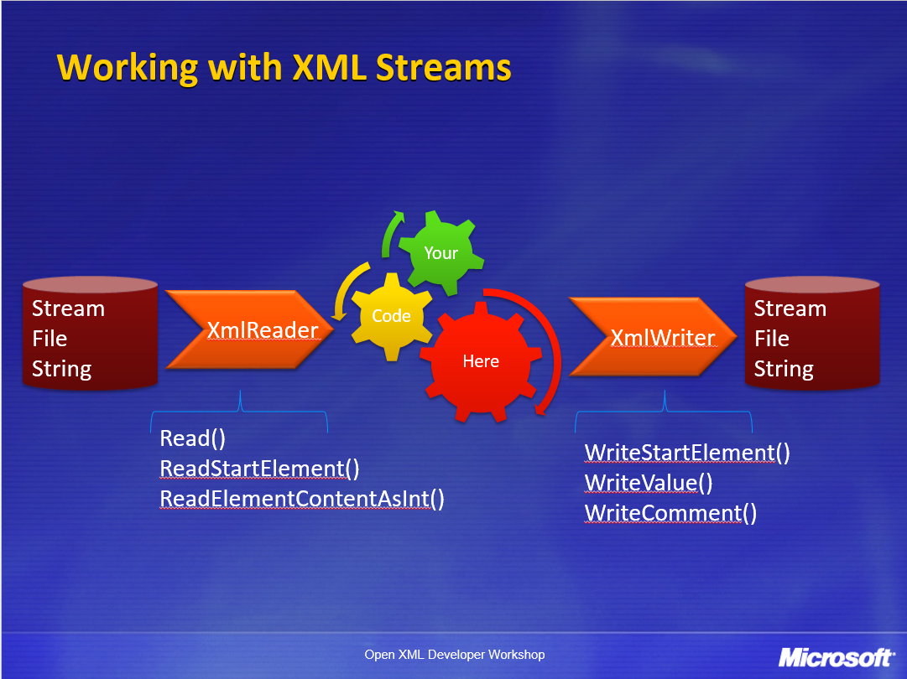
- Read XML with an XmlReader
  - Non cached, read-only, forward-only access
  - You are always at a specific location in the stream
- Write XML with an XmlWriter
  - Same architecture as the XmlReader based classes
Features of this approach
- Read and write from a Stream, String or File
Use this approach for speed and efficiency
- When working with large documents
- In data-centric processing – SOAP message parsing for instance

Reading XML with an XmlReader
<order>
<orderItem>
<quantity>10</quantity>
<unitPrice>34.99</unitPrice>
</orderItem>
</order>

Dim myXMLReaderSettings As New System.Xml.XmlReaderSettings

myXMLReaderSettings.IgnoreComments = True

Using myXMLReader As System.Xml.XmlReader = System.Xml.XmlReader.Create("sample.xml", myXMLReaderSettings)
While myXMLReader.Read
If myXMLReader.IsStartElement And myXMLReader.LocalName = "orderItem" Then
'read quantity value (quantity child node in orderItem parent node)
myXMLReader.ReadToDescendant("quantity")
Dim quantity As Integer = myXMLReader.ReadElementContentAsInt

'read unitPrice value (unitPrice child node in orderItem parent node)
myXMLReader.ReadToNextSibling("unitPrice")
Dim unitPrice As Decimal = myXMLReader.ReadElementContentAsDecimal

Dim total As Decimal = quantity * unitPrice
Console.WriteLine("Total: " & total.ToString)
End If
End While
End Using

XmlReader is an abstract class: you use the Create method to create an instance from an XmlReaderSettings.
Notice the forward only behavior:
- while loop
- Read() method
- ReadToDescendant() methods.
Best practice: always use a USING statement to assure that resources are released at the end of your processing loop.

Writing XML with an XmlWriter
Using myXMLWriter As Xml.XmlWriter = Xml.XmlWriter.Create("sample.xml", myXMLWriterSetting)
myXMLWriter.WriteStartDocument(True)
myXMLWriter.WriteStartElement("order")
myXMLWriter.WriteStartElement("orderItem")
myXMLWriter.WriteElementString("quantity", Xml.XmlConvert.ToString(10))
myXMLWriter.WriteElementString("unitPrice", Xml.XmlConvert.ToString(34.99))
myXMLWriter.WriteEndElement() 'End "orderItem" node
myXMLWriter.WriteEndElement() 'End "order" node
End Using
Typically you’d have nested loops that write out many repeated nodes.
Best practice: use settings. Indent to make your generated XML more human-readable.

Working with the DOM
The DOM is a heavier, more memory-intensive framework than XmlReader/XmlWriter approach.
DOM is compliant with the DOM specification, W3C programming interface for XML
The DOM allows loading/saving from arbitrary locations, the manipulation and validation of elements, and the usage of Xpath to query for content.
DOM is more flexible, but its performance doesn’t scale for huge documents or large numbers of simultaneous documents (e.g., busy server scenarios).
DOM models an XML source as an in memory tree of nodes.
You can use the DOM to navigate, search or modify the content in the in memory tree of nodes.
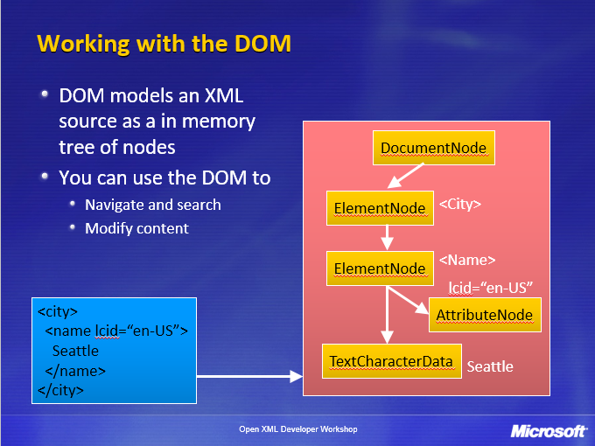

Reading XML with an XDocument -DOM
'Load an XML file into memory
Dim myXMLDoc As New Xml.XmlDocument
myXMLDoc.Load("sample.xml")

Writing XML with an XDocument -DOM
'Save an XML file to disk
myXMLDoc.PreserveWhitespace = False 'auto-indents the output to make it readable
myXMLDoc.Save("books2.xml")

Working with XML with an XDocument
The XmlNode class serves as the base class for various DOM elements
- XmlElement and XmlAttribute are samples

<?xml version="1.0" encoding="utf-8" ?>
<library>
<book isbn="123456789">
<title>XML.NET</title>
<price>19.99</price>
</book>
</library>

'Load an XML file into memory
Dim myXMLDoc As New Xml.XmlDocument
myXMLDoc.Load("books.xml")

'Get Document Node
Dim library As Xml.XmlNode = myXMLDoc.DocumentElement

'Get first child node of document - i.e. get book node
Dim book As Xml.XmlNode = library.FirstChild
'Get second child node in book node - i.e. get price node
Dim priceNode As Xml.XmlNode = book.ChildNodes(1) 'ChildNodes is 0-based
'Get "isbn" attribute of document node
Dim isbnNode As Xml.XmlNode = book.Attributes("isbn")

Dim price As String = priceNode.FirstChild.Value
Dim isbn As String = isbnNode.Value
The XmlDocument allows creation of all DOM elements
Dim comments As Xml.XmlComment = myXMLDoc.CreateComment("Some comment")

To remove nodes, use the parentXmlNode
book.RemoveChild(priceNode)
book.Attributes.Remove(isbnNode)

Appendix – Code examples

Sample XML Data file “MyFriends.XML”
<?xml version="1.0" encoding="utf-8" ?>
<my_friend_list>
<friend>
<family_name>Simpson</family_name>
<given_name>Homer</given_name>
<dob>
<day>19</day>
<month>4</month>
<year>1987</year>
</dob>
<good_looking>False</good_looking>
<address>742 Evergreen Terrace</address>
<surburb>Springfield</surburb>
</friend>
<friend>
<family_name>Nahasapeemapetilon</family_name>
<given_name>Apu</given_name>
<dob>
<day>25</day>
<month>2</month>
<year>1990</year>
</dob>
<good_looking>False</good_looking>
<address>Kwik-E-Mart</address>
<surburb>Springfield</surburb>
</friend>
<friend>
<family_name>Duffman</family_name>
<given_name>Barry</given_name>
<dob>
<day>21</day>
<month>9</month>
<year>1997</year>
</dob>
<good_looking>True</good_looking>
<address>Duffless</address>
<surburb>Keysborough</surburb>
</friend>
</my_friend_list>

Stream Reader code
Structure MyFriend
Dim FamilyName As String
Dim GivenName As String
Dim FriendDob As Dob
Structure Dob
Dim DobDay As Integer
Dim DobMonth As Integer
Dim DobYear As Integer
End Structure
Dim GoodLooking As Boolean
Dim Address As String
Dim Surburb As String
End Structure

Dim AllMyFriends(2) As MyFriend

''' <summary>
''' This sub reads in an XML file via a stream reader. This will process each node from the file and then outputs the content via stringbuilder.
''' </summary>
''' <param name="fileName">The full path and filename of the XML file</param>
''' <param name="ignoreComments">Flag to determine whether to reading comments or not</param>
''' <returns>String containing the content of the XML with one line for each item</returns>
Function ReadFromXMLFileViaStream(fileName As String, ignoreComments As Boolean) As String
Dim myXMLReaderSettings As New System.Xml.XmlReaderSettings

If ignoreComments Then
myXMLReaderSettings.IgnoreComments = True
End If

Dim xmlString As New System.Text.StringBuilder
Dim indentLevel As Integer = 0
Using myXmlReader As System.Xml.XmlReader = XmlReader.Create(fileName, myXMLReaderSettings)
While myXmlReader.Read
Dim whiteSpace As Integer = indentLevel * 5
Select Case myXmlReader.NodeType
Case XmlNodeType.Element
Console.Write("<{0}>", myXmlReader.Name)
indentLevel += 1
whiteSpace = indentLevel * 5
xmlString.Append(" "c, whiteSpace)
xmlString.AppendFormat("<{0}", myXmlReader.Name)
If myXmlReader.HasAttributes Then
While myXmlReader.MoveToNextAttribute
xmlString.AppendFormat(" {0}='{1}'", myXmlReader.Name, myXmlReader.Value)
End While
End If
xmlString.Append(">")
xmlString.AppendLine()
Case XmlNodeType.Text
indentLevel += 1
whiteSpace = indentLevel * 5
xmlString.Append(" "c, whiteSpace)
xmlString.Append(myXmlReader.Value)
xmlString.AppendLine()
indentLevel -= 1
whiteSpace = indentLevel * 5
Case XmlNodeType.CDATA
xmlString.Append("<![CDATA[{0}]]>", myXmlReader.Value)
xmlString.AppendLine()
Case XmlNodeType.ProcessingInstruction
xmlString.AppendFormat("<?{0} {1}?>", myXmlReader.Name, myXmlReader.Value)
Case XmlNodeType.Comment
xmlString.Append("<!--{0}-->", myXmlReader.Value)
xmlString.AppendLine()
Case XmlNodeType.XmlDeclaration
xmlString.AppendFormat("<?xml {0}?>", myXmlReader.Value.ToString)
xmlString.AppendLine()
Case XmlNodeType.Document
Case XmlNodeType.DocumentType
xmlString.AppendFormat("<!DOCTYPE {0} [{1}]", myXmlReader.Name, myXmlReader.Value)
Case XmlNodeType.EntityReference
xmlString.Append(myXmlReader.Name)
xmlString.AppendLine()
Case XmlNodeType.EndElement
xmlString.Append(" "c, whiteSpace)
xmlString.AppendFormat("</{0}>", myXmlReader.Name)
xmlString.AppendLine()
indentLevel -= 1
whiteSpace = indentLevel * 5
End Select

End While
End Using
Return xmlString.ToString

End Function

''' <summary>
''' This sub reads in an XML file with the "myFriends" structure via a stream reader.
''' This will store each "friend" node into the "AllMyFriends". "friend" contains all child nodes which corresponds to the record type "MyFriend".
''' </summary>
''' <param name="inputFilename">The full path and filename of the XML file</param>
Sub ReadFromXMLFileViaStream(inputFilename)
Dim myXMLReaderSettings As New System.Xml.XmlReaderSettings
myXMLReaderSettings.IgnoreComments = True

Dim friendNumber As Integer = -1

Dim xmlString As New System.Text.StringBuilder
Using myXmlReader As System.Xml.XmlReader = XmlReader.Create(inputFilename, myXMLReaderSettings)
myXmlReader.ReadToDescendant("friend")

Do
friendNumber += 1

myXmlReader.ReadToDescendant("family_name")
myXmlReader.Read()
AllMyFriends(friendNumber).FamilyName = myXmlReader.Value
myXmlReader.Read()
myXmlReader.ReadEndElement()

myXmlReader.ReadToFollowing("given_name")
myXmlReader.Read()
AllMyFriends(friendNumber).GivenName = myXmlReader.Value
myXmlReader.Read()
myXmlReader.ReadEndElement()

myXmlReader.ReadToFollowing("dob")
myXmlReader.ReadToDescendant("day")
myXmlReader.Read()
AllMyFriends(friendNumber).FriendDob.DobDay = myXmlReader.Value
myXmlReader.Read()
myXmlReader.ReadEndElement()
myXmlReader.ReadStartElement("month")
AllMyFriends(friendNumber).FriendDob.DobMonth = myXmlReader.Value
myXmlReader.Read()
myXmlReader.ReadEndElement()
myXmlReader.ReadStartElement("year")
AllMyFriends(friendNumber).FriendDob.DobYear = myXmlReader.Value
myXmlReader.Read()
myXmlReader.ReadEndElement()
myXmlReader.ReadEndElement()

myXmlReader.ReadStartElement("good_looking")
AllMyFriends(friendNumber).GoodLooking = myXmlReader.Value
myXmlReader.Read()
myXmlReader.ReadEndElement()

myXmlReader.ReadStartElement("address")
AllMyFriends(friendNumber).Address = myXmlReader.Value
myXmlReader.Read()
myXmlReader.ReadEndElement()

myXmlReader.ReadStartElement("surburb")
AllMyFriends(friendNumber).Surburb = myXmlReader.Value
myXmlReader.Read()
myXmlReader.ReadEndElement()
myXmlReader.ReadEndElement()

Loop While myXmlReader.ReadToNextSibling("friend")

End Using
End Sub

''' <summary>
''' This sub writes contents of an Array of Records to an XML file
''' </summary>
''' <param name="outputFileName"></param>
Sub WriteToXMLFileViaStream(outputFileName As String)
Dim myXMLWriterSettings As New System.Xml.XmlWriterSettings

myXMLWriterSettings.CloseOutput = True
myXMLWriterSettings.Indent = True

Using myXMLWriter As System.Xml.XmlWriter = XmlWriter.Create(outputFileName, myXMLWriterSettings)
myXMLWriter.WriteStartDocument(True)
myXMLWriter.WriteStartElement("my_friend_list")
For Each person As MyFriend In AllMyFriends
myXMLWriter.WriteStartElement("friend")
myXMLWriter.WriteElementString("family_name", person.FamilyName.ToString)
myXMLWriter.WriteElementString("given_name", person.GivenName.ToString)
'dob
myXMLWriter.WriteStartElement("dob")
myXMLWriter.WriteElementString("day", person.FriendDob.DobDay.ToString)
myXMLWriter.WriteElementString("month", person.FriendDob.DobMonth.ToString)
myXMLWriter.WriteElementString("year", person.FriendDob.DobYear.ToString)
myXMLWriter.WriteEndElement()
'end dob
myXMLWriter.WriteElementString("good_looking", person.GoodLooking.ToString)
myXMLWriter.WriteElementString("address", person.Address.ToString)
myXMLWriter.WriteElementString("surburb", person.Surburb.ToString)
myXMLWriter.WriteEndElement()
Next
myXMLWriter.WriteEndElement()

End Using
End Sub

Private Function GetFileName() As String
Dim returnFileName As String = String.Empty

'Create a "OpenFileDialog" object to use
Dim openFileDialog1 As New OpenFileDialog()

'Sets the file extensions that can be selected to filter the list
openFileDialog1.Filter = "txt files (*.xml)|*.xml|All files (*.*)|*.*"
'Sets the initial file extensions filter that is applied
openFileDialog1.FilterIndex = 1
openFileDialog1.RestoreDirectory = True

'Open/Display the control AND if the "OK" button is pressed to close the control
'then do the next section of code
If openFileDialog1.ShowDialog() = System.Windows.Forms.DialogResult.OK Then
Dim fileNameAndFullPath As String
fileNameAndFullPath = openFileDialog1.FileName

returnFileName = fileNameAndFullPath
Else
returnFileName = String.Empty
End If

Return returnFileName
End Function

XDocument - DOM code
Dim doc As XmlDocument

Sub ReadXMLIntoDOM(FilenameAndPath As String)
Try
doc = New XmlDocument()
doc.Load(FilenameAndPath)

Catch xmlex As XmlException ' Handle the Xml Exceptions here
Console.WriteLine("{0}", xmlex.Message)
Catch ex As Exception ' Handle the generic Exceptions here
Console.WriteLine("{0}", ex.Message)
End Try
End Sub

Sub SelectAllFriendNodes()

' 1. Select all the Friends family_name by using an XPath query.
Dim nodeList As XmlNodeList = doc.SelectNodes("//friend/family_name")
Dim node As XmlNode
Console.WriteLine("{0}", "TITLES LIST: ")
For Each node In nodeList
'Console.WriteLine("{0}", node.InnerText)
txtOutput.Text &= node.InnerText.ToString & vbCrLf
Next
End Sub

Sub SelectComments()
' 2. Read the XmlDeclartion values.
Dim decl As XmlDeclaration = CType(doc.FirstChild, XmlDeclaration)
Console.WriteLine("{0}", vbNewLine & "XML DECLARTION:")
Console.WriteLine("{0}", "Version " & "= " & decl.Version)
Console.WriteLine("{0}", "Encoding " & "= " & decl.Encoding)
Console.WriteLine("{0}", "Standalone " & "= " & decl.Standalone)
End Sub

Sub SelectFirstNodesAttributes()
' 3. Move to the first node of DOM and get all of its attributes.
Dim root As XmlElement = doc.DocumentElement
Dim node As XmlNode
node = root.FirstChild
Dim attr As XmlAttribute
Console.WriteLine("{0}", vbNewLine & "ATTRIBUTES OF THE FIRST CHILD:")
For Each attr In node.Attributes
Console.WriteLine("{0}", attr.Name & " = " & attr.InnerText)
Next
End Sub

Sub SelectChildNodes()
' 4. Navigate to the child nodes of the first Friend node.
Dim root As XmlElement = doc.DocumentElement
Dim node As XmlNode
node = root.FirstChild
Dim cNode As XmlNode
Console.WriteLine("{0}", vbNewLine & "FIRST NODE'S CHILDREN:")
If node.HasChildNodes Then
For Each cNode In node.ChildNodes
Console.WriteLine("{0}", cNode.OuterXml)
Next
End If
End Sub

Sub MoveToNextSiblingNode()
Dim root As XmlElement = doc.DocumentElement
Dim node As XmlNode
node = root.FirstChild
' 5. Navigate to the next sibling of the first Book node.
node = node.NextSibling
Console.WriteLine("{0}", vbNewLine & "NEXT SIBLING:")
If Not node Is Nothing Then
Console.WriteLine("{0}", node.OuterXml)
End If

End Sub

