Question 5 (3 marks) 2014SD
The manager of a real estate agency is having new software developed. He wants to be able to use the software in order to maintain the information on the system as well as add and remove new rentals. All his agents need to be able to add the details of new clients who take up a rental property. Everyone must login.
Complete the use case diagram below to show the stated requirements.
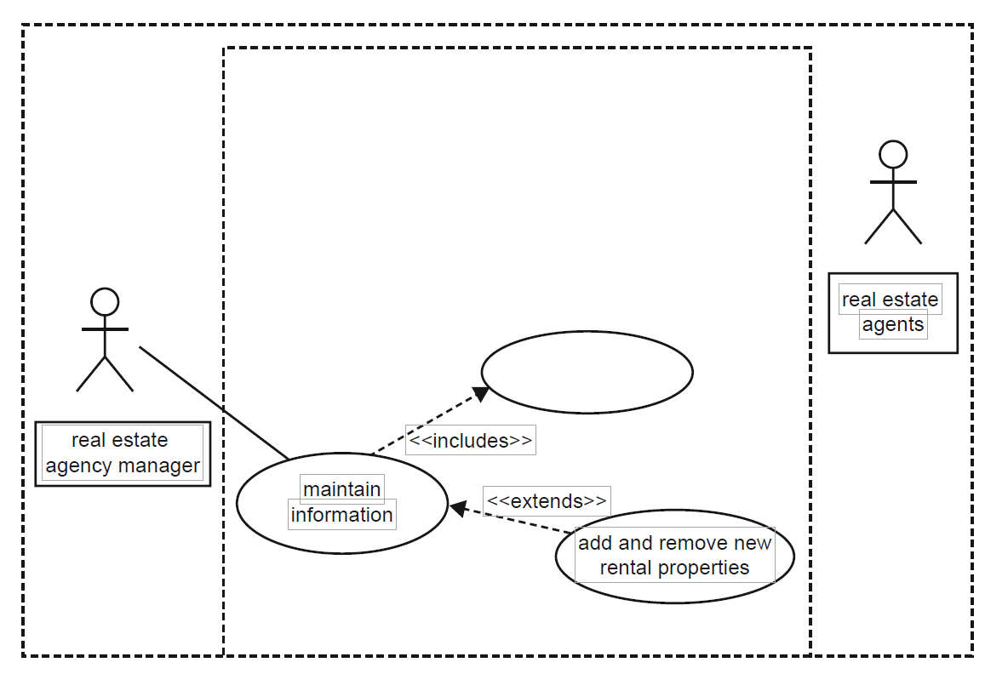
Question 6 (4 marks) 2013SD
An organisation publishes a monthly journal that it sells online to its members. The following use case diagram shows the organisation’s online purchasing system
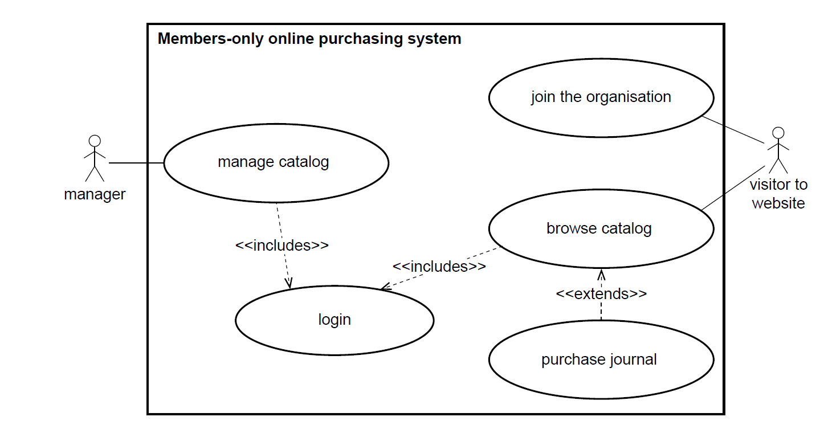
a. What does the diagram suggest that any visitor to the website can do?
b. What does the diagram suggest that the manager must do before the manager is able to manage the
c. Describe the difference between a visitor’s interaction with the ‘login’ use case and their interaction with the ‘purchase journal’ use case.
Question 3 2012SD
Ilma thinks that her non-computer-science colleagues might not understand technical diagrams, so she decides to include a use case diagram in her SRS. Most of the diagram is drawn below.
Based on the case study, complete the diagram by
a. labelling the un-named actor in the diagram
b. identifying the actions that this actor needs to carry out and appropriately labeling the empty use cases.
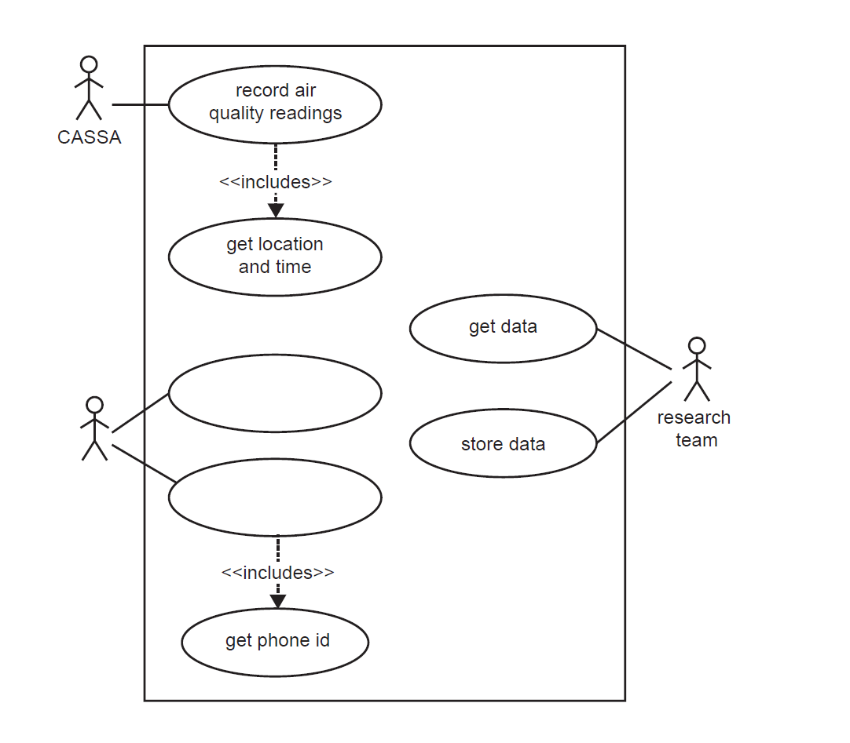
Some resources
http://www.batimes.com/articles/what-questions-do-your-diagrams-ask.html
http://www.uml-diagrams.org/use-case-diagrams-questions-answers.html
https://sourcemaking.com/uml/modeling-business-systems/external-view/constructing-use-case-diagrams

