HOMEWORK SUBMISSION INSTRUCTIONS:

SECTION A: Code for SECTION A should be saved in a file called myCatGUI.py
SECTION B: Code for SECTION B should be saved in a file called myCoding.py

Once complete, upload to Compass: Learning Task: Programming Tasks Week 6

SECTION A: (15 marks total)

Question 1:

8 marks: Create a GUI application based on the following mock-up:

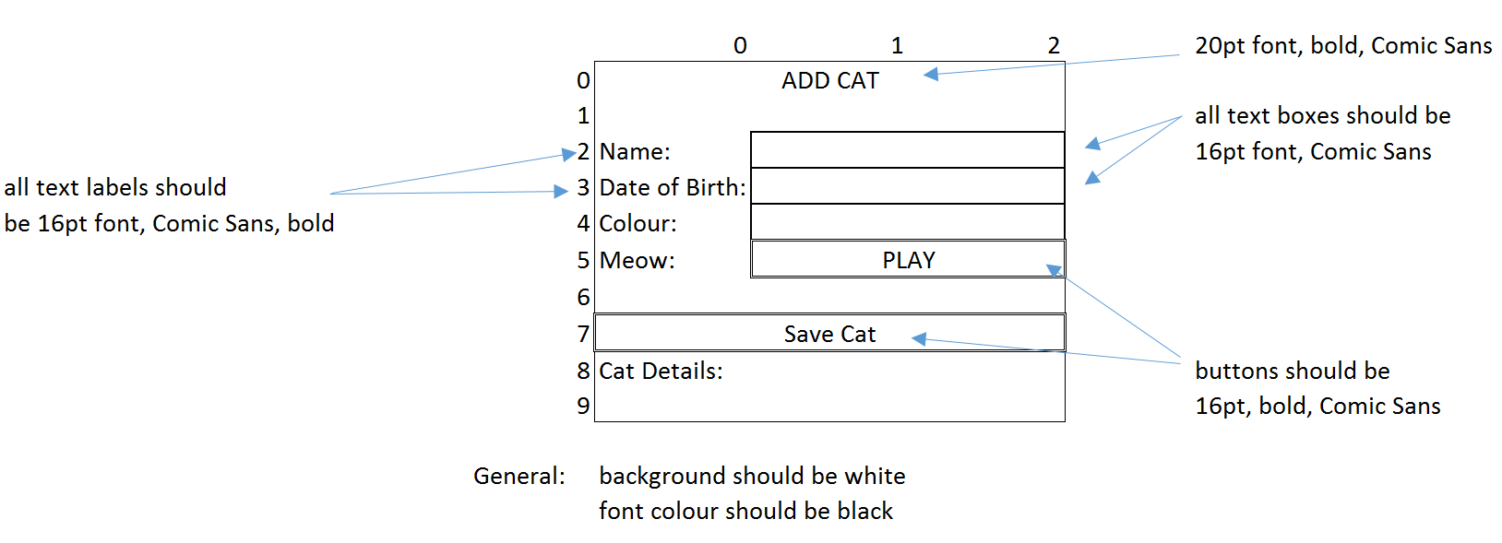
The numbers across the top and left represent columns and rows, respectively.

5 marks: Include the following functionality:
- The “save” button should change the text of the button to ‘Saved!’
  - It should display the contents of Name, Date of Birth and Colour to row 9, column 0, in a Label underneath the ‘Cat Details’ label seen in row 8.
- The “play” button should play a sound file of a cat meowing, looped 4 times. This has been provided for you to download from Compass in the resources folder.

2 marks: appropriate and meaningful internal documentation

SECTION B: (5 marks)

Question 2: (2 marks)

Create a function called fnMultiplyString. This function should take two arguments. The first argument should be a string, the second should be an integer.

The function should return the string passed in as an argument repeated a number of times, as determined by the integer.

For example, passing the first argument of “pie” and the second argument as 3 should produce:
piepiepie

Question 3: (3 marks)

Create a method called fnDisplayDate. This method should print the current date and time, formatted as follows:
Wednesday, March 2, 2016, 9:54 AM

NOTE: If you are unable to print all of the above date and time format, print what you can.

