Multiple Forms

We can use programs which switch between forms or use different forms for different purposes.

Eg

Splash form


Main Menu
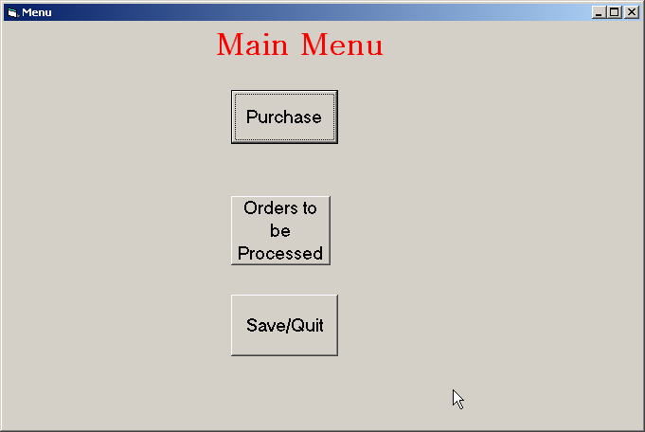

Data entry form
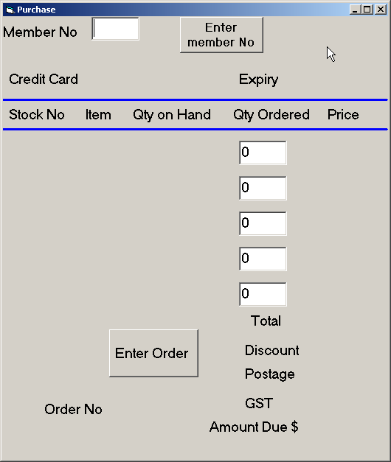

Output form

To switch between forms.

Hide the current form and show the next form
Me.Hide
Form2.Show

To create a new form, from the Project menu, select, new form.

If data ( variables) is to be passed from one form to another, modules can be used. The module is used to declare the variables and once the module is called, by entering the module name, the variables are available to all other forms.
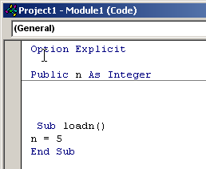
Project – New module

The module is then called from the first form
Private Sub cmd_start_Click()
loadn
msgbox( “ the value of n is “&str(n))
End Sub

N can then be used on all other forms and values stay from one form to another. This is particularly useful for declaring arrays which hold the data to be used in various forms.

Exercise:
Write a program with a splash screen and a menu screen and separate screens to
- Add new customers ( store details in an array ). Provide an automatic 3 digit unique Customer ID number.
- Display all customers ( in a list box) .
- Search for and display customers from a certain post code only

Extension: Give the user the choice of sorting by surname on the display screen. ( remember you will have more than one array to deal with.

