SOFTWARE DEVELOPMENT
UNIT 4 OUTCOME 1

REVISION NOTES

Unit 4 Outcome 1
Apply stages of the problem-solving methodology to produce a solution for use on a mobile device, which takes into account technical and legal requirements.

Key Knowledge

1. Stages of the problem-solving methodology

2. Types and characteristics of mobile computing devices, including PDAs, mobile phones, laptops, gaming consoles

3. Procedures and techniques for handling and managing files, including security, archiving, backing up and disposing of files

4. Methods of organising files to suit particular software needs, including serial access and random access

5. Ways in which file size, storage medium and organisation of files affect access of data

6. Characteristics of efficient and effective user interfaces

7. Factors affecting solution design, including user interface, user needs, processing efficiency, development time, technical specifications of mobile devices

8. Naming conventions for solution elements

9. Methods and techniques of expressing software designs

10. Forms and uses of data structures to organise and manipulate data, including two-dimensional arrays, stacks and queues

11. Syntax of a programming language

12. Validation techniques, including existence checking, range checking and type checking

13. Techniques for searching, including binary search, and techniques for sorting, including bubble sort and quick sort

14. Techniques for checking that coded solutions meet design specifications, including construction of test data

15. Purposes and characteristics of internal documentation

16. Forms and types of user documentation, including printed, online Internet site (forms) and quick start guide, tutorial, content sensitive help and manual (types)

17. Applications and purposes of utilities in a programming environment

18. Legal obligations of programmers

19. Security measures designed to protect the integrity and security of data and information

1. Stages of the problem-solving methodology

1. List the four activities involved in the ‘Development’ stage of the PSM

- __________________________ 2. ______________________________

3. __________________________ 4. ______________________________

2. Describe what occurs in the ‘Manipulation’ stage

_____________________________________________________________________

_____________________________________________________________________

_____________________________________________________________________

3. Explain how ‘Validation’ differs from ‘Testing’

_____________________________________________________________________

_____________________________________________________________________

_____________________________________________________________________

4. Explain what occurs during the ‘Documentation’ Activity

_____________________________________________________________________

_____________________________________________________________________

_____________________________________________________________________

5. Explain in which activity ‘internal documentation’ is created

_____________________________________________________________________

_____________________________________________________________________

_____________________________________________________________________

2. Types and characteristics of mobile computing devices, including PDAs, mobile phones, laptops, gaming consoles

1. Complete the table below giving a description of each device:

Device | Description
Personal Digital
Assistant
Mobile Phone
Laptop
Gaming Consoles

2. Discuss the differences between a PDA and a Mobile Phone

_____________________________________________________________________

_____________________________________________________________________

_____________________________________________________________________

3. Explain an advantage of a Laptop over a Mobile Phone

_____________________________________________________________________

_____________________________________________________________________

_____________________________________________________________________

4. Outline an advantage of a Mobile Phone over a Laptop

_____________________________________________________________________

_____________________________________________________________________

_____________________________________________________________________

3. Procedures and techniques for handling and managing files, including security, archiving, backing up and disposing of files

1. Besides usernames and passwords, discuss two security measures that can be used to protect files

_____________________________________________________________________

_____________________________________________________________________

_____________________________________________________________________

2. Explain how ‘Archiving’ differs from ‘Backing-Up’ files

_____________________________________________________________________

_____________________________________________________________________

_____________________________________________________________________

4. Outline a strategy that organisations could follow to dispose of files securely

_____________________________________________________________________

_____________________________________________________________________

_____________________________________________________________________

5. Complete the table below indicating the file management activity being describe:

Archiving Backing-up Disposal Security

Procedure | Activity
Karen prints off all records at the end of the financial year, deletes all files and keeps the hard copies in a filing cabinet
Jessica moves files to the recycle bin, empties the bin then runs a utility program that erases the files from the HDD
Lauren uses a RAID system to store a file on multiple hard drives
At the start of every day Charlie copies all her school work from her laptop to a USB and leaves the USB at home in her room

4. Methods of organising files to suit particular software needs, including serial access and random access

1. Describe the term ‘Serial Access’

_____________________________________________________________________

_____________________________________________________________________

_____________________________________________________________________

2. Describe the term ‘Random Access’

_____________________________________________________________________

_____________________________________________________________________

_____________________________________________________________________

3. Explain what each record in a ‘Random File’ has in common

_____________________________________________________________________

_____________________________________________________________________

_____________________________________________________________________

4. Outline one advantage of ‘Random’ over ‘Serial’

_____________________________________________________________________

_____________________________________________________________________

_____________________________________________________________________

5. Outline one advantage of ‘Serial’ over ‘Random’

_____________________________________________________________________

_____________________________________________________________________

_____________________________________________________________________

5. Ways in which file size, storage medium and organisation of files affect access of data

David has created a program that will be accessed frequently throughout the day by around 100 staff. When deciding where to locate the database files he has to choose between a portable hard drive, magnetic tape and a solid state drive.

1. Recommend to David which storage medium would be most appropriate. Justify your answer

_____________________________________________________________________

_____________________________________________________________________

_____________________________________________________________________

_____________________________________________________________________

_____________________________________________________________________

Garry’s Graphics have offices located in both Melbourne and Perth. They store all the data as a serial file on a server in the Melbourne office. Each record in the file is around 200 MB and a file consists of around 100 records. A virtual private network (VPN) set up connecting the two offices.

2. Outline problems that Garry’s Graphics might face when accessing the data

_____________________________________________________________________

_____________________________________________________________________

_____________________________________________________________________

_____________________________________________________________________

_____________________________________________________________________

Phil wants to download a 500 MB movie. His maximum internet download speed is 4 Mbps

3. Calculate how long it will take to download the movie

_____________________________________________________________________

6. Characteristics of efficient and effective user interfaces

1. Explain how the use of ‘White Space’ help with the effectiveness of a user interface

_____________________________________________________________________

_____________________________________________________________________

_____________________________________________________________________

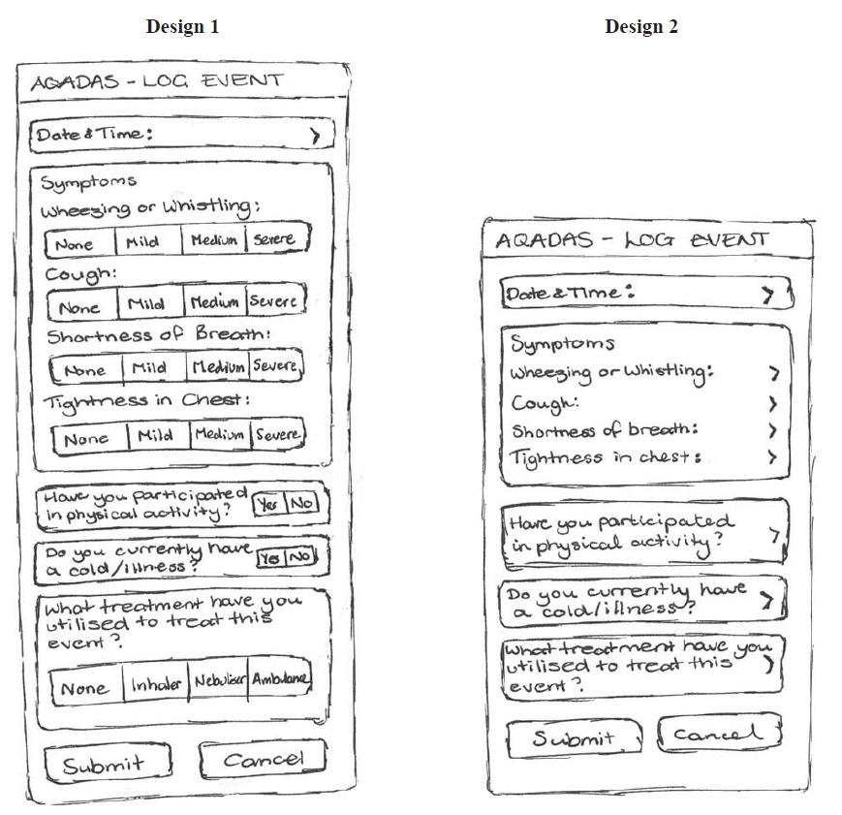

Above are two designs for a mobile phone App

2. Discuss the advantage of each design

_____________________________________________________________________

_____________________________________________________________________

_____________________________________________________________________

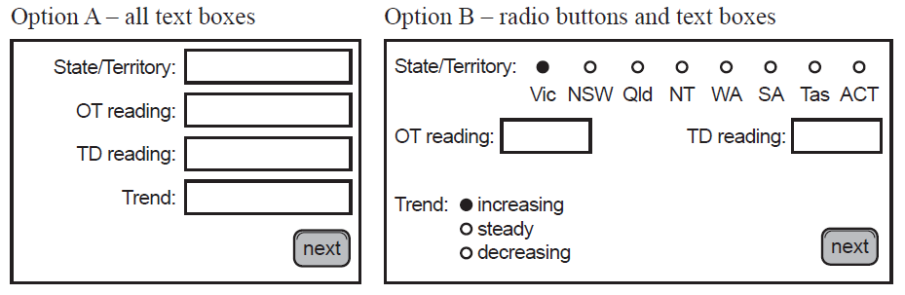

3. Identify which design is more effective and identify which design is more efficient. Justify your answers

_____________________________________________________________________

_____________________________________________________________________

7. Factors affecting solution design, including user interface, user needs, processing efficiency, development time, technical specifications of mobile devices

Ben is developing an application to be used on an IPhone 5.

1. Discuss the factors that will affect Ben’s design

_____________________________________________________________________

_____________________________________________________________________

_____________________________________________________________________

2. Explain how a solutions designed for a touch screen device will differ from that of a traditional keyboard & mouse device

_____________________________________________________________________

_____________________________________________________________________

_____________________________________________________________________

Karen has been told that she needs to design a solution in a hurry. She has been told to fully design the user interface but don’t overly worry about if the algorithms are prefect at this stage.

3. Discuss when it would be appropriate to design a solution like this
_____________________________________________________________________

_____________________________________________________________________

_____________________________________________________________________

Jade is developing a solution for Hanson’s Truck Group, that will used by drivers as they are delivering goods

4. Explain how the need of the users may affect the design of the solution

_____________________________________________________________________

_____________________________________________________________________

8. Naming conventions for solution elements

Lauren is developing a data dictionary and object descriptions for a software development project. Part of the dictionary is shown below:

Data Dictionary
strSurname | String | Contains the name of the each customer’s surname
Object Descriptions
frmMain | Form | Form that will open on start-up

1. Identify three conventions that have been followed in the above naming convention

_____________________________________________________________________

_____________________________________________________________________

_____________________________________________________________________

2. Discuss how the above naming convention will assist in the ‘development’ of the solution

_____________________________________________________________________

_____________________________________________________________________

_____________________________________________________________________

3. Discuss how the above naming convention will assist in the ‘maintenance’ of the solution

_____________________________________________________________________

_____________________________________________________________________

_____________________________________________________________________

4. Explain how the use of ‘CamelCase’ might assist the project

_____________________________________________________________________

_____________________________________________________________________

9. Methods and techniques of expressing software designs

1. Explain how ‘pseudocode’ and ‘algorithms’ are related

_____________________________________________________________________

_____________________________________________________________________

_____________________________________________________________________

2. Identify the output of the following algorithm if the value 2 was input into variable A

Begin
Input A
While A < 10
A = A * 2
End While
Display A
End

_____________________________________________________________________

Robert needs to write an algorithm that will allow him to input two numbers. A loop will begin if the first number is larger than the 2nd number. The first number will have 2 added to it, the 2nd number is doubled. After the loop is completed the 2 two numbers will be displayed – with the larger number displayed first.

3. Create, using pseudocode, the algorithm required

10. Forms and uses of data structures to organise and manipulate data, including two-dimensional arrays, stacks and queues

1. Label each diagram showing the data structure represented

- _______________ B. _______________ C. __________________

2. Explain when using a ‘Two-dimension array’ is suitable

_____________________________________________________________________

_____________________________________________________________________

_____________________________________________________________________

Karen is creating an App for a restaurant to manage bookings. When a customer makes a booking they are added to the waiting list. After they have finished their meals the waiter will remove them from the list.

3. Identify the most appropriate data structure to use for the App. Justify your answer

_____________________________________________________________________

_____________________________________________________________________

_____________________________________________________________________

Billy is creating a program that will allow the user to undo the last action they performed

4. Identify the most appropriate data structure to use for the undo function. Explain why this data structure is appropriate

_____________________________________________________________________

_____________________________________________________________________

_____________________________________________________________________

11. Syntax of a programming language

1. Define the term ‘Syntax’

_____________________________________________________________________

_____________________________________________________________________

_____________________________________________________________________

2. Explain how the pseudocode of a solution differs from the syntax

_____________________________________________________________________

_____________________________________________________________________

_____________________________________________________________________

3. Explain what is meant by a ‘Syntax Error’

_____________________________________________________________________

_____________________________________________________________________

_____________________________________________________________________

4. Discuss two ways a syntax error in a program can be identified

_____________________________________________________________________

_____________________________________________________________________

_____________________________________________________________________

5. Explain how a ‘syntax error’ differs from a ‘logic error’

_____________________________________________________________________

_____________________________________________________________________

_____________________________________________________________________

12. Validation techniques, including existence checking, range checking and type checking

1. Explain the term ‘validation’

_____________________________________________________________________

_____________________________________________________________________

_____________________________________________________________________

2. Complete the table below by identifying the most appropriate validation check to use:

Scenario | Validation Technique
Sophie is creating a program where the mobile phone number of a customer is required
Jack is writing an error handling function that needs the input to be entered to be a string
Olivia needs a program that needs the users to enter an amount greater than $1.00
Geoff is creating a solution that will read in a User ID then check to see if the ID matches an ID already in the solution database
Louise has written code that will enforce the user to enter 2 decimal places when entering currency values
SuperApps has created an App where the user can only select a value from the existing drop down list given

3. Explain how validation can occur either through the user interface or in the code of a program. Give examples to illustrate your answer

_____________________________________________________________________

_____________________________________________________________________

_____________________________________________________________________

13. Techniques for searching, including binary search, and techniques for sorting, including bubble sort and quick sort

Peter wants to perform a binary search on file containing the details of products. He plans to search for a product using the product name.

1. Explain what needs to done before Peter can perform the search

_____________________________________________________________________

_____________________________________________________________________

_____________________________________________________________________

2. Outline the process of how a binary search works

_____________________________________________________________________

_____________________________________________________________________

_____________________________________________________________________

3. Explain why a ‘Quick Sort’ is preferred to a ‘Bubble Sort’ when dealing with large data files

_____________________________________________________________________

_____________________________________________________________________

_____________________________________________________________________

4. Outline two reasons why a programmer may still prefer to use a ‘Bubble Sort’

_____________________________________________________________________

_____________________________________________________________________

_____________________________________________________________________

14. Techniques for checking that coded solutions meet design specifications, including construction of test data

Jason is design a program that will check if each pie cooked in the bakery is at least 500 grams. He has created the following algorithm that will be used to perform the calculation:

Begin
Read Weight
If Weight > 500 Then
Return Acceptable
Else
Return Unacceptable
End If
End

1. Complete the table below showing both the expected and actual results

Test Data | Expected Result | Actual Result
499
500
501

Lucy is developing a program for a medical centre. When patients visit a doctor they are billed on the time they stay with the doctor. Visits 15 minutes or under are consider short consultations and visits over 15 minutes are considered long consolations. Lucy has developed the following pseudocode:

Begin
Read First Pateint Record
For Visit = 1 to NumofPatients
DeadlineTime = StartTime + 15
If DeadlineTime <> - 1 Then
If CurrentTime > DeadlineTime Then
Consulatation = Long
Else
Consultation = Short
End If
End If
Read Next Patient Record
End Loop
End

2. Complete the test table including test data and the reason why the test data was selected

Test Data | Reason

15. Purposes and characteristics of internal documentation

1. Explain the purpose of ‘Internal Documentation’

_____________________________________________________________________

_____________________________________________________________________

_____________________________________________________________________

2. Discuss the effect internal documentation has on processing time

_____________________________________________________________________

_____________________________________________________________________

_____________________________________________________________________

3. Discuss when internal documentation should be used in the code

_____________________________________________________________________

_____________________________________________________________________

_____________________________________________________________________

4. Explain how ‘Internal Documentation’ differs from ‘User Documentation’

_____________________________________________________________________

_____________________________________________________________________

_____________________________________________________________________

5. Identify which of the lines of code below are internal documentation

1. ‘*Developed by the Hound Dog Group 2013
2. Dim A as Integer
3. ‘*Calculate if students passes or fails
4. If A > 49 Then
5. Result = Pass
6. Else
7. Result = Fail
8. End If

_____________________________________________________________________

16. Forms and types of user documentation, including printed, online Internet site (forms) and quick start guide, tutorial, content sensitive help and manual (types)

1. List two advantages of printed documentation over online documentation

_____________________________________________________________________

_____________________________________________________________________

2. List two advantages of online documentation over printed documentation

_____________________________________________________________________

_____________________________________________________________________

3. Complete the following table describing the following user documentation

User Documentation | Description
Quick Start Guide
Tutorial
Content Sensitive Help
User Manual

4. Explain how a Tutorial differs from Content Sensitive Help

_____________________________________________________________________

_____________________________________________________________________

_____________________________________________________________________

17. Applications and purposes of utilities in a programming environment

1. Define the term ‘Integrated Development Environment (IDE)’

_____________________________________________________________________

_____________________________________________________________________

_____________________________________________________________________

2. Explain how a ‘compiler’ differs from an ‘IDE’

_____________________________________________________________________

_____________________________________________________________________

_____________________________________________________________________

3. Explain what is meant by ‘Utilities in a Programming Environment’. Give examples to illustrate your answer

_____________________________________________________________________

_____________________________________________________________________

_____________________________________________________________________

4. Identify if ‘Utilities’ help with the efficiency or effectiveness of developing a solution. Justify your answer

_____________________________________________________________________

_____________________________________________________________________

_____________________________________________________________________

18. Legal obligations of programmers

1. Explain how the Charter of Human Rights & Responsibilities Act (Vic) 2006 may affect software developers?

_____________________________________________________________________

_____________________________________________________________________

_____________________________________________________________________

2. Complete the table below identifying the appropriate law that may be breached:

Scenario | Law
David has decided to use code from another programmer in the solution he is developing
Mornington Peninsula Council has decided not to use any validation techniques on the Internet form it uses to allow residents to pay their rates online
Jessica, a student, created a new smart phone App that displayed the address and mobile number of all her class mates
Bank of Frankston has a function on its customer App that sends data back relating to what other financial applications a customer uses on their smart phone
Funk nightclub sent SMS messages to members on their VIP list without first getting consent of the members
Michael, a dentist from Melbourne, has not enable the username and password function for his IPad that he uses to store patient records

3. Discuss two areas that are not covered under the Copyright Act

_____________________________________________________________________

_____________________________________________________________________

_____________________________________________________________________

19. Security measures designed to protect the integrity and security of data and information

1. Complete the table below for each of following security measures:

Measure | Description | Threat Stoped
Username & Password
Malware Protection
Encryption
Staff
Training
Uninterrupted Power Supply
Back-up
Strategy
Physical
Security

2. Explain why it is important for an organisation to have both a firewall and anti-virus protection installed to protect data and information

_____________________________________________________________________

_____________________________________________________________________

_____________________________________________________________________

