PHP: Meal Cost App

Bonnie Brightlight often goes out for tea or gets takeaway. She forgets her calculator most times but never her phone. It’s important for her to know the total before she orders. This app allows the user to input the costs for 3 choices from a takeaway menu or 3 courses at a restaurant.

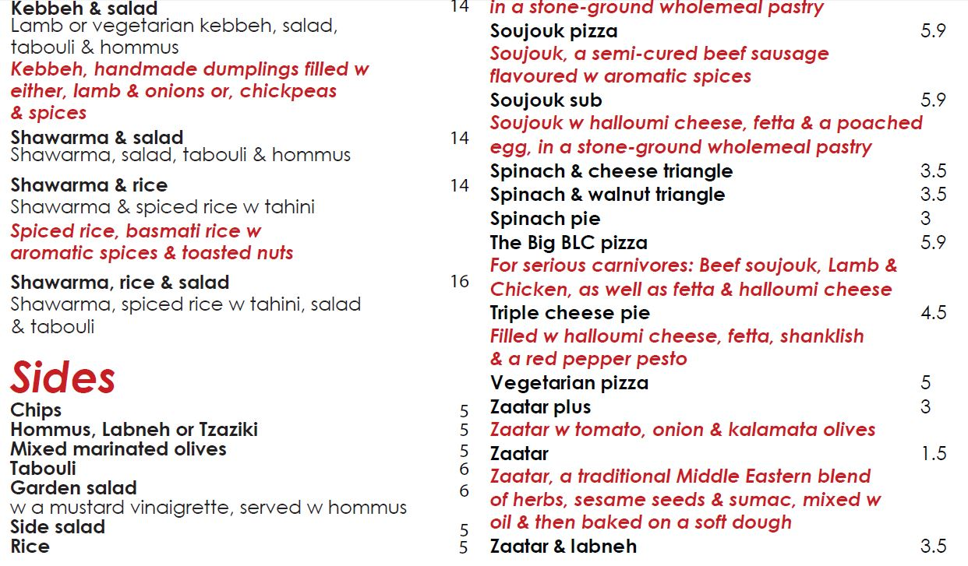

FR01 | Get costs for choice 1, choice 2 and choice 3 from the user
FR02 | Display total cost of meal and the average cost of the 3 courses
FR03 | Range validation for all numeric input; existence validation and datatype validation
FR04 | Display a 15% tip for US users
FR05 | Allow user to return to main form

