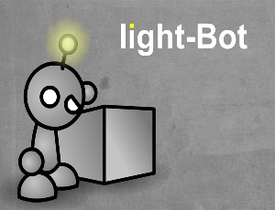
Problem Solving – Light Bot

Start Internet Explorer. Go to http://cache.armorgames.com/files/games/light-bot-2205.swf

Ignore the Advert… once the screen loads, click on “Play”

Click on “New Game” and press Spacebar to begin.

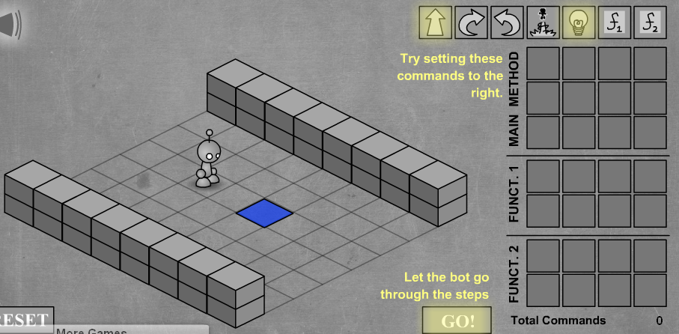

The object is to move the Bot using the commands to the Blue Square, then light it up with the light bulb.

If you haven’t already worked out how to complete level 1, drag the Arrow into the first box, drag a second Arrow and finally drag a Light Bulb into the third square. Like this:

Once you have dragged the commands to make up your program, click the “GO” button to see if you are correct.

If you make a mess of the instructions, just drag the incorrect ones away and drag over the correct ones.

Clicking “RESET” will remove all your commands.

If you are correct, you will move on to the next level. There are 12 levels to complete.

Level 6 – Functions

If you need to use a group of commands you can place them in a Function. That Function can then be called up from the main set of commands. Here’s one way to do level 6:

This box (Function 1) calls up all these commands

If you see a set of moves which is repeated, place them in a Function, and call up the Function from the main set of commands.

For Level 7 you will need to use 1 Function. Here is how you should start off Level 7:

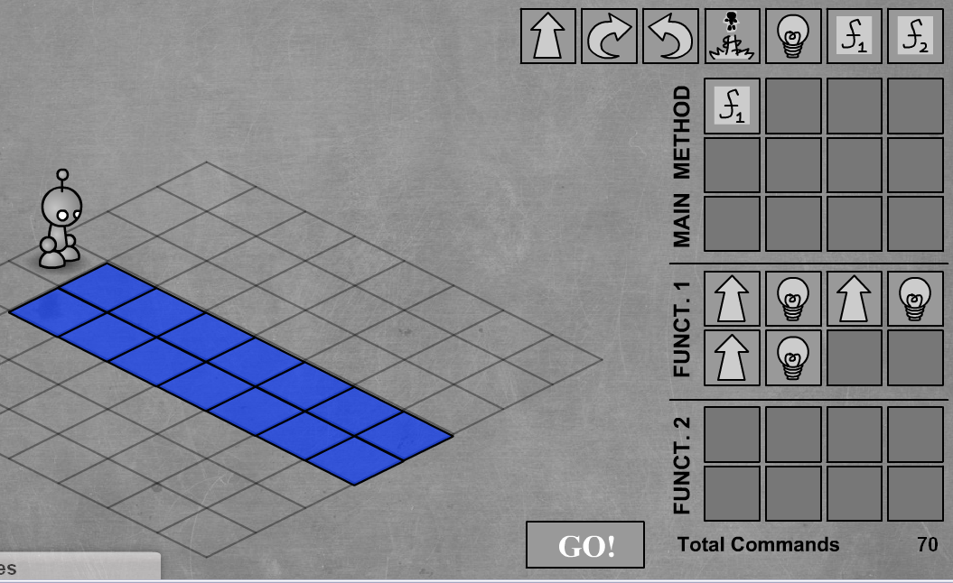

There are 12 levels all together. If you can get past Level 8 you are doing well. Level 9 is a tough one! In Level 10, go for the left square first. Get to level 12 and you are at Genius Level!!

