Software Development 2011 Unit 3 – Outcome 2 (60 marks)

Name: _____________________________

Description: Represent a software design and apply a range of functions and techniques using a programming language to develop a prototype solution to meet a specific need.

Criteria for assessment | Allocated Marks |  | Comments
Design of the software module
Write a set of criteria for evaluating the efficiency and effectiveness of the solution.  effectiveness  - buttons do what they claim to  - accurate spelling and punctuation  - Be easy to use  - Little training required  easy –to-understand help  - Intuitive design – it should be obvious how to do something even for a beginner.  - Easy to read  - simple language  - Avoid words where possible and use icons  - good colour contrast  - Avoid background images  - Be consistent, predictable  - What an icon means must not change from page to page  - The same theme (colours, typefaces, text formatting) should be used throughout a document  - Don’t change things for the sake of change  - follows standard conventions  - Conventions are used to reduce the amount of learning users need to invest in a product. They expect each product to follow standard behaviour  - e.g. The leftmost menu is ‘File’ and the rightmost is ‘Help’  - The software version is always found under Help > About |  |  | / 3
`Efficiency  Easy-to-find  Most commonly-used tasks should be easiest to find, not hidden deep-down in menus  Give users alternative ways of doing things (e.g. Ctrl+C shortcut, a “Copy” in the toolbar, “Copy” menu item, a “Copy” action in the right-click context menu.  Conventions are used to reduce the amount of learning users need to invest in a product. They expect each product to follow standard behaviour  To evaluate time efficiency, you could look at the time taken to:  - start the system  - enter data  - process data  - produce output  - communicate information |  |  | /2
Data types and structures are accurately described using appropriate design methods: Data Dictionary and Data Structure Diagram  Data element name (e.g. a field's name, like "Surname")  * Short description  * Data type (characters, numeric, etc.), size  * Null value allowed: Null or non-existing data value may or may not be allowed for an element.  * Default value: Data element may have a default value. Default value may be a variable, like current date and time of the day  * Allowed values and validation  * Whether the field is a key field.  * Rules used in calculations producing the values are usually written here.  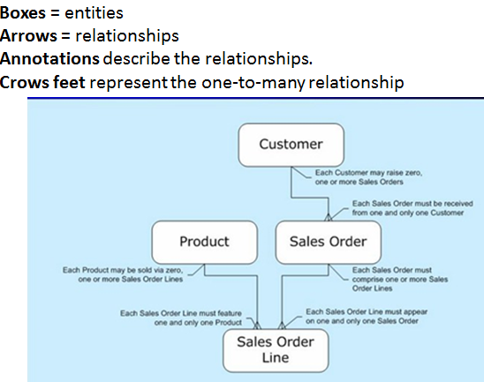 |  | / 10
Solution requirements are accurately and clearly represented in a detailed algorithm using pseudo-code.  BEGIN  Display Form Admin Screen  If Queen Bee price is changed in Form Admin then  Queen Bee price in Form Customer = Queen Bee price in Form Admin  End if  If Worker Bee price is changed in Form Admin then  Worker Bee price in Form Customer = Worker Bee price in Form Admin  End if  If Discount is selected then  Apply Discount to Discount in Form Customer  Else  No Discount applied  End if  If Half-Price Postage is selected then  Apply Half-Price to Half-Price Postage in Form Customer  Else  No Half-Price Postage applied  End if  END  BEGIN  Display Form Customer Screen  Get Firstname  Get Surname  Get Address  Get State  Get Postcode  If Certain Postcode then  Postal Cost = 0  Else if Certain Postcode then  Postal Cost = Variable rates  End if  Get Queen Bee Quantity  Queen Bee Subtotal = price of Queen Bees times quantity  Worker Bee Subtotal = price of Worker Bees times quantity  Surcharge = Subtotal plus surcharge percentage of Queen Bees  Total = Queen Bee Subtotal plus Worker Bee Subtotal plus Surcharge plus Postal Cost  Grand Total = Total minus Discount  Display Grand Total  END |  | / 5
Development of the software module
Manipulation - The prototype solution is efficiently coded with all data types and data structures being appropriately used and integrated.  2 d array |  | / 20
Documentation - Internal documentation is complete, contains relevant program comments, and is clearly stated and well formatted. |  | / 5
The solution meets specifications as stated in the SRS |  | / 10
Testing/Validation - An appropriate range of test data is expressed in a testing table, with both expected and actual output stated. All tests are successfully applied to enable the performance of the prototype solution to be verified.  - carrying out functions to see if they exist and work as expected  - timing how long an operation takes  - counting errors recorded in an error log  - visually inspecting output for quality  - counting and assessing incidents of failure or downtime  - stress-testing the system or abusing it in ways that would be expected in real-life operation  - using the system to its stated capacity  - using the system in conjunction with another system to see if data and hardware are compatible  - attempting to break into the system or get access to secured data  - attempt to configure the system to different users, or add modules, or change the way it works to suit new need |  | / 5
Total : |  | / 60

