VCE SOFTWARE DEVELOPMENT – UNIT 4 OUTCOME 2

The Ultranet has been developed by the Victorian Department of Education and Early Childhood Development (DEECD) as a “protected” networking space for students, parents and students to use.
Students will be able to create a learning portfolio and use online communication tools such as wikis, blogs and discussion boards. They will be able to collaborate, communicate and create with students from within their school and across Victorian government schools.
Parents will be able to access the Ultranet providing another way for them to support their child at school. They can view information that will help them keep up-to-date with their child’s learning. Parents will see test results, teacher feedback, homework activities, attendance and timetables. Information about each child will build up over time, creating an ongoing record that will travel with them from year to year and school to school.
The Ultranet is a secure, closed website. No health, welfare or contact information will be displayed on the site. The only personal information that will be displayed to other students, about a student will be their name and photograph (parents may request that their child’s photograph not be displayed).
The Ultranet is accessible at a parent’s own convenience, from any computer with internet access, and at a time that suits them. They can also log into the Ultranet with their child and discuss their learning progress together. This means they don’t have to wait for formal review sessions with teachers because the Ultranet allows you to recognise their child’s achievements and address learning or schooling issues as they arise.
Question One
The following network diagram demonstrates the physical structure of the Ultranet. – Adapted from VITTA Unit 4 Test 2011
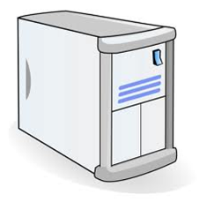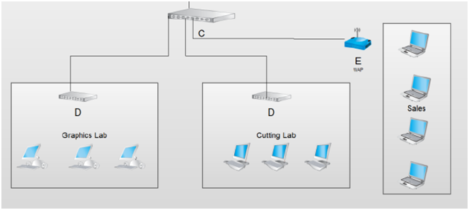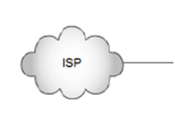
Ultranet Servers

School Server

Other Schools

Identify the following components of the network diagram below:
B: Modem
C: Ethernet Switch
E: Wireless Access Point
(3 marks)
Question Two
- You have been asked to evaluate the security of the school network at point E. List two security features you would consider essential to pass your security evaluation at point E?
The simplest and most direct methods would include
• changing the default SSID and password to secure, non-guessable and non-personal strings.
• use WEP or WPA encryption.
• use WAP firewall functions to enable MAC address for your own hardware only.
• use security monitoring software such as ZoneAlarm to watch for known intrusive activity.
(2 marks)
- Discuss one other technique you could use to assess the level of security provided by the school network.
A packet sniffer to detect malware and spyware that may be active on the network.
OR
Employ a professional hacker to test the security of the network and identify any vulnerabilities.
(2 marks)
Question Three
The Ultranet is a very large project and in order to keep politicians happy you have been given a very limited timeframe to complete the software and make the Ultranet live. You have completed some basic testing and all seems OK. It’s time for training.
a. Describe a method of training that would be suitable to train all 20,000 teachers across the Moon Schools. Justify your selected training method.
In this situation the “Train the Trainer” technique would be appropriate. This is where a selected group of teachers will become trained to become experts in the software and then train the other teachers in their school. This will be the best technique for this situation as there is a large number of teachers and this technique is cheaper than training everyone with professionals.
(2 Marks)
b. Suggest three ways to evaluate the how successful the training technique has been. Again consider effectiveness and efficiency
Test the trainees at the end to see if they can now use the features of the ultranet.
Survey trainees on how effective they found the Ultranet training
Calculate the cost of the training and see if it has come in under budget.
Any other suitable suggestions
(3 Marks)
DEECD decided that parents will need to be educated about the use of the Ultranet and how to use it. They produce a 296 page user guide describing all the components in detail.
- Give two criteria you would use to evaluate this user documentation.
Does the users guide provide too much information for the needs of the parents?
Are the parents able to find the information they need in a reasonable amount of time?
How often do parents consult the user guide?
Are parents asking questions about the Ultranet that should be in the user guide?
(2 marks)
- Describe one problem you can see with the parent user guide described above and what should be done to address this problem.
It is unrealistic to think parents have the time or inclination to read 296 pages. The user guide needs to be simplified into a concise version, or parents need to be provided a quick start guide.
(2 Marks)
- Complete the table below showing two other groups that will require documentation and the criteria you would use to evaluate the suitability of the documentation.
Group of Users | Documentation Type | Evaluation Criteria
Students | on line help guide | Is the help guide easy to use?
teachers | Tutorial | Do the tutorials that are being used cover the necessary tasks teachers will use the Ultranet for?
(4 Marks)

Question Four
Complete the following table outlining the Criteria and Methods of evaluation.
usability, reliability, robustness, attractiveness, efficiency, completeness, accuracy, stability, compatibility,timliness
Goal | Evaluation Criterion(s) | Strategy for the evaluation | When should the evaluation be undertaken. (many of these answers will be the same)
Guaranteed to work on any network. | Compatibility | Run the Ultranet from a variety of network setups across different schools. | Immediately after the Ultranet is live for schools to access
Student attendance is displayed accurately at all times and updated daily. | Accuracy,  Timeliness | Review a large number of student’s attendance records and check they have been updated that day and check for errors against the school roll. | Three weeks after implementation
Provide instant, up to date information to parents about their child’s progress, rather than waiting for a school report | timeliness | Survey parents before and after the implementation of the Ultranet to establish their use and their opinions on the information presented | Three months after implementation
Allow personal learning plans for students at risk to be completed by year level coordinators far more quickly. | efficiency | Observe and record the time a year level coordinator spends creating a personalized learning plan for a student at risk and compare to the time taken before the implementation of the Ultranet. | 3 Months after implementation
The software and system should have down time of less than two hours per month | reliability | Check error logs of down time and ensure it is less than two hours per month | Three months after implementation
Teachers software should in intuitive to use and require little support on use. | usability | Survey teachers on their use and opinions of the ultranet | Three months after implementation
(10 marks)
Question Five
The login screen for the Ultranet appears below.
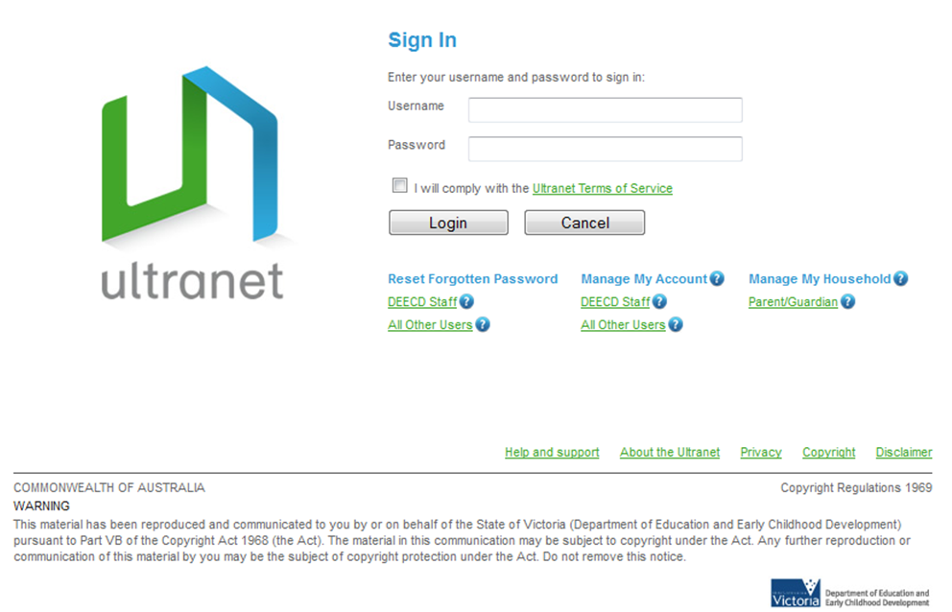
- Describe the importance of each of the three circled features in terms of security and managing any conflicts that may occur between users and DEECD. Hint: the “terms of service” is a “code of ethics” that applies to the Ultranet
A user name and password ensure the security of the site, helping to protect user data.
The terms of service must be agreed to and outlines the acceptable use and consequences of breaching the terms of service.
There is easy access to the privacy and copyright policies that must be followed when using the Ultranet
(3 Marks)
- Some parents are concerned about bullying that may occur through the discussion forum components of the website. Outline two strategies that can be used to both prevent bullying on the Ultranet and how to deal with any bullying that does occur on the Ultranet.
All users must login so there is no anonymous postings
Teachers should moderate all postings (or approve before they are posted)
There should be a “report comment” button so students can report bullying
All comments should be saved so that they can be referred to if there is an allegation of bullying.
(2 Marks)
- You have been asked by the DEECD to complete the project within budget however you are worried about the recommendations that have been outlined in the Privacy Impact Statement that was completed about the Ultranet. What should you do as a programmer to address this?
While addressing the privacy issues will add extra cost and may go over budget ,which may be ethically wrong, you are bound by law to comply with the Information Privacy Act (2000) so should implement the privacy features that are needed.
See VCAA 2008 Question 8
(2 Marks)
Below is an extract of the Ultranet terms of service:
“The only purpose for which teachers should use student data from the Ultranet is when it is necessary to enable the teacher to fulfill their official teaching or pastoral care duties to that student.”
- Mr Borris the maths teacher and is approached by his good friend Gary at the pub one evening asking him to look up how his son’s grades for all of his classes. Gary has not got custody of his son so does not have access to the Ultranet. He is concerned his son’s mother has mental health issues and is not taking his son to school. Discuss the ethical considerations that Mr Borris has to make and justify what you would do in Mr Borris’s situation.
Mr Borris will want to help out his friend Gary and may not see any harm in providing a student’s father with data. However, the terms of service clearly state that teachers should only use student data for their official teaching duties. As Mr Borris only teaches maths he should not be discussing or hand over information about other classes to Gary.
(2 Marks)

TOTAL 40 MARKS

