VCE SOFTWARE DEVELOPMENT – UNIT 4 OUTCOME 2

The Ultranet has been developed by the Victorian Department of Education and Early Childhood Development (DEECD) as a “protected” networking space for students, parents and students to use.
Students will be able to create a learning portfolio and use online communication tools such as wikis, blogs and discussion boards. They will be able to collaborate, communicate and create with students from within their school and across Victorian government schools.
Parents will be able to access the Ultranet providing another way for them to support their child at school. They can view information that will help them keep up-to-date with their child’s learning. Parents will see test results, teacher feedback, homework activities, attendance and timetables. Information about each child will build up over time, creating an ongoing record that will travel with them from year to year and school to school.
The Ultranet is a secure, closed website. No health, welfare or contact information will be displayed on the site. The only personal information that will be displayed to other students, about a student will be their name and photograph (parents may request that their child’s photograph not be displayed).
The Ultranet is accessible at a parent’s own convenience, from any computer with internet access, and at a time that suits them. They can also log into the Ultranet with their child and discuss their learning progress together. This means they don’t have to wait for formal review sessions with teachers because the Ultranet allows you to recognise their child’s achievements and address learning or schooling issues as they arise.
Question One
The following network diagram demonstrates the physical structure of the Ultranet. – Adapted from VITTA Unit 4 Test 2011
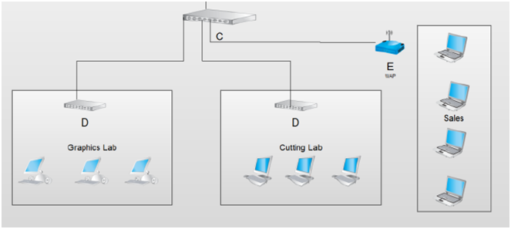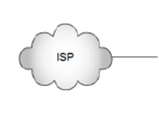
Ultranet Servers

School Server

Other Schools

Identify the following components of the network diagram below:
B:
C:
E:
(3 marks)
Question Two
- You have been asked to evaluate the security of the school network at point E. List two security features you would consider essential to pass your security evaluation at point E?

(2 marks)
- Discuss one other technique you could use to assess the level of security provided by the school network.

(2 marks)
Question Three
The Ultranet is a very large project and in order to keep politicians happy you have been given a very limited timeframe to complete the software and make the Ultranet live. You have completed some basic testing and all seems OK. It’s time for training.
a. Describe a method of training that would be suitable to train all 20,000 teachers across the Moon Schools. Justify your selected training method.

(2 Marks)
b. Suggest three ways to evaluate the how successful the training technique has been. Again consider effectiveness and efficiency

(3 Marks)
DEECD decided that parents will need to be educated about the use of the Ultranet and how to use it. They produce a 296 page user guide describing all the components in detail.
- Give two criteria you would use to evaluate this user documentation.

(2 marks)
- Describe one problem you can see with the parent user guide described above and what should be done to address this problem.

(2 Marks)
- Complete the table below showing two other groups that will require documentation and the criteria you would use to evaluate the suitability of the documentation.
Group of Users | Documentation Type | Evaluation Criteria
(4 Marks)

Question Four
Complete the following table outlining the Criteria and Methods of evaluation.
usability, reliability, robustness, attractiveness, efficiency, completeness, accuracy, stability, compatibility,timliness
Goal | Evaluation Criterion(s) | Strategy for the evaluation | When should the evaluation be undertaken. (many of these answers will be the same)
Guaranteed to work on any network.
Student attendance is displayed accurately at all times and updated daily. | Accuracy,  Timeliness
Provide instant, up to date information to parents about their child’s progress, rather than waiting for a school report
Allow personal learning plans for students at risk to be completed by year level coordinators far more quickly. |  | Observe and record the time a year level coordinator spends creating a personalized learning plan for a student at risk and compare to the time taken before the implementation of the Ultranet. | 3 Months after implementation
The software and system should have down time of less than two hours per month
Teachers software should in intuitive to use and require little support on use.
(10 marks)
Question Five
The login screen for the Ultranet appears below.
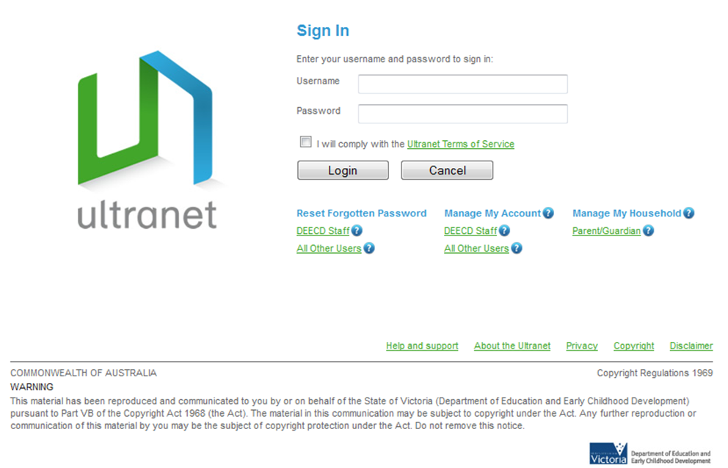
- Describe the importance of each of the three circled features in terms of security and managing any conflicts that may occur between users and DEECD. Hint: the “terms of service” is a “code of ethics” that applies to the Ultranet

(3 Marks)
- Some parents are concerned about bullying that may occur through the discussion forum components of the website. Outline two strategies that can be used to both prevent bullying on the Ultranet and how to deal with any bullying that does occur on the Ultranet.

(2 Marks)
- You have been asked by the DEECD to complete the project within budget however you are worried about the recommendations that have been outlined in the Privacy Impact Statement that was completed about the Ultranet. What should you do as a programmer to address this?

(2 Marks)
Below is an extract of the Ultranet terms of service:
“The only purpose for which teachers should use student data from the Ultranet is when it is necessary to enable the teacher to fulfill their official teaching or pastoral care duties to that student.”
- Mr Borris the maths teacher and is approached by his good friend Gary at the pub one evening asking him to look up how his son’s grades for all of his classes. Gary has not got custody of his son so does not have access to the Ultranet. He is concerned his son’s mother has mental health issues and is not taking his son to school. Discuss the ethical considerations that Mr Borris has to make and justify what you would do in Mr Borris’s situation.

(2 Marks)

TOTAL 40 MARKS

