Letter Frequency Counter
Mark Kelly 2011-08-05
Write a program that lets the user select a text file. The program opens the file and counts how often each alphabetical letter (A-Z) appears in the text file. Uppercase or lowercase does not matter. Non-letter characters are ignored.
Display the frequencies of each letter and the percentage each letter contributes to the total letter count.
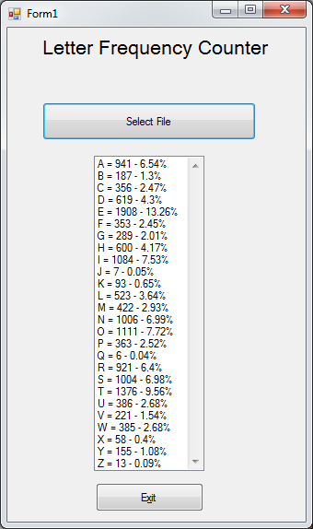

Public Class Form1
'TEXT FILE LETTER FREQUENCY COUNTER
'Counts the number of each A-Z alphabetical letter in a given text file.
'Version 1
'Mark Kelly 2011

Dim infile As String
Dim letters(0 To 26) ' to store letter frequency counts

Private Sub cmdOpenFile_Click(ByVal sender As System.Object, _
ByVal e As System.EventArgs) Handles cmdOpenFile.Click
Dim line As String
Dim i As Integer
Dim a As Byte ‘ascii code of letter
Dim filelength As ULong 'number of A-Z letters in the file - for % purposes

OpenFileDialog1.FileName = "" ‘initialise to null
If OpenFileDialog1.ShowDialog() <> Windows.Forms.DialogResult.Cancel Then
infile = OpenFileDialog1.FileName ‘get the filename
Else
infile = "" ‘cancelled file open dialog
Exit Sub
End If

Dim filehandle As Integer = FreeFile() ' get a file number for the file

FileOpen(filehandle, infile, OpenMode.Input, OpenAccess.Read, _
OpenShare.Shared) ' Open the file.

While Not EOF(filehandle) 'this method uses file handles like old BASIC
line = LineInput(filehandle) 'read a line from text file

For i = 1 To Len(line) 'scan each letter in the line
‘grab each letter, uppercase it so case is irrelevant then
‘convert letter to ascii code
a = Asc(UCase(Mid(line, i, 1)))

If a >= 65 And a <= 90 Then 'ignore non-alphabetical characters
letters(a - 64) += 1 'convert ascii code to array index
filelength += 1
End If
Next

End While
For i = 1 To 26
'use a listbox for display.
‘Show letter, raw count and % of all letters, nicely formatted
ListBox1.Items.Add(Chr(i + 64) & " = " & letters(i) & " - " & _
Format((letters(i) / filelength), "###0.##%"))
Next
FileClose(filehandle)

End Sub

Private Sub cmdExit_Click(ByVal sender As System.Object, ByVal e _
As_System.EventArgs) Handles cmdExit.Click
End
End Sub
End Class

