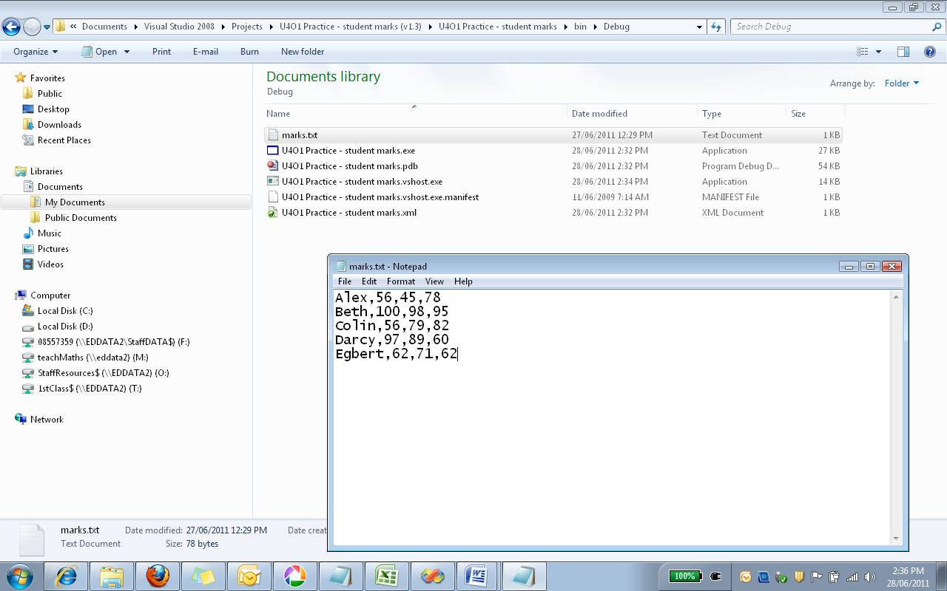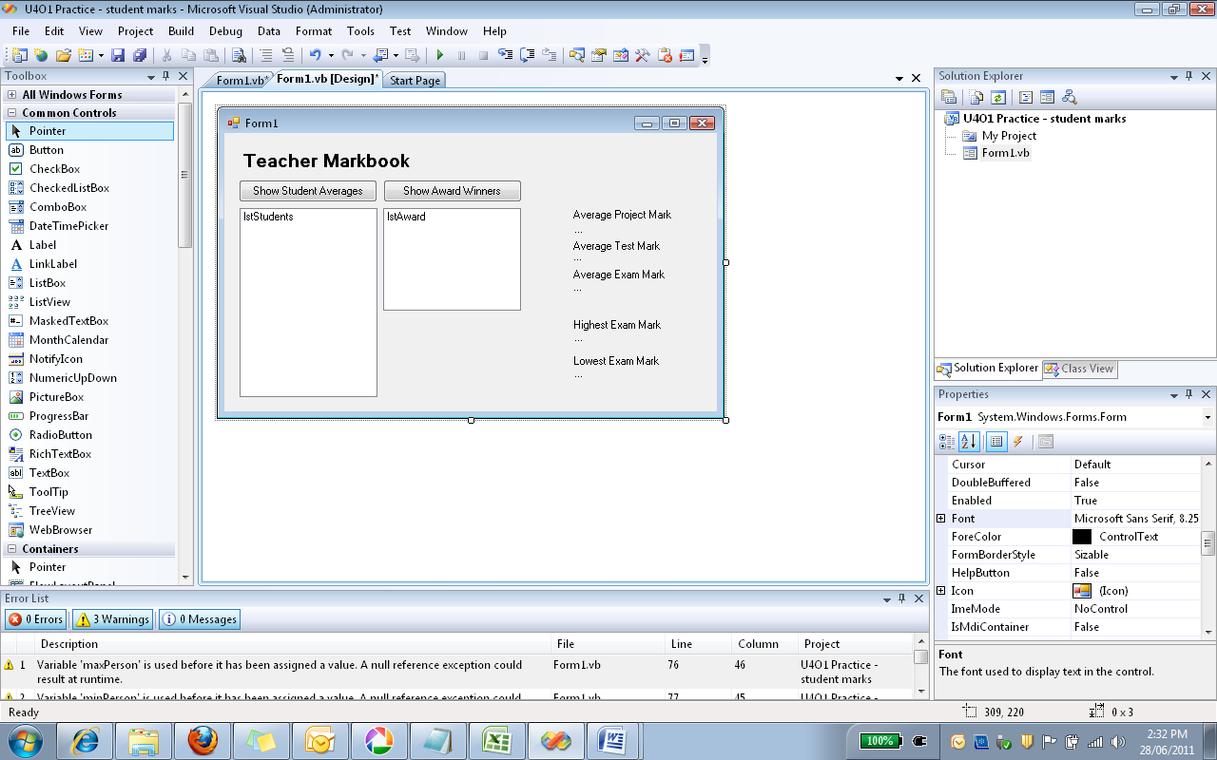

Text file containing data separated by commas

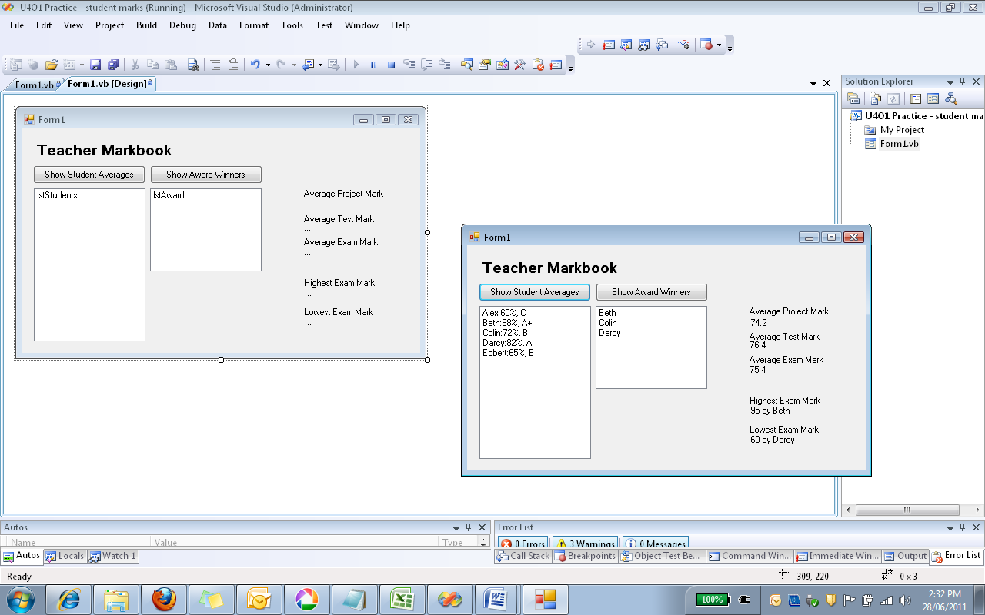

Imports System.IO

Public Class Form1

'set up a 2D array of 5 rows and 4 columns. This is a global variable as it is

'to be referred to everywhere

Dim strMarks(4, 3) As String

'set number of students in the class

Dim numStudents As Integer = 5

'set constants for commonly used array items so it's more readable

Const StudentName = 0, Project = 1, Test = 2, Exam = 3

Private Sub Form1_Load(ByVal sender As System.Object, ByVal e As System.EventArgs) Handles MyBase.Load

'opens the selected file

Dim openFile As StreamReader = File.OpenText("marks.txt")

'strStudent is each record, stored as a seperate line in marks.txt

'StrSplit(3) is a 1D array, which is made up of 4 elements. These are

'Student Name, Project Mark, Pracitical Test and Exam.

Dim strStudent, StrSplit(3) As String

'intCount is a counter that will be used again and again

Dim intCount As Integer

Do While openFile.Peek <> -1

'there are 5 students in the the file.

For intCount = 0 To (numStudents - 1)

strStudent = openFile.ReadLine()

'Each element of StrSplit is gotten from whatever is read, seperated

'by a comma

StrSplit = strStudent.Split(",")

'Filling out the 2D array

strMarks(intCount, 0) = StrSplit(0)

strMarks(intCount, 1) = StrSplit(1)

strMarks(intCount, 2) = StrSplit(2)

strMarks(intCount, 3) = StrSplit(3)

Next intCount

Loop

openFile.Close()

'------------------------------------------------------------------------------------

'work out the average marks for each assessment task

For intCount = 0 To (numStudents - 1)

lblProjectMark.Text = Val(lblProjectMark.Text) + Val(strMarks(intCount, Project))

lblTestMark.Text = Val(lblTestMark.Text) + Val(strMarks(intCount, Test))

lblExamMark.Text = Val(lblExamMark.Text) + Val(strMarks(intCount, Exam))

Next intCount

'the final result is divided by 5 to find the averages

lblProjectMark.Text = lblProjectMark.Text / numStudents

lblTestMark.Text = lblTestMark.Text / numStudents

lblExamMark.Text = lblExamMark.Text / numStudents

'------------------------------------------------------------------------------------

'work out the highest and lowest marks, and who achieved them

Dim max As Integer = 0

Dim min As Integer = 100

Dim maxPerson As String

Dim minPerson As String

For intCount = 0 To (numStudents - 1)

If strMarks(intCount, Exam) < min Then

min = Val(strMarks(intCount, Exam))

minPerson = strMarks(intCount, StudentName)

End If

If strMarks(intCount, Exam) > max Then

max = Val(strMarks(intCount, Exam))

maxPerson = strMarks(intCount, StudentName)

End If

Next intCount

lblHighestExam.Text = max & " by " & maxPerson

lblLowestExam.Text = min & " by " & minPerson

End Sub

Private Sub Button1_Click(ByVal sender As System.Object, ByVal e As System.EventArgs) Handles Button1.Click

'declaring a counter

Dim intCount As Integer

Dim averageScore As Integer

Dim grade As String

'this first adds up the scores for each tasks and divide by 3

For intCount = 0 To (numStudents - 1)

averageScore = (Val(strMarks(intCount, Project)) + Val(strMarks(intCount, Test)) + _

Val(strMarks(intCount, Exam))) / 3

'this allocates a grade for each student depending on the average grade.

Select Case averageScore

Case 0 To 30 : grade = "UG"

Case 31 To 45 : grade = "E"

Case 46 To 50 : grade = "D"

Case 51 To 60 : grade = "C"

Case 61 To 79 : grade = "B"

Case 80 To 90 : grade = "A"

Case 91 To 100 : grade = "A+"

End Select

'adds the student, their average score and the corresponding grade to the listbox

lstStudents.Items.Add(strMarks(intCount, StudentName) & ":" & averageScore & "%" & ", " & grade)

Next intCount

End Sub

Private Sub Button2_Click(ByVal sender As System.Object, ByVal e As System.EventArgs) Handles Button2.Click

'intCount is a counter that will be used again and again

Dim intCount As Integer

For intCount = 0 To (numStudents - 1)

'checks whether a student will get an achievement award according to the criteria

If strMarks(intCount, Test) > 75 And _

(strMarks(intCount, Project) >= 80 Or strMarks(intCount, Exam) >= 80) Then

lstAward.Items.Add(strMarks(intCount, StudentName))

End If

Next

End Sub

End Class