VCE: Software Development
Unit 3: Semester 1, 2011
Strathmore Secondary College
SAC 2 – OUTCOME 2

Outcome 2

On completion of this unit the student should be able to represent software design and apply a range of functions and techniques using a programming language to develop a prototype solution to meet a specific need. (60 marks)

Scope of Task

Software: Python, Microsoft Word

Time: 220 minutes

This task contributes 60% of School Assessed Coursework for Unit 3.

ALL SAC RELATED FILES MUST BE SAVED IN

\\SERVERNAS\Year 12\SAC_DN_U3O2\<YOURLOGIN>

OR

\\SERVERNAS\Year 11\SAC_DN_U3O2\<YOURLOGIN>

NO FILE OUTSIDE OF THIS DIRECTORY WILL BE ASSESSED!

Name:
Dee Dee Games Profit Margin System

Denise Corpora, owner of Dee Dee Games, has come to you with a large problem. After reading your Software Requirements Specification and modifying it slightly to “better meet her financial needs”, she hired 14 off-shore programmers to work in 18 hour shifts to try to get it built in less than a week – for Denise, more programmers means faster coding!

Unfortunately for Dee Dee, this wasn’t quite the case, and all of her programmers quit for being underpaid and overworked, leaving her new system – the Dee Dee Games Profit Margin System (PMS) – in an incomplete state. Denise has hired you, a secondary school student, to finish writing the software that will calculate the profit margin on her games after taking into account the initial cost involved in sourcing them from Irkutsk. She initially only promised to pay you in baked goods, but you weren’t keen on that and demanded 1% of her profits as payment instead. As Denise is desperate to have her software completed, she has agreed to your demands.

The incomplete code has been placed on the school server – it is called deePMS.py and has an image to go with it called deePMS.gif. Denise needs your help to finish coding the profit calculation.

Task Requirements
- Read the following SRS. It outlines the analysis of the new system. You have been hired for a part of the design and production phase of the system’s development.
- Write an algorithm in pseudocode to represent the calculation process. (10 marks)
- Design a data dictionary that shows (6 marks)
  - the required data items
  - a description of their purpose
  - their size
  - their data type
- Design a testing table to test the program which contains: (5 marks)
  - An appropriate range of test data to thoroughly test all aspects of the software’s functionality and accuracy
  - Columns titled
    - Element Tested
    - Test Data
    - Expected Result
    - Actual Result
    - Fixed? Y/N
- Create a complete set of criteria for evaluating the efficiency and effectiveness of the solution. (4)
- Create the prototype software module using efficient code that appropriately uses data types and structures to create an effective solution to the problem that meets all of the software requirements specifications. (25 marks)
- Include sufficient internal documentation so that others will be able to modify the code as part of the whole system development. The documentation should be relevant, non-trivial, clearly expressed and well formatted. (5 marks)
- Test the program using test data and fill in the ‘result’ columns in the testing table. (5 marks)

Software Requirements Specification

for

Dee Dee Games Pty Ltd

VERSION 1.2
Author | Date
Denise Corpora | 10/May/2011
Denise Corpora | 15/May/2011
Denise Corpora | 25/May/2011
Denise Corpora | 26/May/2011
Denise Corpora | 28/May/2011

Preface

This is the Software Requirements Specification (SRS) for Dee Dee Games Pty Ltd, intended to represent the results of the Analysis stage of the Problem Solving Methodology. In particular, this SRS represents the solution requirements for a new system that will track the profit margins of purchases through Dee Dee Games online eBoi store.

The intended audience of this SRS is Denise Corpora, owner of Dee Dee Games as well as the developer of the new system, a VCE Software Development student.

This document also acts as a contract between the development team and the client, DDG, as it pertains to the portion of the system that is being delivered.

Data Collection
Collection Method | Justification
Collect existing order completion forms | Determine input data requirements to generate the profit margin
Interview management regarding their requirements of the software | Identify basic functional requirements Denise is expecting
Interview management to determine their organisational goals | To ensure the software is supporting their long term organisational ambitions for ‘making profit’
Survey Denise to determine her IT skills | To discover how easy to use the software will need to be
Time how long it takes to process a variety of completed orders under the existing order system | Allows accurate evaluation of the new system’s efficiency when it’s implemented.
Collect existing error logs to determine cases where Denise’s calculations of profit have been incorrect | Allows accurate evaluation of the new system’s accuracy when it’s imnplemented.

Introduction

Purpose

The purpose of this document is to provide a detailed description of all the parameters and goals of the software product for Dee Dee Games, who requires that a profit margin system is created to keep track of the profits made from sales of online games. The software module will calculate the total profit margin made from customer purchases over a given length of time. It will need to include the total cost charged to the customer, while subtracting shipping costs, and the purchase cost of the product. It should also take into account the programmer payment based on a percentage of the profits.

The software module in this SRS concerns the Dee Dee Games’ PMS – it is a portion of a larger software product. This particular module is needed to finalise the entirety of the system. This functionality will remove the possibility of human error in the calculation of profit margins. This will also provide a faster and easier to use solution than manual calculations.

Dee Dee Games PMS will provide accurate accounting records for the sales of gaming products via the eBoi system used by Dee Dee Games. It will reduce labour costs by quickly and easily producting accurate profit and loss statements.

Dee Dee Games PMS aims to work efficiently by providing accurate and timely profit and loss statements to Denise. This will allow the company to provide a greater selection of games to customers, as time-consuming manual tasks will have been automated. More accurate profit and loss statements will be able to be produced, in any given timeframe, increasing the flexibility of the system.

Scope

Items within Scope

The items that are within scope of this project include:

- Algorithm design.

- Data dictionary.

- Testing table.

- Evaluation criteria.

- Creation of the software module and internal documentation.

- Testing.

Items not in Scope

The items that are not within the scope of this project include:

- Any work on the eBoi system, SpendFriend system or other aspects of that are not outlined within this SRS.

- Interface design.

- Data validation is not required (e.g. invalid dates need not be detected)

- Data security.

Operating Environment

The software module must be fully functional when running on:

- A 32 bit or 64 bit Intel or AMD CPU with a minimum speed of 1.7GHz.

- A minimum of 2G RAM.

- Minimum 1024 x 768 screen resolution.

- A 100Mbps connection to a client-server Ethernet LAN.

- Windows XP and above.

Documentation

Context Diagram
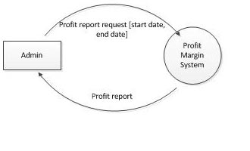

Data Flow Diagram Level 1
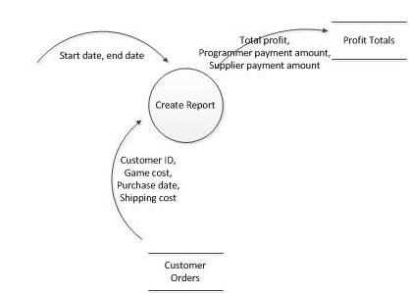

Use Case Diagram

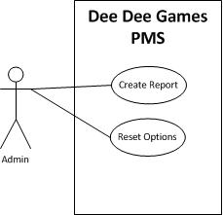

Requirements

Functional Requirements

Create Report
Introduction

The Dee Dee Games PMS shall have a ‘create report’ screen that allows an admin to enter in the start date and end date required for the report. There should be a button that allows them to create the report, and one that allows them to reset the form fields in the user interface.

Inputs

Start Date – Day, Month, Year: all separate fields, in dropdown boxes.
End Date – Day, Month, Year: all separate fields, in dropdown boxes.

Sequence of Operations

The admin shall enter a start date and end date and can select ‘reset’ or ‘create report’.

Selecting ‘reset’ simply clears all fields back to default status (blank).

Selecting ‘create report’ will:

Open a file of customer orders [this will exist in the same folder as the software product]. It will then read the contents of the file and discard any of the orders that do not sit between the date range given. It will then add up the game cost paid by the customer and determine the profit margin after subtracting the 15% required to be paid to the Irkutsk distributor. It will also calculate the amount to be paid to the programmer – 1% of the total profit AFTER the distributor has been paid – and subtract that from Denise’s profits before saving.

The customer order file is in the following format:

The elements are in the following order:

Customer ID, game cost, purchase date, shipping cost

Game prices are variable so should only come from the customer order data.

If no date range is given, all orders should be used in the calculation.

Outputs

Profits should be stored into a new file, called profitTotals.txt.

The profit total file should contain the total profit amount, the programmer 1% payment and the distributor payment amount for all orders within the date range, all on separate lines. The 1% programmer payment should display in the GUI itself as well as be saved into the profit total file.

Example:

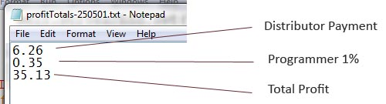

Non-Functional Requirements

No. | Requirement | Notes
NFR01 | Reliability | The calculations must be 100% accurate for any valid inputs.

Constraints

Within the Dee Dee Games PMS:
- Prices change based on Simmer prices and could change daily or even hourly. The customer order data file will contain this information, so no cost information should be hardcoded into the program.
- The GUI has been provided by Dee Dee Games and must not be changed.

