Profit calculator for outback farmers

Cattle on the big outback properties in Northern Australia have always been trucked to Darwin for live export to Indonesia. This has worked fine until this year, which has been very wet and created a massive amount of feed in the desert. This has resulted in very fat cows.

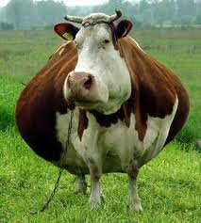

You would think this would be good news but Indonesia only accepts cattle less than 350kg. This is so that the cattle still need to go through a feedlot (fattening farm) which creates employment in Indonesia and helps their economy. Many cows are well over 350kg this year.
For more info: http://www.abc.net.au/rural/content/2011/s3147733.htm

When a cow gets to the docks in Darwin it is weighed and a farmer is presented with the following options:

- If a cow is under 350kg it can be live exported immediately and the farmer receives $2 per kilo
- If the cow weighs more than 389kg, it is most cost effective to send the cow on a truck to Townsville to the abattoir for a cost of $180. Here they receive $1.50 per kilogram.
- If a cow is between 350 and 389kg inclusive there is the Jenny Craig paddock. This is a baron paddock that costs $25 per week for agistment. Cattle loose 1% of their mass per week in it. When the cow gets below 350kg it can be exported. As ships depart weekly, cows may drop a bit below 350Kg before departure.

Create a profit calculator for the farmer for a list of cattle weights.

Functional Requirements:
  - Enter the weight of each cow into an array
  - Calculate the income from each cow and store in another array
  - Add up the values in the array and display total income.

