Software Requirements Specification

For

Playtime Theatre Company

By Joseph and Cheryl

Introduction

Identification of the software product

This is a prototype theatre ticket system for the Playtime Theatre Company

Intended audience of this Software Requirements Specification

This document is for the Playtime Theatre Company management team and for the software developer.

Purpose of the software product

This software product should calculate the cost of tickets, record the ticket sales, allow the ushers and volunteers to check seating and print replacement tickets

Scope

Items within Scope
- Calculation of ticket cost
- Saving the data to file
- Searching for ticket sales
- Printing tickets

Items not in Scope
- Automatic allocation of seats
- Validation of data entry
- Online booking
- Issuing of receipts
- Summary reports such as list of theatre goers or total takings for shows (these might be features of the final product, but this is only a prototype)

Operating Environment

The theatre has is a star network using an Ethernet protocol 100Mbps/1Gbps speed.

There is a desktop computer in the front office and netbooks available to theater members who wish to prepare fliers or do some web browsing. The netbooks connect to a wireless router. All computers run Windows 7.

There is also TCP/IP for browsing the web

Documentation

Context Diagram

Data Flow Diagram
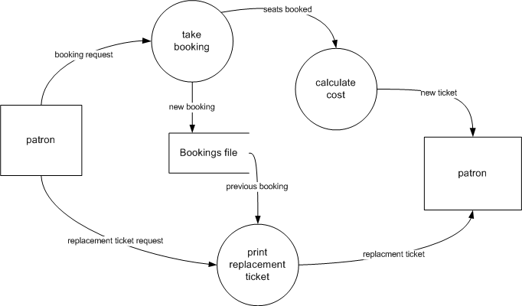

Use Case Diagram

Requirements

Functional Requirements
No | Functional Requirement
FR1 | allow for entry of new bookings with the following details  - customer’s title, first and last name and phone number  - number of adult and children’s tickets  - membership number if the patron is a member (the membership number is a five-digit number eg. 17642)  - row and seat number of their first ticket (if a patron booked 5 tickets in A15, they would have A15 – A19)  - date of the performance  - whether they’ve paid
FR2 | The program should automatically display the  - total amount payable  - GST  - discount (if any)  The user must be able to send data to a text file to print a replacement for a lost ticket so that they can show the usher their seat number.  The program must automatically save a record of the sale after each transaction.
FR3 | Print tickets
FR4 | Save a record of the sale to a file after each transaction
FR5 | Load sales from the file to search for lost tickets

Non - Functional Requirements
No | Non - Functional Requirement
NFR01 | Enable usher to quickly search for a patron’s name to find their allocated seats
NFN02 | Print accurate and easy to read tickets
NFR03 | Accurately calculate the cost of the tickets
NFR05 | Easy to use for non-technical theatre volunteers
NFR06 | Secure connection to network so that private information about patrons is not visible to sniffers.

Constraints
No | Constraint | Explanation
C1 | Cost | The Playtime Theatre Company have a very small operating budget and cannot afford to buy any more equipment so the software must run on the existing desktop computer and netbooks.
C2 | Screen brightness | In order for the ushers to check tickets without interfering with other patrons, the screen must not be bright.

Developed by Esther Andrews, Bendigo Senior Secondary College.

Acknowledgements:
- Claudia Graham for Edulists distribution, 2011
- Lony Hem for Edulists distribution, 2011
- Karl E. Wieggers for SRS Template, 2002
- Adrian Janssen of Melbourne High School, 2011

