Question 1:
Study the following algorithm.
BEGIN
READ A
READ B
WHILE A <> 2 AND B <> 2
PRINT A * B
READ A
READ B
ENDWHILE
END

From the input data
0, 1, 1, 2, 2, 3, 2, 2
the output produced will be

(A) 0
(B) 0, 2
(C) 0, 2, 6
(D) 0, 2, 6, 4

Question 2:
BEGIN
set A = 2
WHILE A < 7
read B
set A = A + B
print A
ENDWHILE
END
If the values available for B in the above algorithm are 1, 3, 1, 1, 5, then the output from the algorithm would be
(A) 3, 6, 7
(B) 3, 6, 7, 8
(C) 2, 3, 6, 7
(D) 3, 5, 3, 4, 7

Question 3:
The set of numbers 8, 5, 1, 7, 3, 2 was read into the following program:
BEGIN
SET COUNT TO 1
READ A
REPEAT
READ A
READ B
WHILE A > 0
DISPLAY B
A = A – 1
ENDWHILE
COUNT = COUNT + 1
UNTIL COUNT = 3
END
Which of the following is the correct output?
(A) 1111333333
(B) 111113333333
(C) 555555557
(D) 555555557222

Question 4:
IF TEMP = 35°C THEN
SET CONDITION TO "HOT"
ELSE
IF TEMP = 25°C THEN
SET CONDITION TO "WARM"
ELSE
IF TEMP = 20°C THEN
SET CONDITION TO "NORMAL"
ELSE
SET CONDITION TO "COLD"
ENDIF
ENDIF
ENDIF

How many values would be required to form a minimum set of test data for checking this
algorithm?
(A) 3
(B) 4
(C) 5
(D) 6

Question 5:
Study the following algorithm.

READ A
READ B
REPEAT
SET C TO (A+B)/2
PRINT C
READ A
READ B
UNTIL A = 0

The following values are entered in sequence
4 6 2 0 0 8 3 5.

Which of the following shows the correct output?
(A) 5
(B) 51
(C) 514
(D) 5144

Question 6:
What will be the output produced by the following algorithm if A = 1 and B = 2?
READ A
READ B
WHILE NOT ((A<=0) AND (B<=0))
IF A>B THEN
PRINT ‘First’
ELSE
IF A<B THEN
PRINT ‘Second’
ELSE
PRINT ‘Equal’
ENDIF
ENDIF
READ A
READ B
ENDWHILE
(A) First
(B) Equal
(C) Second
(D) no visible output

Question 7:
BEGIN
set A = 2
WHILE A < 7
read B
set A = A + B
print A
ENDWHILE
END
If the values available for B in the above algorithm are 1, 3, 1, 1, 5, then the output from the algorithm would be
(A) 3, 6, 7
(B) 3, 6, 7, 8
(C) 2, 3, 6, 7
(D) 3, 5, 3, 4, 7

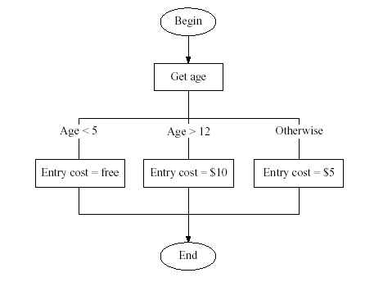
Question 8. An algorithm to determine the entry fee to an amusement park would be:
A minimum test set for the algorithm is
(A) 4, 13
(B) 4, 5, 13
(C) 4, 5, 12, 13
(D) 4, 5, 12, 13, 15

Question 9: Two players take turns until they guess a secret number. After each guess the player is told if the guess is too low, too high, or correct.
The algorithm that best illustrates this game is

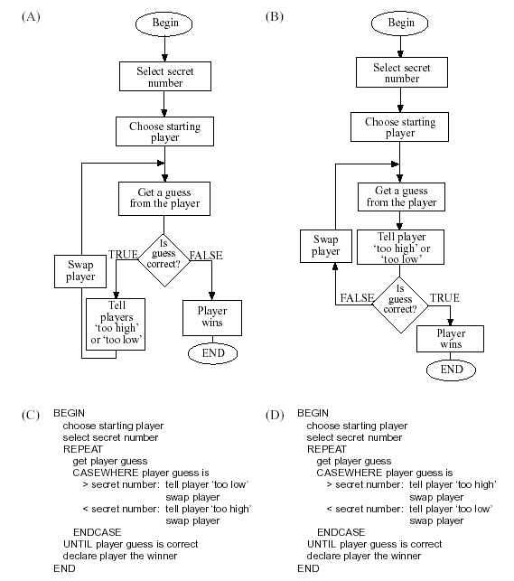

Question 10:
A person wants to use a lawnmower. The person goes to a lockable shed, opens the shed door, removes each object, in turn, that may be in the way and pushes the lawnmower out of the shed. Which of the following algorithms best describes this task?

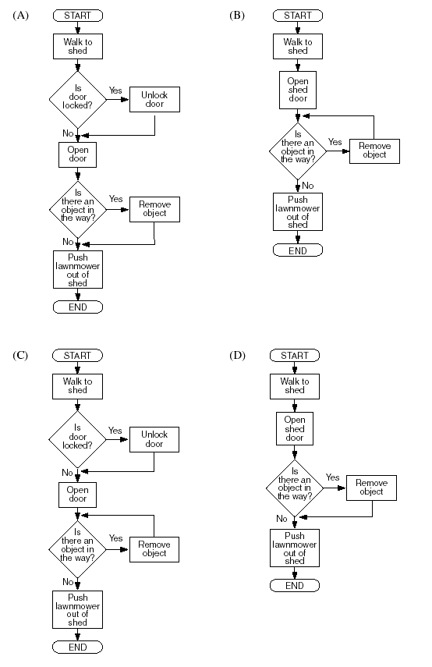

Question 11:
Array A = [7, 21, 8, 7, 23, 11, 27]
Array B = [a, b, c, d, e, f, g, h, i, j, k, l, m, n, o, p, q, r, s, t, u, v, w, x, y, z]
B [1] = a

Using the data in Array A and Array B, what will be the output of the following algorithm?

BEGIN
FINAL = A [3]
COUNT = 2
REPEAT
DISPLAY B [A [COUNT] – COUNT]
COUNT = COUNT + 1
UNTIL COUNT = FINAL
END

(A) select
(B) second
(C) secret
(D) seconds

Question 12:
The following diagram shows the contents of an array of records used for mixing colours.
The name of the array is ‘COLOUR’.

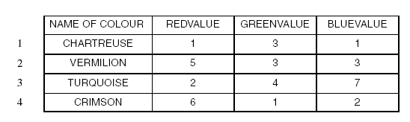
The algorithm below is used to calculate colour values, using an array.
BEGIN
SET TOTAL TO 0
SET COUNTER TO 1
WHILE COUNTER < 4
TOTAL = TOTAL + COLOUR [COUNTER] . GREENVALUE
ADD 1 TO COUNTER
ENDWHILE
WHILE COUNTER < 4
TOTAL = TOTAL + COLOUR [COUNTER] . REDVALUE
ADD 1 TO COUNTER
ENDWHILE
PRINT TOTAL
END

What will be the output of this algorithm?
(A) 10
(B) 11
(C) 18
(D) 25

