Visual Studio .NET
Allowing Network Drive full trust

Please run the local file

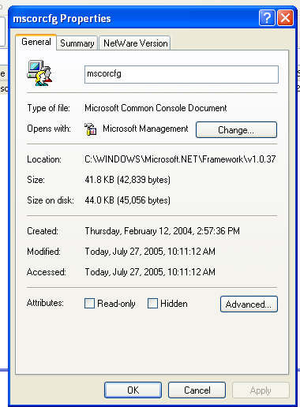

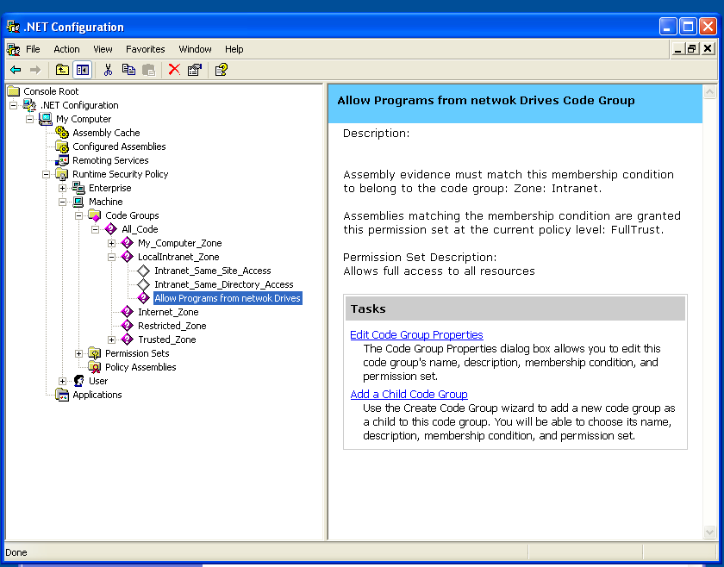

In the Machine – All code – Local Intranet add new Child Code Group

Membership Condition – Zone – Local Intranet. Permission – Full Trust

