Visual Basic Exercises
Access XP Front Ends

Activity 2

Aim: To design tables in MS-Access XP
To enter and browse data
To append data.

To create a Visual Basic form linked to an Access table

The Access tables that you create will have a file extension of .mdb
Create a folder in H: called vbprog. Store all your files in this folder.

Creating the CUSTOMER Table

- Start up MS-Access XP
- Choose Blank Database
- Name it Customer, making sure that you are in the right folder (H:\vbprog).
- Click on Create
- Select “Create Table in Design View”
- Click on Design.
- Enter the fields listed in the following table.

FIELD NAME | TYPE | SIZE | INDEX
Cust_id | Text | 4 | None
Name | Text | 20 | Yes (Duplicates allowed)
Suburb | Text | 20 | As above
Mail_date | Date/Time |  | As above
Postcode | Number | Integer | As above

(DO NOT create an Index for Cust_id yet. It will be done next.)

Setting The Type, Size & Index Properties
- Use the Tab key to move across the cells.
- Use the Drop Down list in the Data Type column to select the correct Type.
- Use the F6 key to move down to the properties section in order to adjust the Field Size. F6 will also take you back up to the design window.
- Close the Table Designer. Yes to save.
- Make sure that you are in the vbprog folder and name the table CUSTOMER.
- Save the file.
- “No” to create a Primary key
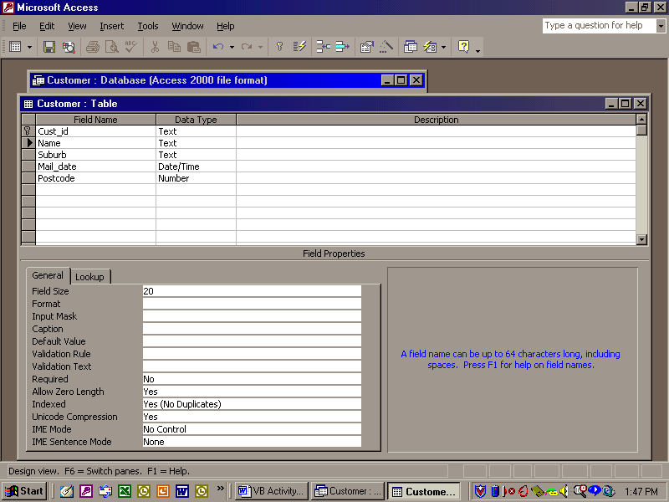

Defining the Primary Key
Tables must have a field in which every data entry is unique. This is called the Primary Key.
Open the CUSTOMER table in Design mode again.
Click on Cust_id and click on the Primary Key icon (The key) on the toolbar.
The table design should now look like the screen dump above.

Adding Data to the CUSTOMER Table
- Click on the View icon at the top left of the Menu bar.
- You will be able to add the data from the attached sheet.
- Use theTAB key to move across the rows.

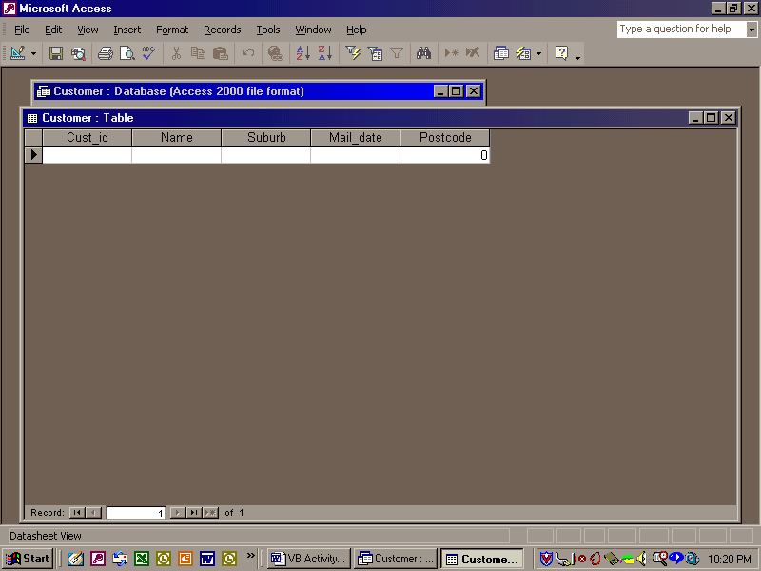

Close the table when you are finished.

Creating the JOBS table
Repeat the steps above to create the JOBS table.
Use the table structure set out below.

FIELD_NAME | TYPE | WIDTH | INDEX
Job_id | Text | 4 | Yes(No Dups)
Cust_id | Text | 4 | Yes(Duplicates allowed)
Descrip | Text | 20 | No

Adding data to the JOBS table.
Repeat the steps above to enter the jobs data from the handout.

Creating a relationship between the tables
MAKE SURE THAT YOU HAVE FINISHED ENTERING ALL DATA.
- Close all tables
- Select Tools, Relationships.
- Add both tables to the relationship form.
- Close the Tables window

Drag the Cust_id field from the Customer field list onto the Cust_id field in the jobs field list.
You should have the following screen at this stage.

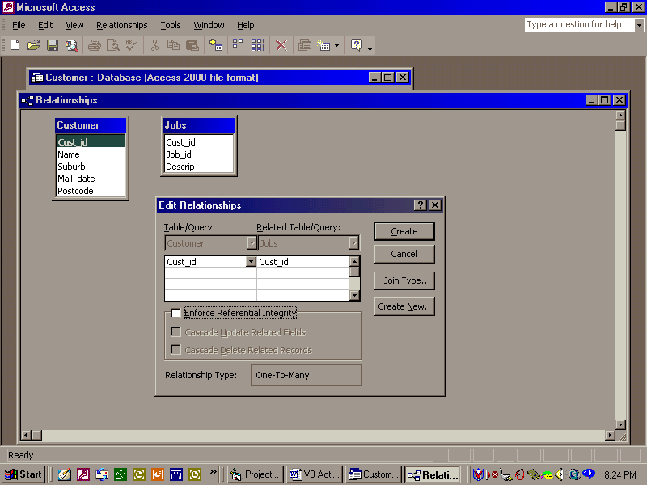

Check the Referential Integrity button
Check the Cascade Delete Related Records button so that when a customer is deleted, any jobs associated with that customer will also be deleted.
Click on Create.
A connection should appear showing a one-to-many relationship.

The Cust_id field in the Customer table is called the Primary key.
The Cust_id field in the Jobs table which links the tables is called the Foreign key.
Close the relationship window and save.

Designing a Visual Basic Form Linked to the Customer Table
This form will become the “front-end” to the Access tables
- Open up a Standard EXE file in Visual Basic
- Click on Project, Components and tick “Microsoft ADO (ActiveX Data Objects) Data Control”
- Click OK (The new control should appear on the toolbox)
- We are going to place several objects from the toolbox onto the form and link them up to the CUSTOMER table.
- Click on the ADO control and then draw it on the form.
- Change it’s name property to adCustomer and it’s caption property to Customer.

To place the other components on the form:
Click on an object in the toolbox and then draw it on the form. The object will appear on the form and can be moved and re-sized using the mouse.
One way to set up the form is shown below.

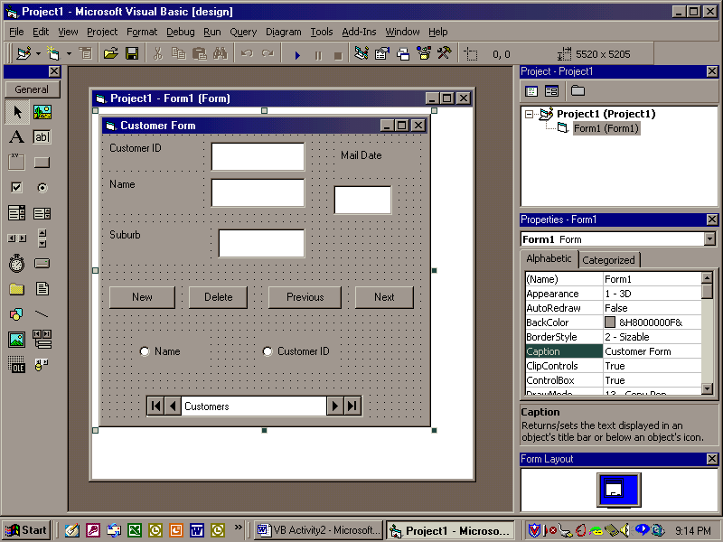

Customise the form according to the following table by clicking on each object in turn and entering the following values in the appropriate properties.

 | OBJECT | PROPERTY | SETTING
A | Form | Name  Caption | frmCustomer  The Customer Form
B | Label | Name  Caption  Position in a suitable place on the form | lblCustomerID  CustomerID
C | Textbox | Name  Text  Position in a suitable place on the form | txtCustomerID  (Empty)
D | Label | Name  Caption  Position appropriately | lblName  Name:
E | Textbox | Name  Text  Position appropriately | txtName  (Empty)
F | Label | Name  Caption  Position appropriately | lblSuburb  Suburb:
G | Textbox | Name  Text  Position appropriately | txtSuburb  (Empty)
H | Label | Name  Caption  Position appropriately | lblMailDate  Mail Date:
I | Textbox | Name  Text  Position appropriately | txtMailDate  (Empty)
J | Command button | Name  Caption  Position appropriately | cmdPrevious  &Prev
K | Command button | Name  Caption  Position appropriately | cmdNext  N&ext
L | Command button | Name  Caption  Position appropriately | cmdNew  &New
M | Command button | Name  Caption  Position appropriately | cmdDelete  &Delete
O | Option Button | Name  Caption  Value | optName  Name  .T.
P | Option Button | Name  Caption  Value | optCustId  Cust ID:  .F.

Make sure that you are in the vbprog folder.
Close the form and save it

***This completes the Visual programming section.***

Linking the ADO Data Control to the Access database
Click on the ADO Data Control and find the Connection String in the properties window.
Click on the ellipses (3 dots)
The Property pages will appear as shown below.

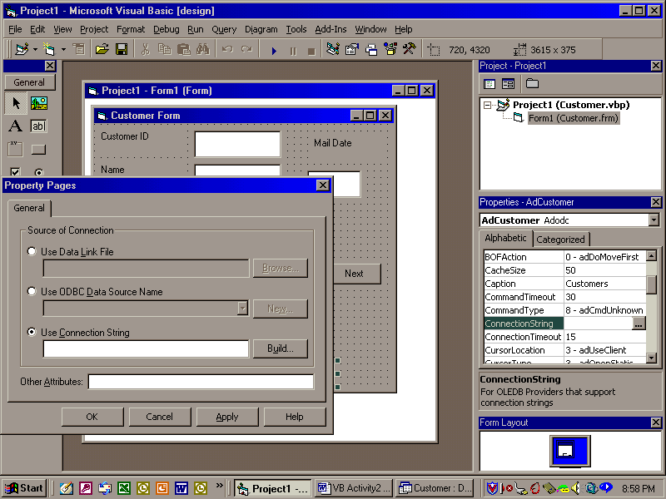

- Click on the Connection String option.
- Click on Build and select the Microsoft Jet 4.00 OLE DB Provider
- Click on Next and Browse to find the Customer database.
- Click on the Test Connection and a message will be displayed if all has gone well.
- Click OK and OK again
- Close the Property Pages window

Observe the connection string in the property window.
The connection to the database has been completed.

Connecting to the correct information
Go to the record source property and click on the ellipses
Set the command type to 2-adCmdTable (This allows us to access the same table each time.)
Select the Customer table from the drop down list below it.

****************
Later in the exercise, we will change this to 8-adCmdUnknown (Allows the use of SQL)
Click OK

Binding a field (in a table) to a bound control (eg a Textbox)
You will now link the fields in the table to the objects on the form
Set the Datasource property for all the textboxes to the name of the data control, namely adCustomer.
Now set the Datafield property of each text box to the corresponding field name.

Setting Other ADO control properties
We are intending to use the command buttons to navigate our records rather than the inbuilt ADO control navigation.
Make the ADO control invisible by setting it’s visible properties F
Run the program and check that the control is no longer visible.

Entering Code for the Customer Program
We will now place some code behind the Command Buttons so that they will do something when clicked.
NOTE: When you use these navigation buttons, you may claim the credit for the code. It is not wise to use the ADO navigations in VCE as you CANNOT claim credit for the programming.
Also set the ADO control visible property to False to be sure.
Open the Customer form.

- Attaching code to the OnClick event of the Next Button.

Double click the Next button on the Customer form
Private Sub cmdNext_Click()
adCustomer.Recordset.MoveNext
End Sub

- Attaching code to the OnClick event of the Previous Button.

Double click the Next button on the Customer form
Private Sub cmdPrevious_Click()
adCustomer.Recordset.MovePrevious
End Sub

D. Attaching code to the OnClick event of the New Button
Double click the Next button on the Customer form

Private Sub cmdNew_Click()
adCustomer.Recordset.AddNew
End Sub

Attaching code to the OnClick event of the Delete Button
Double click the Next button on the Customer form and add the code.

Private Sub cmdDelete_Click()
adCustomer.Recordset.Delete
End Sub

- Attaching code to the OnOpen event of the frmCustomer form.

At this stage we will introduce the SQL (Structured Query Language) in order to make some of our code easier.
SQL is specifically designed to manipulate database information. You can use SQL to Add, Update or Delete records.
You can also use SQL to select records from a table and return them as a recordset.
Return to the RecordSource property of the ADO data control.
Change it’s Command Type to:
8-adCmdUnknown
In the Command Text type:
Select * FROM Customers

Double click on a free part of the form. Then type the extra lines as shown below:

Private Sub Form_Load()
adCustomer.RecordSource = "select * FROM Customer ORDER BY name"
adCustomer.Refresh
adCustomer.Recordset.MoveFirst
End Sub

Save and Close
Go over each of the commands used and make sure that you understand all of them.
Run the customer.wfm form and test each button.

The screen dump below is one way of setting the form out.

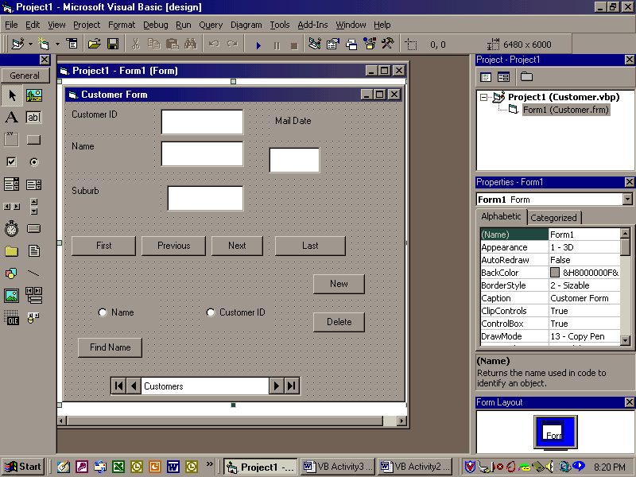

Exercises

Adding some new buttons
Add two new command buttons to the Customer form. The Names and Text properties are suggested below in the table:
- FIRST - Goes to the first record when pressed
The syntax for first record is MoveFirst and don’t forget that it will be a record in the recordset on the form.
- LAST - Goes to the last record when pressed.
The syntax for last row is MoveLast

Object | Name | Text
First commad button | cmdFIRST | &First
Last command button | cmdLAST | &Last

Position these buttons appropriately and write the code in the OnClick event for each. Don’t forget to copy and past at every opportunity.
Test all buttons and Save.

