Visual Basic (v6)
And OOP (Object Orientated Programming)

Activity 1
- Visual Programming involves:
- The Visual Programming step or the Design step
And b) The Code Programming step

- The Visual Basic desktop is made up of :
- The Toolbox
- The Project Explorer
- The Properties Window
See the diagram below for details.

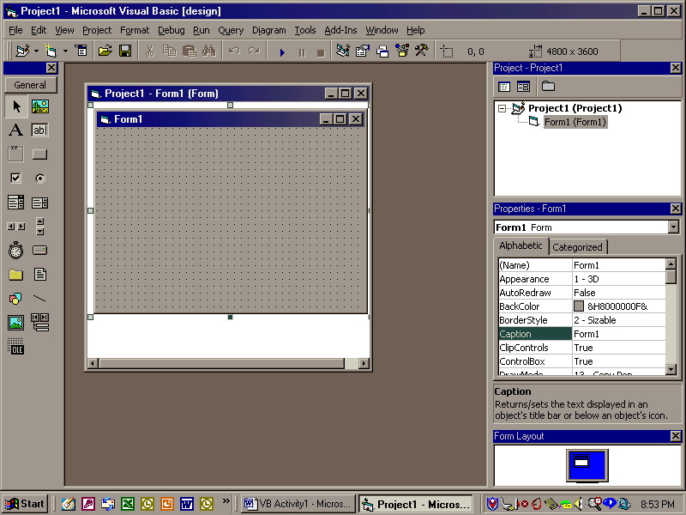

Visual Basic is based on some familiar data management entities:
- Tables (Containing the records)
- Indexes (allowing quick dynamic sorts)
- Queries (to obtain specific records)
- Forms (for better input)
- Reports (for better output)

********
The desktop of Dbase is an MDI (Multiple Document Interface) window. This means that the desktop window can have several windows in it and the menu will change depending on which window is currently active.

File Extension | Type of File
BMP | Windows Bitmap file
DBF | DBASE table
DMD | Datamodule
JPG | JPEG graphics file
MDX | Production index
NDX | DBASE III single index
PRG | Program file
REP | Report Form
WFM | Form file

Finding Help
- Press the F1 key at any time
- Search under Help, Search and the topic
- Using the interactive tutors under Help
- The Sample directory has sample files for viewing and examining
- Right Mouse Button – a shortcut to speed menus.

A Sample Form - Hello.wfm
This is an example of creating an input form using various objects and code.

Section 1 - Visual Programming
- Make sure the blank form is currently selected by clicking in it with the mouse.
- If the Toolbox is not showing, select View from the menu and then Toolbox.
- Select the Command Button and draw it on the form.
- Repeat this again
- Select the Textbox and draw one on the form.
- Click on the first Command box. In the properties window, change the name to cmdHello.
- Change the caption entry to &Say Hello (The ampersand underlines the letter). Make sure that you move out of the property by clicking elsewhere or by using a cursor key.

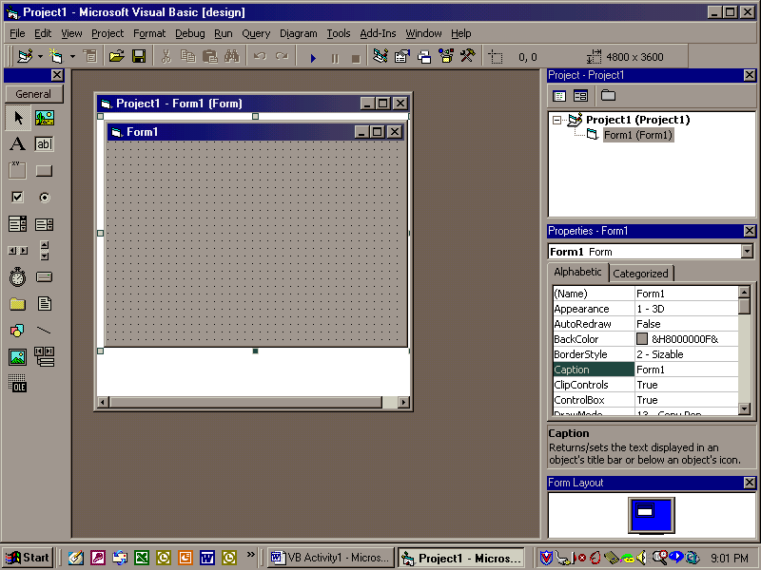
Textbox
Command Button

10. Click on the second Command button. In the properties section, change the caption field to &Clear, and the name field to cmdClear. Your form should look like the following, but without the long Textbox at the top; this is next.

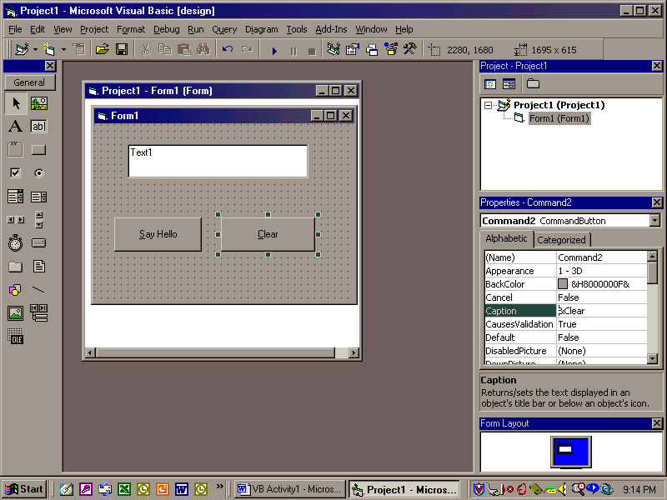

- Click the Textbox control in the Toolbox (see icons list). Draw the Textbox onto the form.
- Move and resize the Textbox Control to make the form look as above.
- Select the Textbox control..
- Change the name property to txtMyfield..
- Change the text property (this is the text displayed in the entryfield control) to blank by deleting the contents which should be showing “entryField1”.

Executing the Hello program
- Click on the Run icon. (Small blue triangle). You will be asked to save the form. Call it Hello
- Click the Say Hello button. What happens?
- Click the Clear button. What happens?
- Click in the Textbox and type something. What happens?

Modifying the Hello Program
- Click the End icon (Small blue square) to stop the program.
- Click a free area of the hello form
- Locate the caption property and change it to “The Hello Program”
- Run the program again (Triangle). What’s happened ?
- Close the form.

This is the end of Section I, the Visual Programming Section.

Section 2 - The Code Programming Section
In this section you will:
- Attach code to the Say Hello Command button
- Attach code to the Clear Command button
- Design the menu Bar of the HELLO program.

i) Attaching code to the Say Hello pushbutton

As you have seen, at the moment the Say Hello and Clear pushbuttons do not perform any action when clicked.

- Double click on the SAYHELLO button.
- You want to attach code to the Click event
- Enter the following code:

Private Sub Command1_Click()
‘This will fill the entry field with a Hello Message
‘This is a comment only
Form1.txtHello.Text =”Hello! This is my first VDB Program !”
End Sub

The line starting with ‘ is a comment. The first and last lines should already be there.
- The next line fills the contents of the MyField Textbox with the value “Hello! This is my first VDB Program!”
- Close the editor. (It saves automatically). Run the program. Try out the buttons. What happens? Why? Close the form.

- Attaching Code to the Clear Pushbutton
- Repeat steps 1 to 6 above, replacing the SAYHELLOBUTTON with the CLEARBUTTON and in step 3 replace the code with:

Private Sub Command2_Click()
‘This clears the Entry field
Form1.txtHello.Value=””
End Sub

Close the editor. Run the program and try both pushbuttons. What happens / Why ?

- Designing the Menu Bar of the HELLO program (See below)

Right click on the form and select Menu Editor
- Type &File in the small caption rectangle in the top left corner.
- Change the name to mnuFile.
- Choose Next. Indent to the right using the arrows. Type E&xit in the caption rectangle. Change the name to mnuExit.
- Remember the ampersand character underlines the next letter.
- Close and Save the file. Call it Hello
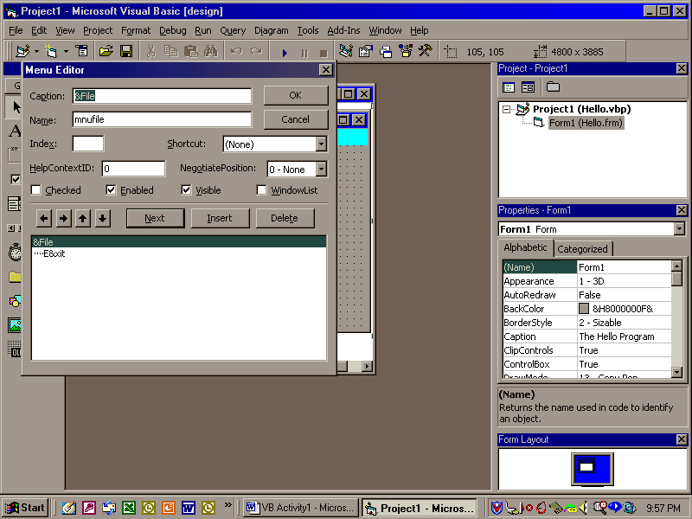

- The menu is now attached to the form
- Run the form. (Triangle)

What happens ? Do you have a menu?

End the program

v) Attaching code to the Exit Menu Item
- Open up the Hello menu form in design mode.

Select &Exit on the menu.
- Enter the following code (The first and last line will already be in place):

function EXIT_OnClick
‘Terminate the program by exiting the form
form.Close()
return

The form.Close() statement executes the Close() method on the form. The Close() method closes an object. In this case, it’s form
- Close and save the form.
- Run the Hello form by clicking on the Run icon.
- Test each button and menu choice.

