Lesson Notes U42 – Creation of User Documentation

One form of user documentation is Help. The authoring tool HelpStudio Lite is offered with the Visual Studio 2005 SDK as an installed component that integrates with Visual Studio 2005. However, I found it to be missing. An alternative is to use Microsoft Office’s HTML Help Workshop and link the Help files to the application. This turned out to be a nice and easy way of doing it.

Resources:

- Essential Software Development by Dawson and Janson.
- “Software Development” by Fitzgerald and Keane (F & K). Thomson Press 2006
- Course Website – see “Course Notes”
- Download free Microsoft HTML Help Workshop (HHW)
- Download free HHW Tutorial by Char James-Tanny
- Read the article by The Making of Help by George Poth

In Unit 4 Outcome 1, part A, you will be required to build be an application that interacts with a database, and write a software report. In part B, you will be required to produce User Documentation (and include in the report how you did it and references) as part of your application.

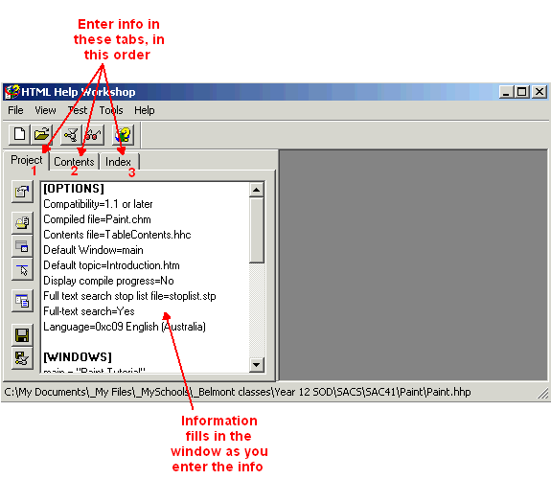
The HHW Interface

Luckily, I found some good material on the internet and put together a package of work in preparation for outcome 1B. So this week’s Lesson Notes will be a set of instructions leading you to a tutorial on how to create your own Help module (a Paint tutorial using HHW) and call it as part of your application.

Once you have created the Help module of the tutorial, it should be relatively easy to modify it later, making a version for your own database application in outcome 1.

Instructions:

- If working from home, download both the HTML Help Workshop and Tutorial by Char James-Tanny from the links provided in the resources section above. The tutorial consists of a .pdf file and a folder of HTML files.

- If working from school, the tutorial is stored on the Shared server and HHW is available from the Start menu.

- Open the .pdf tutorial file. Read the general intro. Go down to exercise 1, read the instructions just above it before completing the exercise. Go down to exercise 2, read the instructions just above it….and so on until you have completed the tutorial and have a working Help module. Most of the basic work is up to Exercise 6.

- Warning! You will have access to autosync checkbox only by first clicking the only checkbox on the Project/Navigation tab.

- Once your tutorial Help module is functional, test run from Visual Basic using the following line of code (assumes we have placed the file under c:\ and note, Shell() works in both VB6 and VB.Net).

Call Shell("hh.exe " & "c:\Paint.chm", AppWinStyle.NormalFocus)

Ta da! Below is the finished product called from VB.Net.

The Finished Product:

