Outcome 1: Janson’s EZ-X10-Shuns-4U!

Background

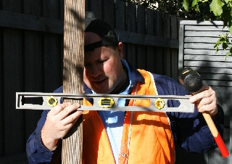
Janson’s EZ-X10-Shuns-4U (Easy Extensions for You!) is an extension company located in Glenhuntly. Its founder, ‘AJ’ Janson has been doing home extensions for about 6 years now after completing a thorough training qualification via post. He has received several industry awards (although none of these were for building – he was heavily involved in the construction and delivery of Internet spam for some years, and was the keynote presentation at “Spammin’ Nigeria ‘98”).
AJ on site – starting an extension.
AJ currently performs all of the quoting for jobs and the majority of the work. As the quoting for jobs can be tedious and time consuming, AJ has decided that he would like to use some of his other staff members for this task. He has three builders / specialists that he uses for the jobs: ‘Shawne Merriman’, ‘Lorenzo Neal’ and ‘Phillipa Rivers’. Back at the office, AJ employs an office manager: ‘LaDana Tomlinson’, who manages all of the administrative tasks, including handling queries from customers and sending out invoices. ‘Beany’ the dachshund is the acting site manager.

Organisational Goals

The most important aim of Janson’s EZ-X10-Shuns-4U is to provide a quality service to its clients. In addition to this, AJ also wants his company to be profitable, professional and well regarded in the industry.

The Current ICT Set-up

The office has two standalone PCs. One PC is on AJ’s desk and one is on LaDana’s desk. Both are IBM Pentium IV 1.8Ghz, 512Mb RAM, 40Gb HDD and running Windows XP. LaDana’s PC is connected to a multifunction printer (Epson AcuLaser CX11NF) which is used for all of the office printing, receiving and sending faxes and scanning of quotes. AJ’s PC is connected to the Internet by a cable modem on a Bigpond 200Mb monthly plan. All staff use the Internet or use their email from AJ’s PC. To enable this process to work a little more efficiently, AJ has purchased a small inkjet printer (Epson Stylus C79) which he has connected to his PC so that he can read staff email and print it out for them to save them the time and trouble of using his PC.

Needs

AJ would like a new networked information system to be installed to enable better electronic communication (both within and outside of the company) and better use of the existing resources. At present, only AJ and LaDana (technically speaking) have dedicated access to a PC, but AJ would like all employees (excluding Beany) to have their own access. As employees are often out of the office on a building site or on the road, the proposed solution needs to take this into account. That is, AJ does not want to set up a desk and a desktop PC for every employee – there is simply no room in the office. He has heard about new mobile technologies that utilize the mobile phone network and is interested in exploring this.

The Processes

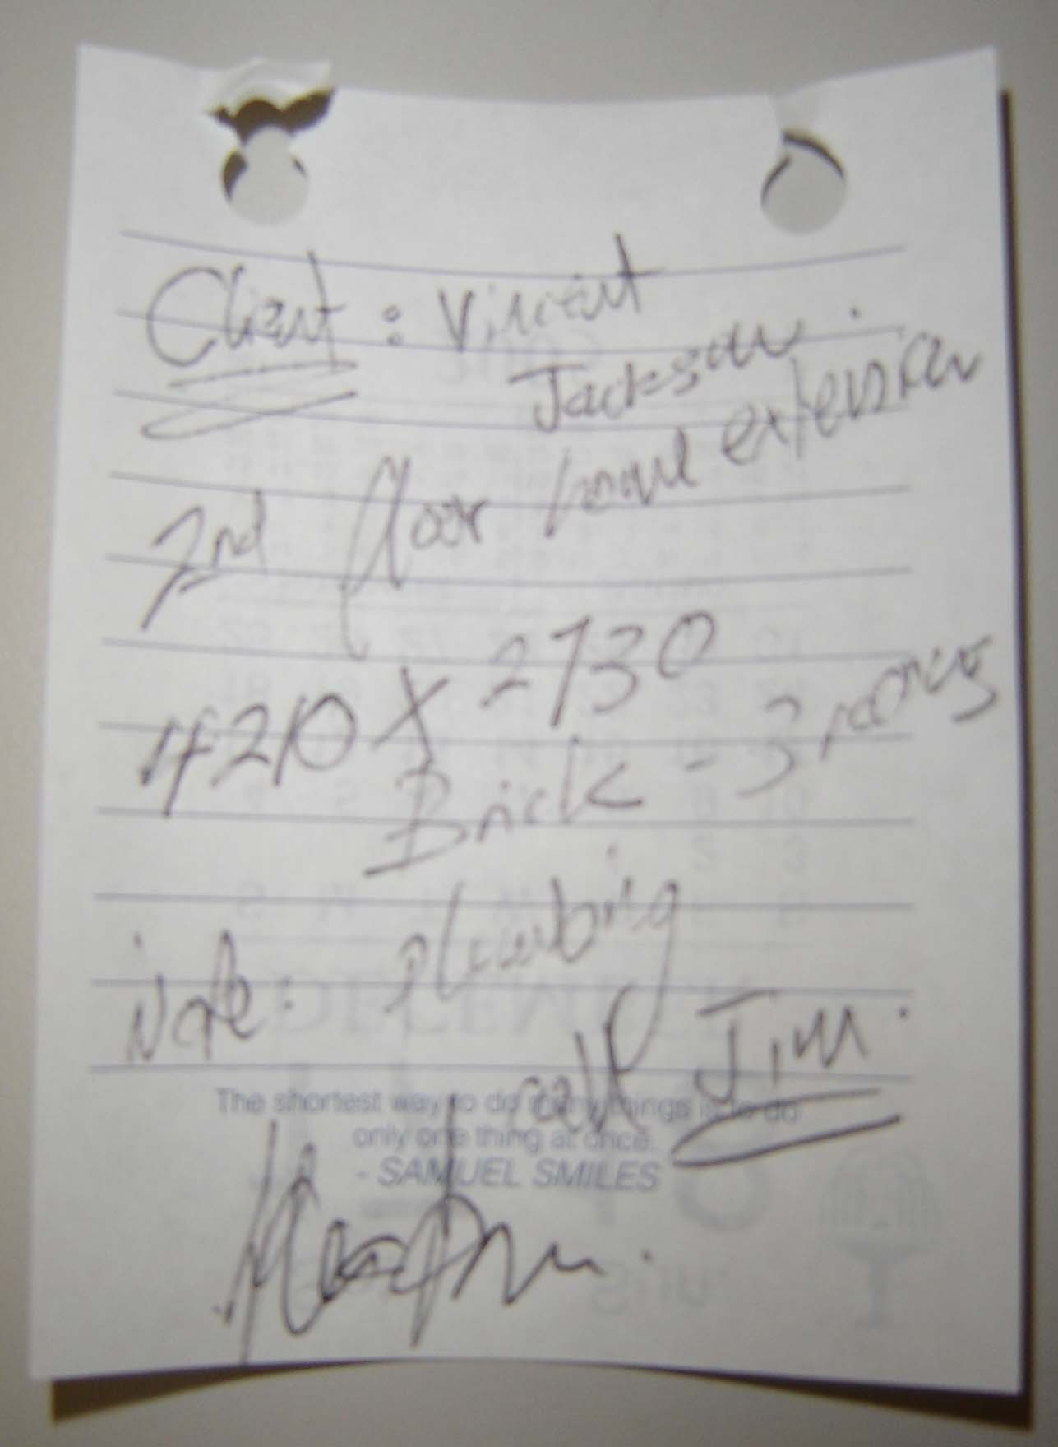
When a request for a quote is received from a prospective client (usually by email), the client is contacted and an appointment time is arranged. AJ visits the client, measures the building site and then gives these measurements to LaDana (on a sheet of paper – see the example shown) to prepare a quote. Once the quote is prepared, LaDana prints it out for AJ to approve or edit. AJ either signs the quote ‘approved’ or makes edits using a red pen and then hands this back to LaDana. She then makes the required changes, prints the quote out again and sends it to the client.

The Task

Analyse an existing networked information system used in an organisation, and propose physical design specifications for a new or modified networked information system.
Sample quote produced by AJ.

- Define the purpose of the current information system at Janson’s EZ-X10-Shuns-4U. Discuss this in terms of the organizational goals of the company.

- Suggest a variety of methods that could be used to collect data on the current information system so that a new information system can be designed.

- What economic, technical and social factors need to be addressed in regards to the design of a new information system?

- Draw a DFD to represent the current process of producing a quote for a prospective client.

- What security concerns need to be addressed in regards to the design of a new information system?

- What inefficiencies with data processing will need to be addressed in regards to the design of a new information system? Refer to evidence gathered via the DFD in your response.

- Draw an accurate network diagram for the proposed network for Janson’s EZ-X10-Shuns-4U showing the physical location and connections of all nodes and network elements. Label any specific use of nodes by staff members or groups in the company.

- List and describe the purpose of the main network components in this system.

- Name the topology chosen and explain why was the best choice for your design.

